Lesson thoughts: Discussion for Part 1 and Part 2. No technology needed for these parts.

Part 1:

# **Discuss with your table:**

# *So, if Beethoven was completely deaf, how did he compose?*

1. *Where do we observe waves in the real world?*
2. *What is sound?*
3. *If a tree falls in the forest, and no one is around to hear it....does it still make a sound?*
4. *Can sound travel through empty space? Why or why not?*

Part 2:

**Introduction; Vocabulary**

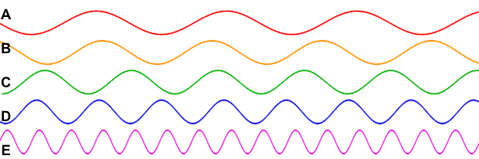

## **Looking at the picture above:**

1. The sine wave with the highest frequency is _________________ , and the sine wave with the lowest frequency is _________________ .

2. The sine wave with the longest period is _________________ , and the sine wave with the shortest period is _________________ .

3. The sine wave with the shortest wavelength is _________________ , and the sine wave with the longest wavelength is _________________ .

4. What relationship exists between frequency and wavelength?