

Relationship Between CO2 Absorption and Plant Growth

Name: _________________________ Class: _____________ Date: _______

Subject:________________ Teacher’s Name:___________________

Problem
How does the amount of Carbon Dioxide absorption affect plant growth?

Hypothesis
What do you think will happen?
Write your hypothesis in the “If…(independent variable), then…(dependent variable)” format?
If __________________________________________________________________________________________________________________________________
then __________________________________________________________________________________________________________________________________

Materials:
- COSMOS Toolkits
- COSMOS Toolkit Framework
- IoT nodes
- Mobile Nodes
- Carbon Dioxide Sensors
- Rulers
- Clip board
- Post-it Chart Paper
- Markers
- Graph Papers
- Graphing Calculators
- Graphic Organizers

PROCEDURE:

Pre-lab preparations
In each group, decide which job each person will have:
- Facilitator-help the team in making sure that each one performed their job functions and work together to accomplish the experiment.
- Data Recorders-responsible for data gathering and make sure that all details needed are recorded for the team to discuss and analyze later.
- Program Runner/Operator- will make sure that the sensors are up and running and the COSMOS Toolkit attached or the Raspberry pi used as a mobile node will display the data or the chronograf or the csv file.
- Time Keeper-collaborate with the group for proper time allotment of each section of the experiment so that no time is wasted or the time frames set for each section are all followed.

NOTE:
- Each one in the team should work well together to ensure that the whole experiment is done well despite your individual job descriptions.
- If it is the first time for students to use the COSMOS Toolkit, the teacher should introduce the different parts of kit as part of the Pre-lab preparations.

*Ensure that students are running the COSMOS program correctly*

Vocabulary:

Biology
Germination-the stage in which a germ or a living thing starts to sprout, grow and develop. Supplement. Germination in plants is the process by which a dormant seed begins to sprout and grow into a seedling under the right growing conditions.

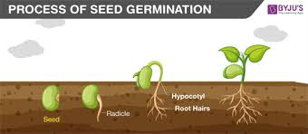

Carbon Dioxide-is a colorless, odorless gas found in our atmosphere. Its chemical formula is CO2, which means it is one carbon atom bonded to two oxygen atoms. It is a waste product in our bodies and is also produced by burning fossil fuels.

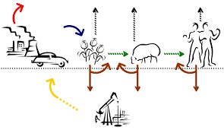

Photosynthesis- the process by which green plants and certain other organisms transform light energy into chemical energy. During photosynthesis in green plants, light energy is captured and used to convert water, carbon dioxide, and minerals into oxygen and energy-rich organic compounds
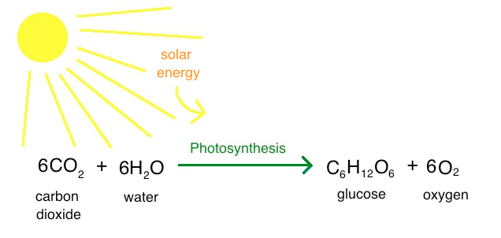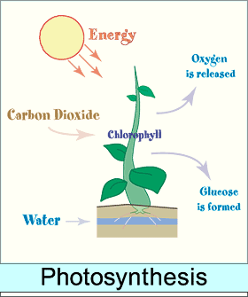

Plant Glucose- after carbon dioxide enters the leaf through stomata it moves into the mesophyll cells where photosynthesis occurs and glucose is constructed. Respiration/Photosynthesis is the process by which plants use light energy to convert carbon dioxide and water into sugars/glucose.
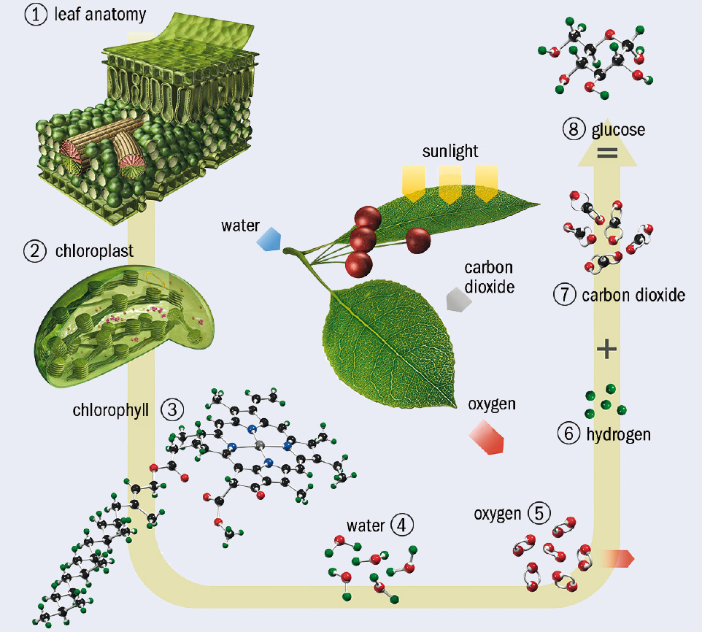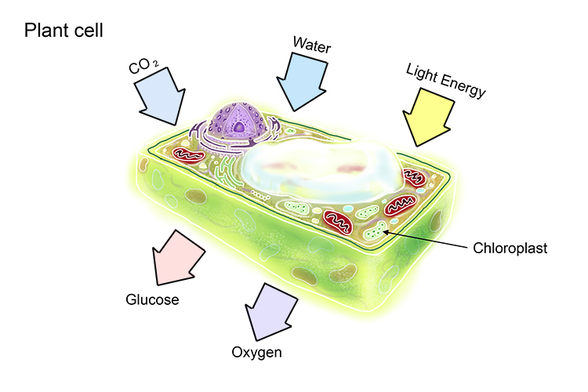

Absorption-is the process of absorbing or assimilating substances into cells or across the tissues and organs through diffusion or osmosis, as in absorption of nutrients by the digestive system, or absorption of drugs into the bloodstream. Supplement. Absorption, in a general sense, is the act or process of absorbing or assimilating.
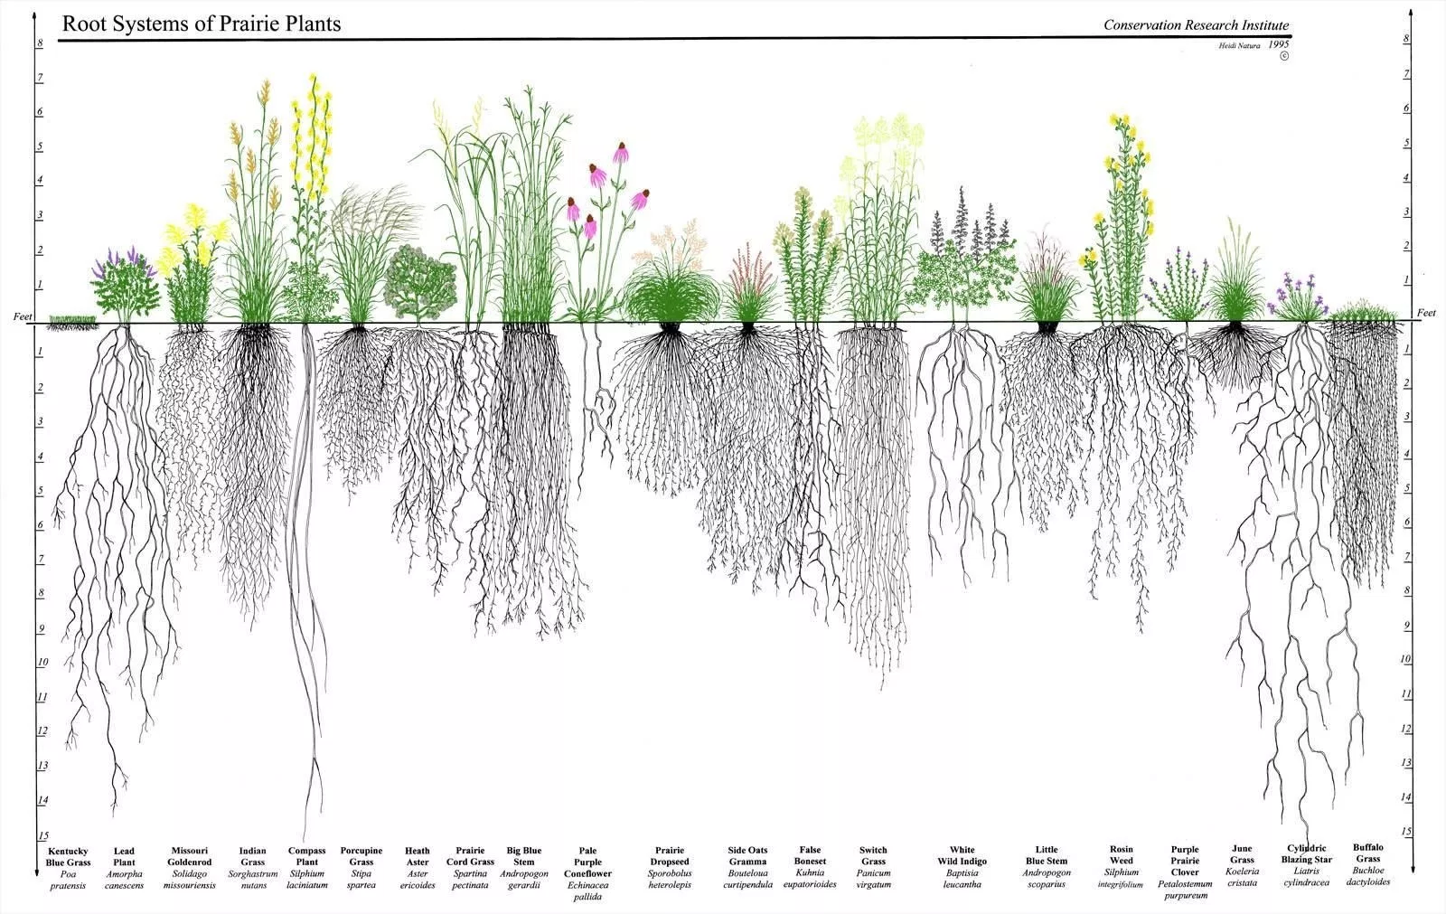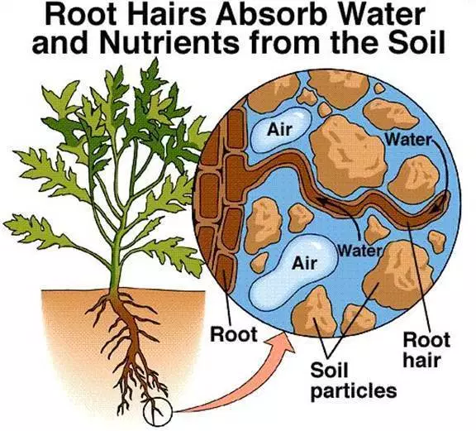

Respiration-is the biochemical process in which the cells of an organism obtain energy by combining oxygen and glucose, resulting in the release of carbon dioxide, water, and ATP (the currency of energy in cells).

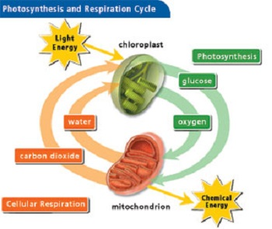

Math
Area-is the number of unit squares that can be contained within it. The unit square is usually some standard unit, like a square meter, a square foot, or a square inch.
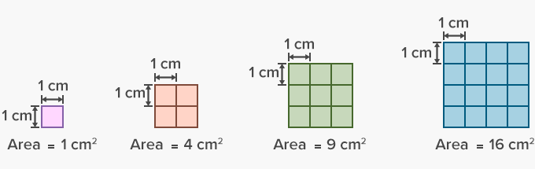
Surface Area -The total area of the surface of a three-dimensional object. Example: the surface area of a cube is the area of all 6 faces added together.
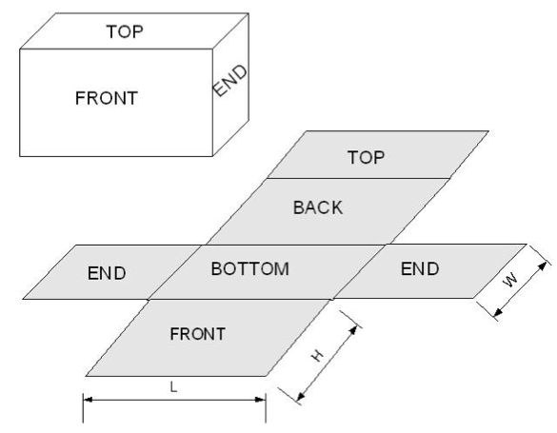
Median -is the average of the numbers. It is easy to calculate: add up all the numbers, then divide by how many numbers there are. In other words it is the sum divided by the count.

Mode-The number which appears most often in a set of numbers. Example: in {6, 3, 9, 6, 6, 5, 9, 3} the Mode is 6 (it occurs most often).
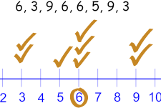
Median-is the middle most number. To find the Median, place the numbers in value order and find the middle number. Example: find the Median of {13, 23, 11, 16, 15, 10, 26}. Put them in order: {10, 11, 13, 15, 16, 23, 26} The middle number is 15, so the median is 15. (When there are two middle numbers we average them.)
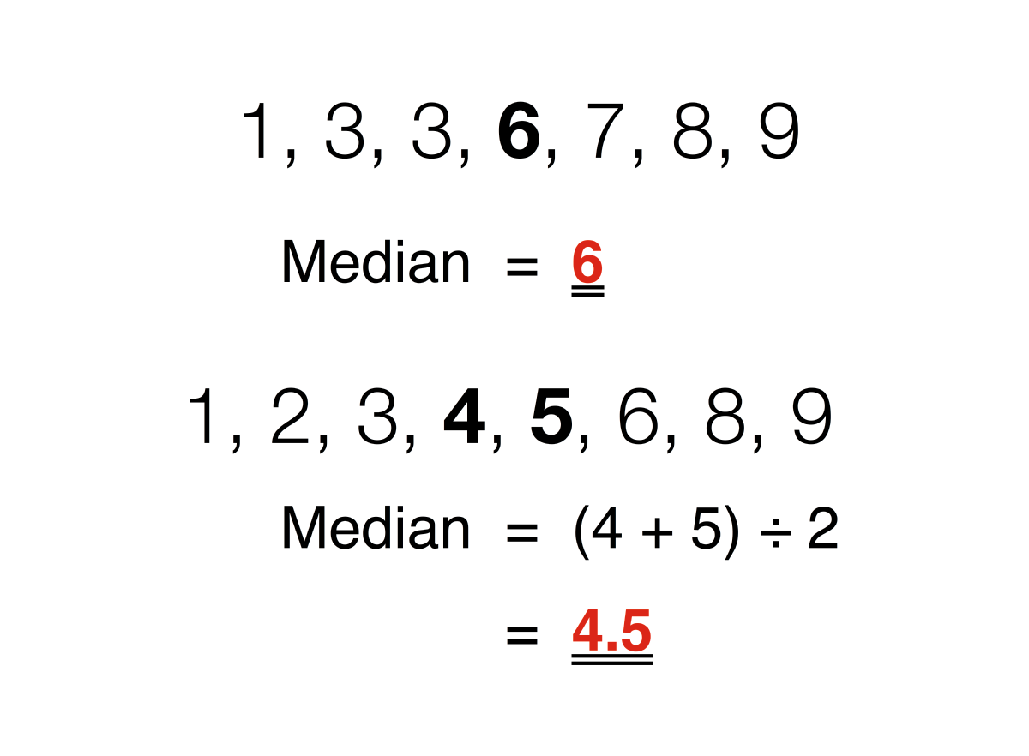
Range-is the difference between the lowest and highest values. In {4, 6, 9, 3, 7} the lowest value is 3, and the highest is 9, so the range is 9 − 3 = 6. Range can also mean all the output values of a function.
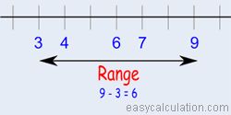
Interquartile range (IQR)- is a measure of variability, based on dividing a data set into quartiles. Quartiles divide a rank-ordered data set into four equal parts. The values that divide each part are called the first, second, and third quartiles; and they are denoted by Q1, Q2, and Q3, respectively.

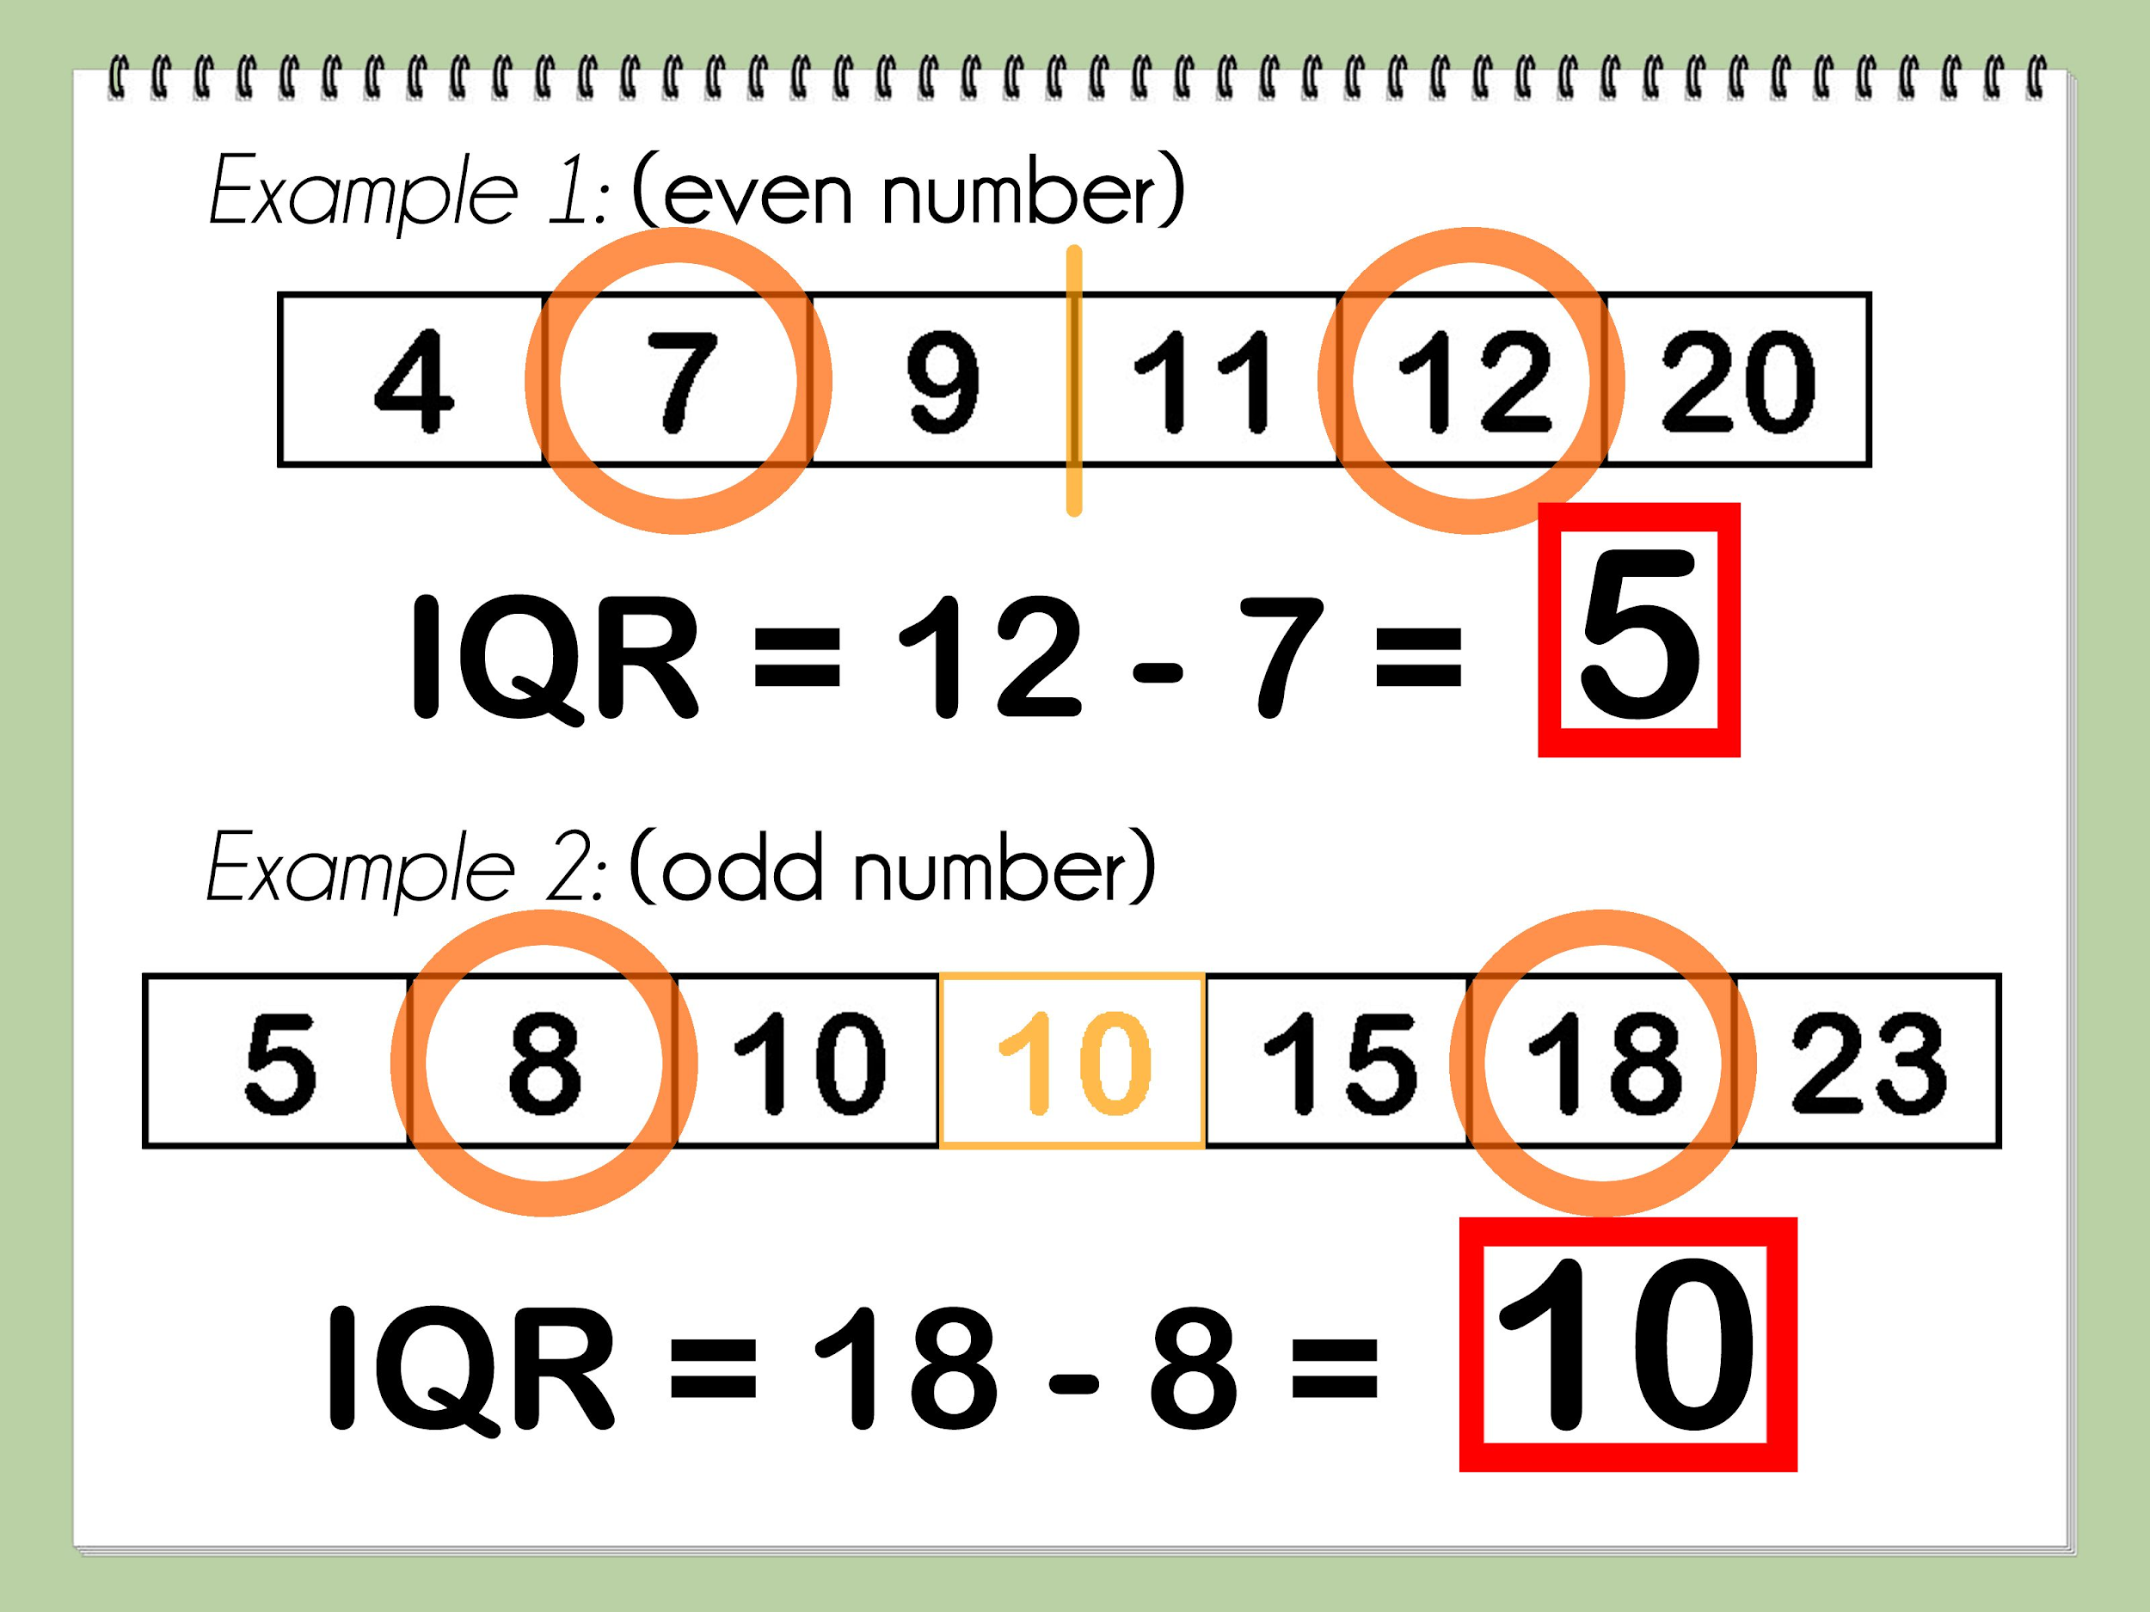
Box Plot-is a graphical rendition of statistical data based on the minimum, first quartile, median, third quartile, and maximum. The term "box plot" comes from the fact that the graph looks like a rectangle with lines extending from the top and bottom.
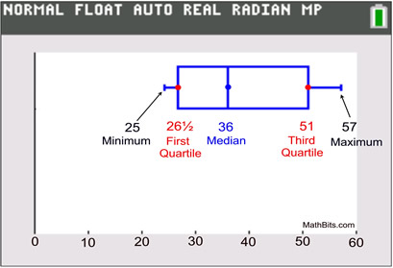
Mean absolute deviation (MAD) -of a data set is the average distance between each data value and the mean. Mean absolute deviation is a way to describe variation in a data set.
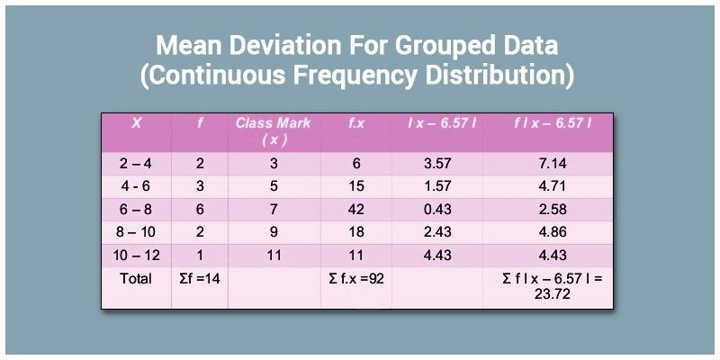
Statistical Graphs- or chart is defined as the pictorial representation of statistical data in graphical form.
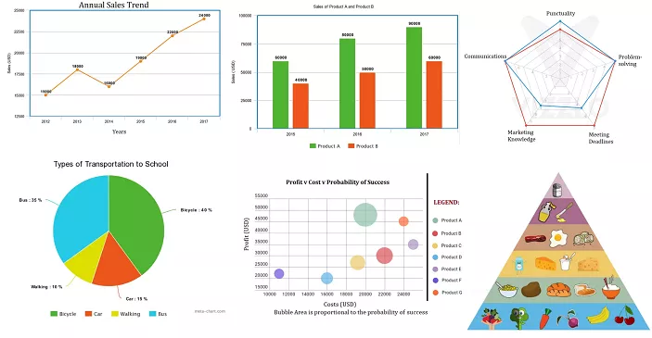

Slope-is the 'steepness' of the line, also commonly known as rise over run. We can calculate slope by dividing the change in the y-value between two points over the change in the x-value.

Proportional relationship-is one in which two quantities vary directly with each other. We say the variable y varies directly as x if: y=kx. for some constant k , called the constant of proportionality.

Percent is a ratio whose second term is 100. Percent means parts per hundred. The word comes from the Latin phrase per centum, which means per hundred. In mathematics, we use the symbol % for percent.

Rate-is a ratio that is used to compare different kinds of quantities.

Unit rate-describes how many units of the first type of quantity corresponds to one unit of the second type of quantity. Some common unit rates are miles (or kilometers) per hour, cost per item, earnings per week, etc.

Independent variable is a variable that represents a quantity that is being manipulated in an experiment. A dependent variable represents a quantity whose value depends on those manipulations.

Constant of Proportionality-constant value of the ratio of two proportional quantities x and y; usually written y = kx, where k is the factor of proportionality.
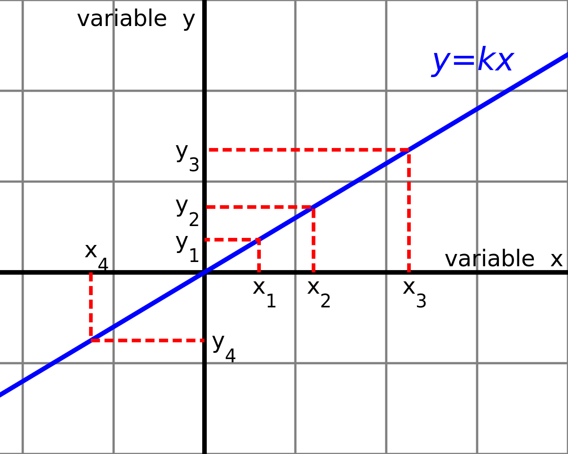
Ordered Pair-A pair of numbers used to locate a point on a coordinate plane is called an ordered pair. An ordered pair is written in the form (x, y) where x is the x-coordinate and y is the y-coordinate.

Cartesian Coordinate System-is a system that specifies each point uniquely in a plane by a set of numerical coordinates, which are the signed distances to the point from two fixed perpendicular oriented lines, measured in the same unit of length. Each reference line is called a coordinate axis or axis (plural axes) of the system, and the point where they meet is its origin, at ordered pair (0, 0). The coordinates can also be defined as the positions of the perpendicular projections of the point onto the two axes, expressed as signed distances from the origin.

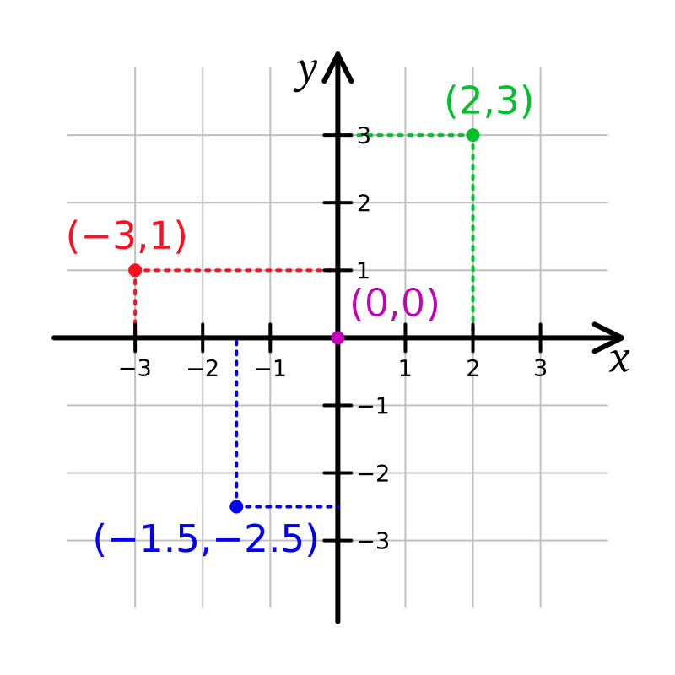
Regression Analysis- is a process of creating a mathematical model that can be used to predict the values of the dependent variable based upon the values of an independent variable. In other words, we use the model to predict the value of Y when we know the value of X. (The dependent variable is the one to be predicted).

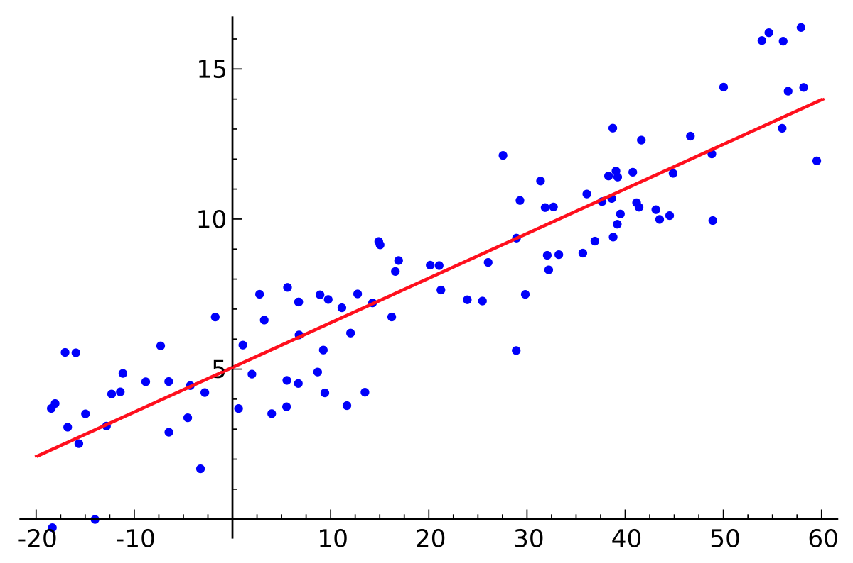

Scatter Plot- a graph of plotted points that show the relationship between two sets of data..

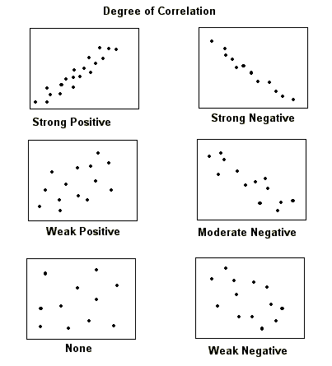
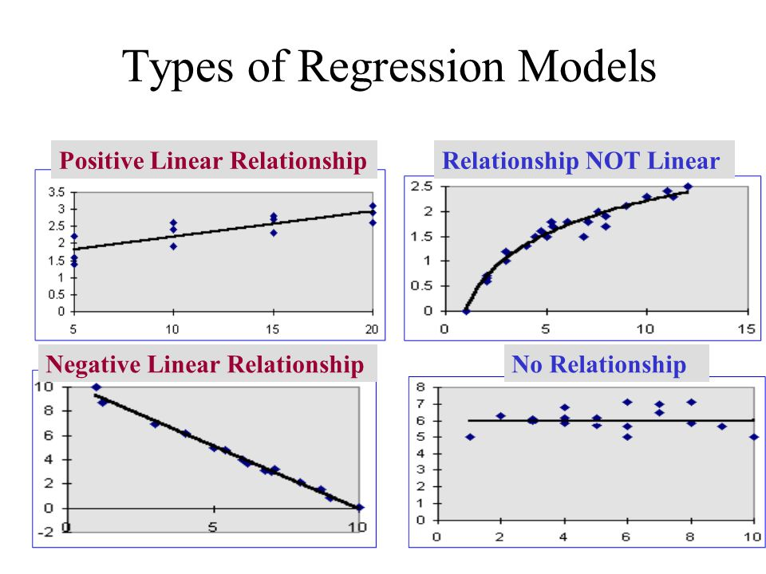

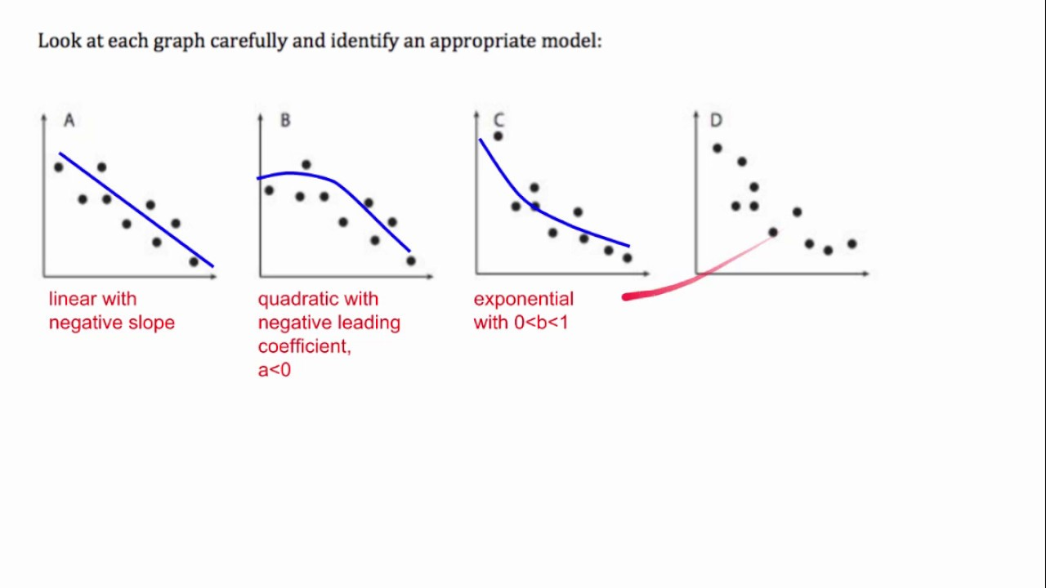

Hardware and Software Equipment
Chronograf-is InfluxData’s open source web application. Use Chronograf with the other components of the TICK stack to visualize your monitoring data and easily create alerting and automation rules. This is where we see the CO2 levels, heat/temperature, humidity, noise, etc displayed on a graph.

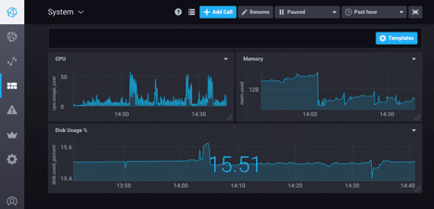
IoT Node- is a combination of hardware and software - where the sensors and actuators play the role of capturing data and taking action respectively. Embedded modules, packaged devices, smart thermostat, wifi and iot enabled tubelight and the iot gateways or controllers can all be classified as iot nodes
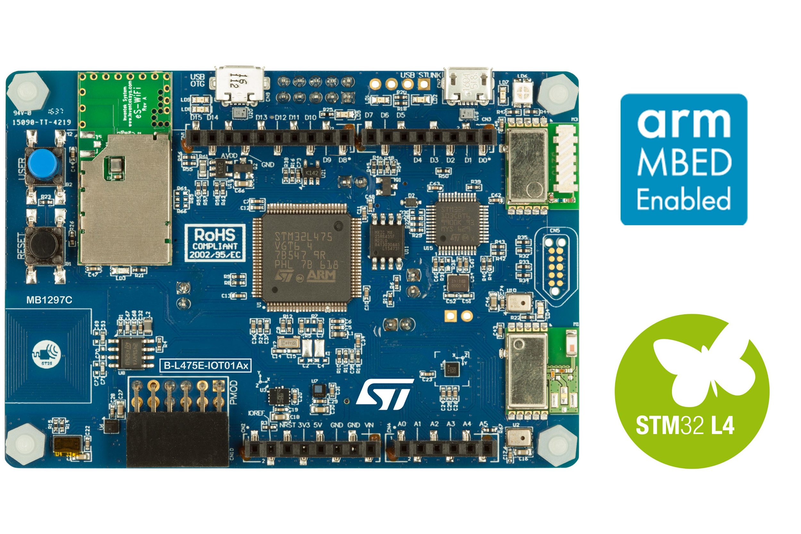

Carbon Dioxide Sensor-measures gaseous carbon dioxide levels by detecting the quantity of IR radiation absorbed by carbon dioxide molecules. The sensor employs a hot metal filament that acts as an IR source to generate IR radiation.

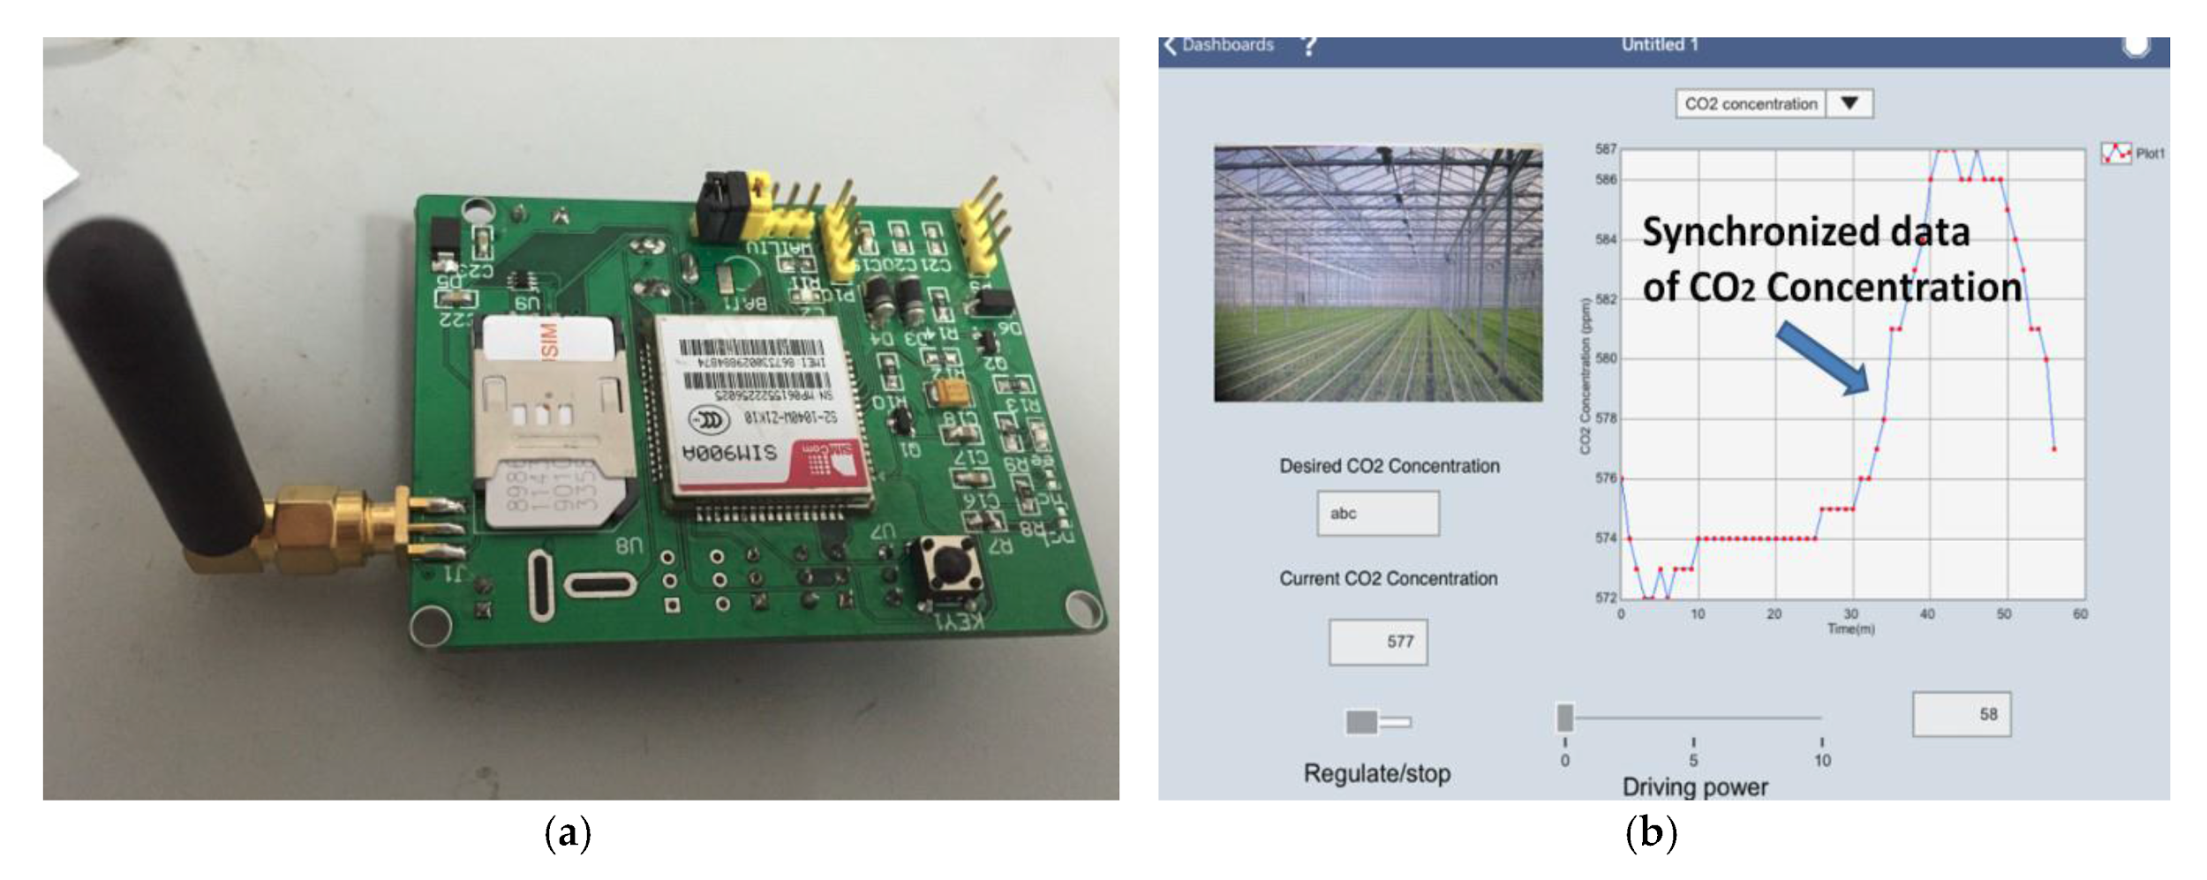
Zigbee protocol-is an open global standard for wireless technology designed to use low-power digital radio signals for personal area networks. ZigBee operates on the IEEE 802.15.4 specification and is used to create networks that require a low data transfer rate, energy efficiency and secure networking.
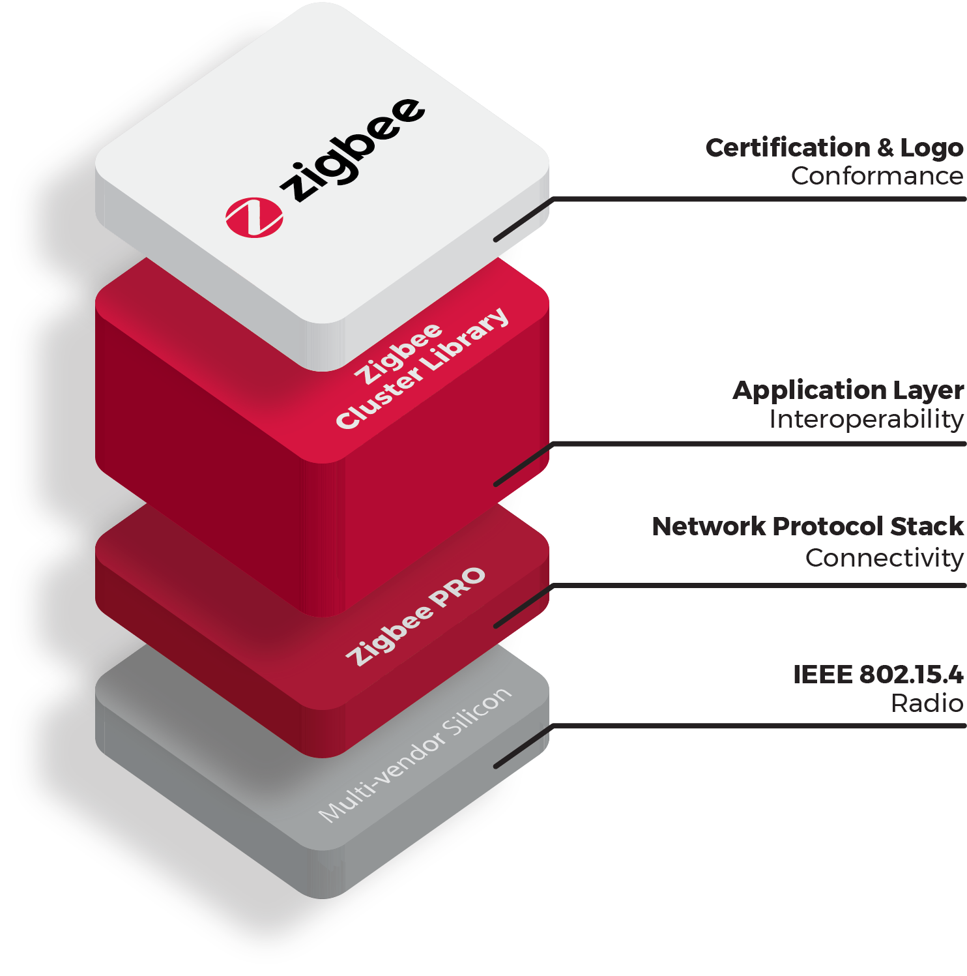

Mobile Node-is an Internet-connected device whose location and point of attachment to the Internet may frequently be changed. This kind of node is often a cellular telephone or handheld or laptop computer, although a mobile node can also be a router.
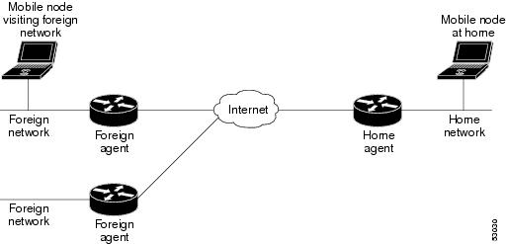

Web browser-is a software program that allows a user to locate, access, and display web pages. In common usage, a web browser is usually shortened to "browser." Browsers are used primarily for displaying and accessing websites on the internet, as well as other content created using languages such as Hypertext Markup Language (HTML) and Extensible Markup Language (XML).



Experiment Proper
The students will explore this experiment for two weeks.
Day 1- Teacher will introduce the carbon dioxide sensor and the IoT nodes, mobile nodes and how data is read in the COSMOS Toolkit Framework. Expectations and rationale of this experiment will be given to prepare the students for the whole activity.
Day 2- The class will be divided into four groups. Group 1 and 2 will do the Experiment A while Groups 3-4 will perform Experiment B. Each team will have a pot and germinate their own plants. The members are responsible for taking care of their set-up.
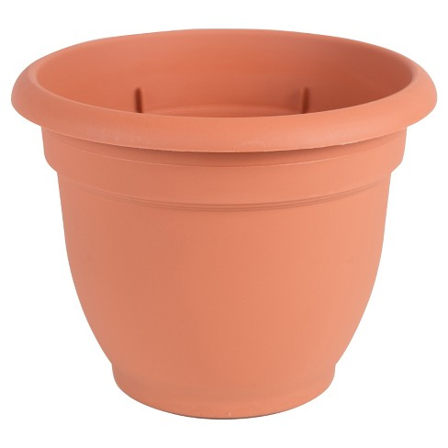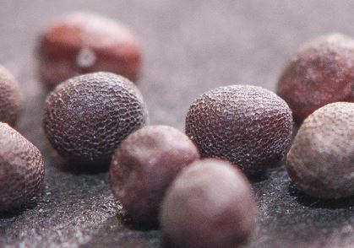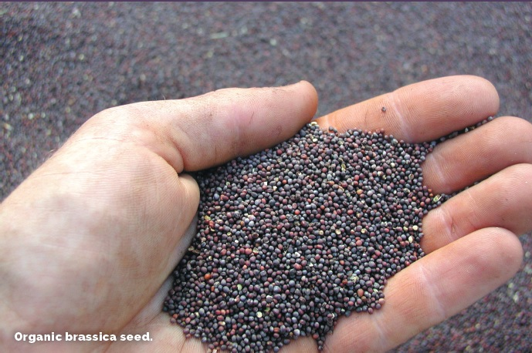
Day 3-7 Nurture germination and growth first for a week. The students will spend 10 minutes, before every class, watering their plants, making sure the temperature is at least 20C and exposed to light. The Brassica rapa plants should be breaking the surface and sprouting leaves very soon! The teacher will germinate in separate pots at the same time some seeds just in case the seeds student germinate will not sprout.
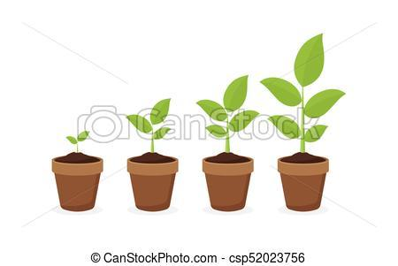
Brassica rapa is a plant consisting of various widely cultivated subspecies including the turnip (a root vegetable); napa cabbage, bomdong, bok choy, and cime di rapa (leaf vegetables); and Brassica rapa subsp.
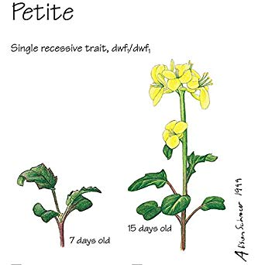
Day 8- 14 Students will start observing the results on the chronograph and record them in their graphic organizer.

Experimental Group A
These group of plants will be exposed to the sunlight and must be placed near the window from Day 2-14.

Weekly Graphic Organizer
-recording these data will start on Day 8 after a week of germination.

 |  | Plant Growth
Day | CO₂ Level | No. of leaves | Average Leaf Area | Average Plant Height | Average Stem Length | Average weight of the plants  (taken after day 14)
8
9
10
11
12
13
14

Constant Variables:
amount of water, fertilizer, humidity, size of the pots

Replicate the graph below for other comparisons that you wanted to show. This will allow the group to analyze and show the relationship of the two variables you are observing at a time.
For example:
CO2 level versus Average Leaf Area



Experimental Group B
These group of plants will not be exposed to sunlight and must be placed inside the closet from Day 8-14.

Weekly Graphic Organizer
-recording these data will start on Day 8 after a week of germination.

 |  | Plant Growth
Day | CO₂ Level | No. of leaves | Average Leaf Area | Average Plant Height | Average Stem Length | Average weight of the plants  (taken after day 14)
8
9
10
11
12
13
14

Constant Variables:
amount of water, fertilizer, humidity, size of the pots

Replicate the graph below for other comparisons that you wanted to show. This will allow the group to analyze and show the relationship of the two variables you are observing at a time.

For example:
CO2 level versus Average Stem Height

IMPORTANT:
Students calculate the approximate total surface area of the plant’s leaves by tracing an outline of all the leaves onto graph paper (grid area = 1 cm²); see example below.
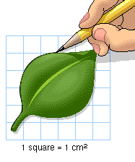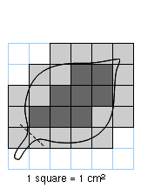

Guide Questions:
- What have you noticed about the trend in your table and graphs?
- Which two variables show a proportional relationship? Why or why not?
- Can you explain possible reasons why they don’t come out proportional?
- What trends have you noticed when you plotted the points on the Cartesian Plane?
- Using regression analysis, can you tell the specific function that will fit each of the given data?
- Is there a strong correlation between the variables you compare? Is it strong, medium, low or no correlation at all? Justify your thinking. Support your reasons with possible factors affecting each phenomenon.

(Middle School students can use those questions above to discuss the results among themselves. This will help them organize, record, analyze and present the data gathered for class or group presentation.)

NOTE:
Students will discuss the details of this section of the experiment within their group and find out the factors affecting their results. They need to present all data in a powerpoint presentation and show all the mathematical calculations involved.

RULES:
Use the data/facts gathered from experiments as basis of your discussion.

Think about your experiment!!
Your discussion must be detailed and include answers to the following questions:
- What are some factors that could’ve led to precision or mistakes in this experiment?
- Do you feel the data is valid (reliable and accurate)? Why or Why not?
- What were the sources of error in this experiment (factors that may have affected your results)? Explain.
- If you had the opportunity to redo the experiment, what changes would you make? How would you improve it? Explain.
- What new questions did the experiment generate? Explain.
- What did you learn from the experiment? Explain or justify your reasoning.

EXTENSIONS for PROJECTS:
- Students can create an investigation on how the carbon dioxide absorption among different types of plants affects their growth.

- They can use 3-5 different types of plants to do the same experiment for two weeks.

- They can compare the different results and look at the similarities as well as the differences.

