**Scientific Inquiry – Using sensors to determine relationship between plant’s leaf size, photosynthetic potential and CO2 absorption**

**Student name: ________________________________________________________________**

Overview Over the next few weeks you will be applying the scientific process to better understand certain aspects of photosynthesis. As you (and your teammates) setup your terrarium and monitor the growth of your Brassica rapa plant, you will use an electronic, wireless sensor that measures carbon dioxide levels. If you recall photosynthesis is basically a two stage process whereby the light-dependent reactions generate enough adenosine triphosphate (ATP) and electron carriers (adenine dinucleotide phosphate (NADP)) for construction of glucose from atmospheric carbon dioxide (CO2). As your plant grows and develops new and larger leaves it should be more photosynthetically active which means it will be absorbing more CO2 through its leaves’ stomata to continue fueling growth.

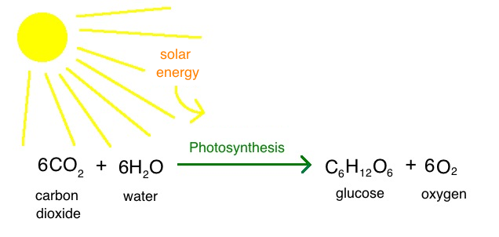

For a refresher on the principles of photosynthesis visit these tutorials: 1) http://www.biology4kids.com/files/plants_photosynthesis.html

2) [http://highered.mheducation.com/sites/0072437316/student_view0/chapter10/animations.html\](http://highered.mheducation.com/sites/0072437316/student_view0/chapter10/animations.html\\)

3) https://www.khanacademy.org/science/biology/photosynthesis-in-plants/introduction-to-stages-of-photosynthesis/v/photosynthesis

Now that we are familiar with the basic ingredients a plant requires to synthesize glucose, we need to figure out what part of this plant is responsible for such an important part of its survival.

Take a look at the image below of a plant’s stages of growth. Base on the tutorials you have visited which part of the plant’s anatomy is directly responsible for photosynthesis?

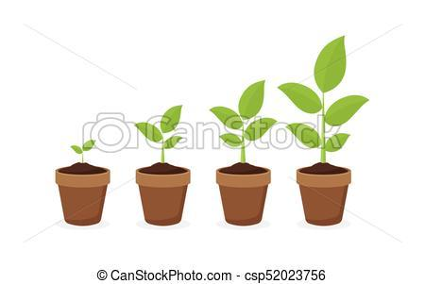

If you guessed the leaf, you were correct! In fact, there seems to be a strong correlation to a plant’s leaf size and its ability to photosynthesize and continued growth. Over the next couple

of weeks we are going to study the relationship between this relationship and light availability.

**You (and your teammates) will graded in the following ways:**

50% Team preparedness: I will briefly visit your group and asking questions regarding some aspect of the photosynthesis experiment. In addition, I will be looking for productive conversations and on-time, progress reports.

50% Individual preparedness: Homework assignments, quizzes.

**Day 0 - homework to submit - worksheet (good preparation for quiz!)**

Before you start the experiment you should peruse these resources and familiarize yourself with the two basic stages of reactions of photosynthesis (light dependent and light-independent) and the role certain environmental factors (sunlight for this experiment) play in the photosynthesis of a plant. After visiting these tutorials, please answer these questions:



For a refresher on the principles of photosynthesis visit these tutorials: 1) http://www.biology4kids.com/files/plants_photosynthesis.html

2) [http://highered.mheducation.com/sites/0072437316/student_view0/chapter10/animations.html\](http://highered.mheducation.com/sites/0072437316/student_view0/chapter10/animations.html\\)

3) https://www.khanacademy.org/science/biology/photosynthesis-in-plants/introduction-to-stages-of-photosynthesis/v/photosynthesis

1. Briefly explain how carbon dioxide and water are entering the plant.

A. carbon dioxide enters a plant through…

B. water enters a plant through…

2. Explain how these two reactants for photosynthesis are connected to the products.

A. Carbon dioxide eventually results in…

B. Water eventually results in…

3. Briefly explain what each of the 2 photosynthetic stages produce.

A. The light dependent stage produces…

B. The light-independentstage produces…

**Day 1 - Quiz – Student name: _______________________________________________**

1-4. List any 2 food stuffs from the seed and explain the roles they play during germination.

Reactant #1 + Reactant #2 -----yields--🡪 Product #1 + Product #2

__________ __________ __________ __________

5. What organelle within plant cells are specifically responsible for photosynthesis?

6. What is the principal pigment that capture sunlight, fueling photosynthesis?

7. Predict what would happen to the plant if it went without light or water for too long.

8. Describe the relationship between sunlight and carbon dioxide absorption.

**Day 1 Terrarium setup (this have already been performed by your teacher) Read basic germination information:** The mustard plant (Brassicaceae) is a biennial that grows 1-3 feet with many branches. Leaves can reach 12 inches long, with bright yellow flowers clustered at stem tops. The fruit is an elongated, two-parted capsule that splits open at the base to release the seeds at maturity. Seeds are nearly round, and reddish-gray to black. This is an extremely adaptable plant, growing in sandy to heavy clay soils and tolerates a pH 5-9 range. It grows best in well-drained, moist soil, but may also grow in droughty conditions, moderate heat, and soils with low fertility. Although it grows best in full sun, it will grow in moderate shade.

**For best germination and growth results:** Lights on all the time and 5–10 cm from growing tip, room temperature ~22°C), soil moist with water all time (reservoir system), 1 oz fertilizer (Osmocote NPK pellets @N/14, P/14, K/14).

References for the optimal germination and growing conditions for the Brassica rapa plant.

(file:///C:/Users/jason%20george%20econome/Desktop/00000%202019%20WFPgermbk!.pdf; <http://www.fastplants.org/pdf/growing_instructions.pdf>; https://fastplants.org/2017/09/19/physical-environment-blog/).

Homework: Explain what processes are occurring within the seed right now that are allowing it to grow in the absence of photosynthesis.

**Day 2-4 Nurture germination and growth**

Spend 10 minutes, before every class, watering your plant, making sure the temperature is at least 20C and exposed to light. The Brassica rapa plants should be breaking the surface and sprouting leaves very soon!

**Day 5 Correlating light with photosynthesis and carbon dioxide (CO2) absorption**

A) Student teams use electronic sensors to measure carbon dioxide (CO2) levels just outside

of the classroom in the hallway; no plants should be present. They can measure and record this value using several locations in the hallway and calculate the overall average ambience CO2 levels (CO2 levels are approximately 405 parts per million or 0.1% of the atmosphere).

Ambience CO2 levels = _________________ ppm.

B) Students return to classroom and place the sensor near their light-exposed plants. A large, transparent beaker or bag should be placed over the potted plant and sensor. Students record an average CO2 value over 5 minutes.

CO2 levels near plants = _________________ ppm.

C) Students calculate the total surface area of the plant’s leaves by tracing an outline of all the leaves onto graph paper (grid area = 1 cm2); see example below.

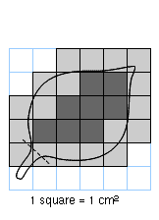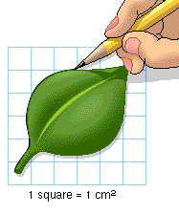

**Calculating Leaf Surface Area**

Hold a piece of graph paper (1-cm grid ) up against

a representative leaf of your young pea plant and trace its outline.

Count the number of square centimeters within the outline; include all of the whole and half squares but nothing smaller.

Add up all of these squares from this one leaf to calculate it’s surface area (cm2).

In the example above, the leaf’s surface area = 13 cm2 and the total would be 130 cm2

if there 10 similarly sized leaves altogether; if not tally all of the individual leaf area values.

Do not include stem (petiole) in your calculation.

**Plant’s total leaf surface area = ________ cm2.**

D) Student teams place their plants back by the window sill or under fluorescent light) for the next 2 days. *Don’t forget to keep watering the plants during this time.

Homework: Explain relationship between total leaf surface area and CO2 absorption; even

if difference between CO2 levels near the plant versus in their absence was not significant.

**DAY 7 Correlating light with photosynthesis and carbon dioxide (CO2) absorption**

A)Student teams repeat the activities that they performed on day 5.

B) Students place their plants back by window sill or under fluorescent light) for next 2 days.

*Don’t forget to keep watering the plants during this time.

Homework: Looking at the raw data can you explain a relationship between photosynthesis and plant size or total leaf surface area?

**DAY 9 Correlating light with photosynthesis and carbon dioxide (CO2) absorption**

A)Student teams repeat the activities that they performed on day 5.

B) Student teams place their plants into a cupboard or cover them with black bags or aluminum foil over all of the plant’s leaves for the next 2 days; no light should be present.

*Don’t forget to keep watering the plants during this time.

C) Students generate a graph “Days of light exposure versus total leaf surface area of plant and CO2 absorption (days 5-9)"; both of which should display increasing slopes; results should be significantly improved due to increased size and leaf count of the growing plant.

**graph: __________________________________________________________________**



Homework: As the plant gets larger what other parts of its anatomy need to sustain it?

**DAY 11 Measuring photosynthetic activity of plant in absence of light**

A) Student teams place CO2 sensors near their plants while in the dark.

CO2 levels near non-photosynthesizing plants = _________________ ppm.

Ambience CO2 levels = _________________ ppm.

B) Students, using formula from “day 5” to calculate the total leaf surface area.

Plant’s total leaf surface area = ________ cm2.

Homework:

C) What conclusions can you draw about a plant’s “health” (CO2 absorption, total leaf surface area) when light is missing?

D) How can you use the term “negative feedback” to explain the drop in photosynthetic activity by the plant in the absence of light?

E) What is the advantage to the plant to be able to perform “negative feedback” in response to a change in its immediate environment?

F) Can you think of any other examples of negative feedback that affect your own health?