

**Regression Models Along the Layers of Communication Worksheet**

**Name: _________________________ Class: _____________ Date: _______**

**Subject:________________**

**Teacher’s Name:___________________**

***Problem***

How do you determine the Regression model that will best fit for the data sent along the line of communication over the network layers? How is a complete file eventually transferred over the network?

***Hypothesis***

What do you think will happen?

Write your hypothesis in the “If…(independent variable), then…(dependent variable)” format?

If __________________________________________________________________________________________________________________________________

then __________________________________________________________________________________________________________________________________

***Materials***

* COSMOS Toolkit
* SDR receiver (500 hz -1.7 Ghz)
* Pencil (colored)
* Ruler
* Clip board
* Post-it Chart Paper
* Markers
* Graph Paper
* Graphic Organizer to record data
* Vocabulary Sheet for the students
* WiFi Access Point
* Ethernet Cables
* Cellphones

**PROCEDURE:**

**Pre-lab preparations**

In each group, decide which job each person will have:

1. **Facilitato**r-help the team in making sure that each one performed their job functions and work together to accomplish the experiment.
2. **Data Recorders**-responsible for data gathering and make sure that all details needed are recorded for the team to discuss and analyze later.
3. **Program Runner/Operator**-follow the instructions on how to run the terminal and the local host from the computer browser for the group to have the program running smoothly for the entire experiment.
4. **Time Keeper**-collaborate with the group for proper time allotment of each section of the experiment so that no time is wasted.

**NOTE:**

* Each one in the team should work well together to ensure that the whole experiment is done well despite your individual job descriptions.
* If it is the first time for students to use the COSMOS Toolkit, the teacher should introduce the different parts of kit as part of the Pre-lab preparations. They have to know how to put it on and how to run a terminal and find the local host from a browser in order to run this experiment before conducting this on their own.

**\*Ensure that students are running the COSMOS program correctly\***

**NOTES and Vocabulary Terms:**

**Math**

**Slope**-is the 'steepness' of the line, also commonly known as rise over run. We can calculate **slope** by dividing the change in the y-value between two points over the change in the x-value.

**Proportional relationship**-is one in which two quantities vary directly with each other. We say the variable y varies directly as x if: y=kx. for some constant k , called the constant of **proportionality**.

**Percent** is a ratio whose second term is 100. **Percent** means parts per hundred. The word comes from the Latin phrase per centum, which means per hundred. In **mathematics**, we use the symbol % for **percent**.

**Rate**-is a ratio that is used to compare different kinds of quantities.

**Unit rate**-describes how many **units** of the first type of quantity corresponds to one **unit** of the second type of quantity. Some common **unit rates** are miles (or kilometers) per hour, cost per item, earnings per week, etc.

**Independent variable** is a **variable** that represents a quantity that is being manipulated in an experiment. A **dependent variable** represents a quantity whose value depends on those manipulations.

**Constant of Proportionality**-constant value of the ratio of two **proportional** quantities x and y; usually written y = kx, where k is the factor of **proportionality**.

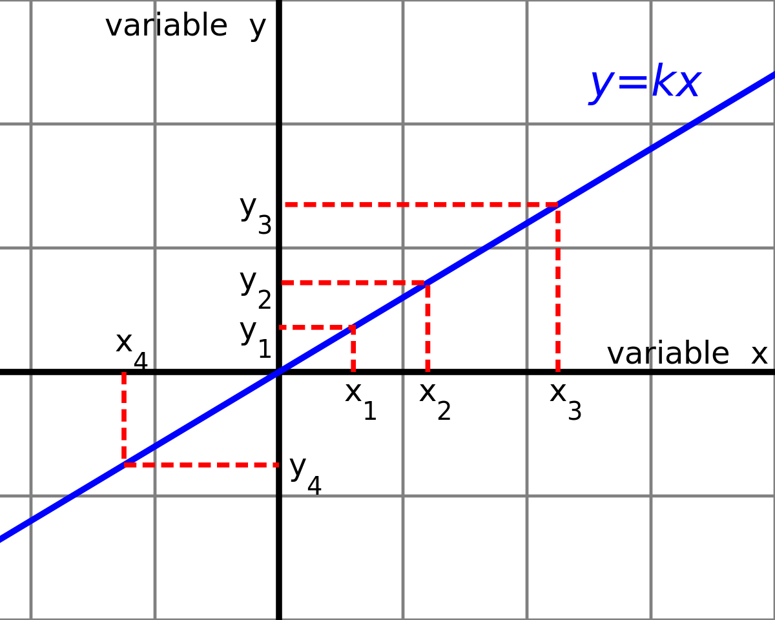

**Ordered Pair**-A pair of numbers used to locate a point on a coordinate plane is called an ordered pair. An ordered pair is written in the form (x, y) where x is the x-coordinate and y is the y-coordinate.

**Cartesian Coordinate System**-is a system that specifies each [point](https://en.wikipedia.org/wiki/Point_(geometry)) uniquely in a [plane](https://en.wikipedia.org/wiki/Plane_(geometry)) by a set of [numerical](https://en.wikipedia.org/wiki/Number) **coordinates**, which are the [signed](https://en.wikipedia.org/wiki/Positive_and_negative_numbers) distances to the point from two fixed [perpendicular](https://en.wikipedia.org/wiki/Perpendicular) oriented lines, measured in the same [unit of length](https://en.wikipedia.org/wiki/Unit_length). Each reference line is called a *coordinate axis* or just *axis* (plural *axes*) of the system, and the point where they meet is its [*origin*](https://en.wikipedia.org/wiki/Origin_(mathematics)), at ordered pair (0, 0). The coordinates can also be defined as the positions of the [perpendicular projections](https://en.wikipedia.org/wiki/Orthogonal_projection) of the point onto the two axes, expressed as signed distances from the origin.

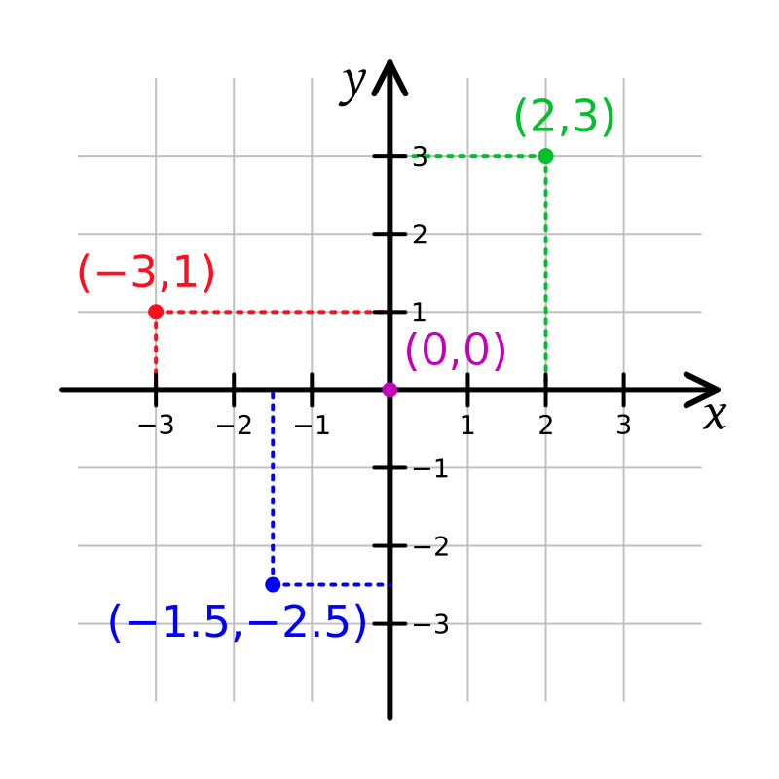

**Regression Analysis**- is a process of creating a **mathematical model** that can be used to predict the values of a dependent variable based upon the values of an independent variable. In other words, we use the **model** to predict the value of Y when we know the value of X. (The dependent variable is the one to be predicted).

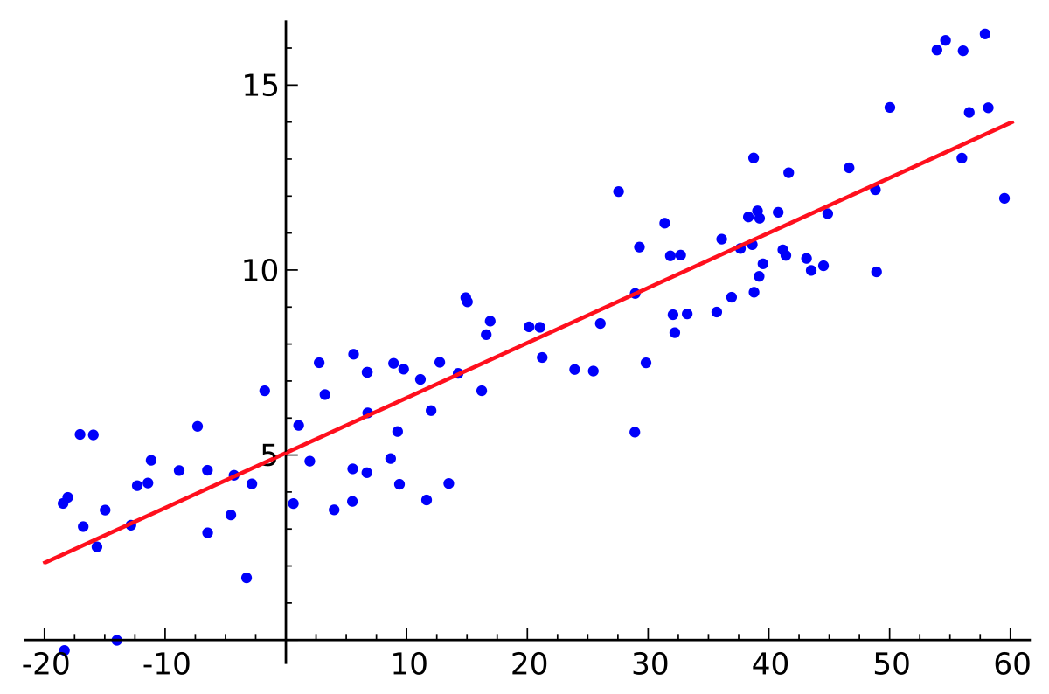

**Scatter Plot**- a graph of plotted points that show the relationship between two sets of data..

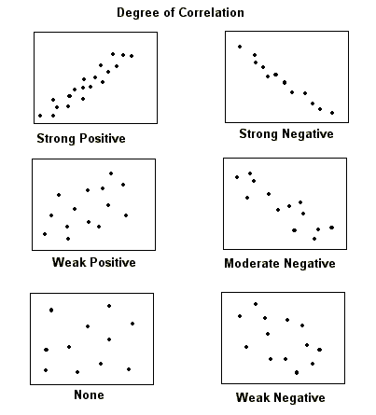

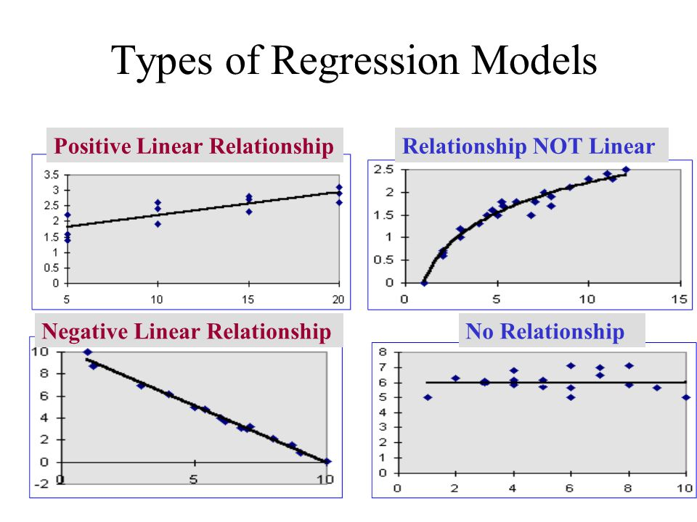

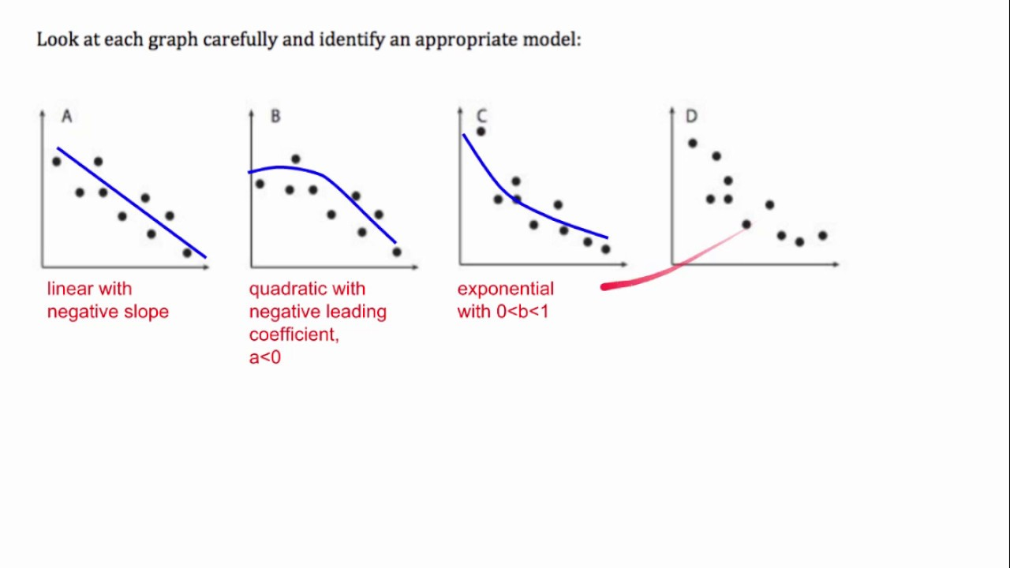

**Wireless Technology**

**Wireless Signal**- A signal is an electrical or electromagnetic waves that travel through air to transfer data from one device or network to another.

It is the key component behind virtually all:

* Communication
* Computing
* Networking
* Electronic devices

A signal can be either analog or digital.

**Web browser**-is a software program that allows a user to locate, access, and display web pages. In common usage, a web browser is usually shortened to "browser."

**Fiber optic** cable consists of a bundle of glass threads, each of which is capable of transmitting messages modulated onto light waves. ... **Fiber optic** cables have a much greater bandwidth than metal cables.

**Cables** are **networking** hardware used to connect one **network** device to other **network** devices or to connect two or more computers to share printers, scanners etc. ... Electrical connections using twisted pair or coaxial **cable** are used within a building.

**Satellite**- refers to Internet access provided through **satellites**. In other words, it is a telecommunications **network** provided by orbital communication stations. Signals from these **satellites** allow a user with a dish to have a high speed internet connection.

**Wi-Fi** is the name of a popular wireless **networking** technology that uses radio waves to provide wireless high-speed Internet and **network** connections. A common misconception is that the term **Wi-Fi** is short for "wireless fidelity," however this is not the case. **Wi-Fi** is simply a trademarked phrase that **means** IEEE 802.11x.

**Digital Subscriber Line (DSL)** is a communications medium used to transfer digital signals over standard telephone lines. Along with cable Internet, DSL is one of the most popular ways ISPs provide broadband Internet access.

**Transmission Control Protocol/Internet Protocol (**TCP/IP), which is a set of networking protocols that allows two or more computers to communicate. The Defense Data Network, part of the Department of Defense, developed TCP/IP, and it has been widely adopted as a networking standard

**User Datagram Protocol** (UDP)is part of the Internet Protocol suite used by programs running on different computers on a network. UDP is used to send short messages called datagrams but overall, it is an unreliable, connectionless protocol.

**Media Access Control** (MAC) address, a hardware address that uniquely identifies each node of a network. In IEEE 802 networks, the Data Link Control (DLC) layer of the OSI Reference Model is divided into two sub-layers: the Logical Link Control (LLC) layer and the **Media Access Control** (MAC) layer.

**Internet Protocol address** (IP address) is a numerical label assigned to each device connected to a computer **network** that uses the Internet Protocol for communication. An **IP address** serves two main functions: host or **network** interface identification and location addressing Access Control.

The TCP/IP stack has five layers, which are:

1. **Physical layer:** responsible for transmitting bits as a physical signal over some medium, e.g. sending electrical signals over a cable, or transmitting an electromagnetic wave over a wireless link.
2. **Link layer** (also called the data link layer or network access layer): responsible for transmitting messages between devices that are connected to the *same* network. Services provided by this layer include:
   * Identifying devices by their link-layer *address* (called a MAC address), which is used by devices to *locally* address neighbors on the same network, and helping other devices on the network find out that address.
   * Deciding which device should transmit, when - this is called *medium access control*.
   * Checking for and sometimes correcting errors (e.g. flipped bits) that occur during transmission.
3. **Network layer** (also called Internet layer): responsible for transferring messages between *different* networks. The primary services provided by this layer are
   * Identifying devices by a *global* address (called an IP address), which identifies devices to neighbors in other networks.
   * Determining how messages should be sent between network - i.e. once a message is received, if the intended destination is not in *this* network, where should it be sent next?
4. **Transport layer**: responsible for end-to-end communication between *applications*. Since there are many different programs (*applications*) running on any given device, we need some way to distinguish which messages should be passed along to which programs. The transport layer passes messages from the network layer to the designated application. There are two major variations of this layer:
   * *UDP* is a minimal transport layer that just passes messages exactly as they are received to the designated application
   * *TCP* is known as a *reliable* transport layer. It provides additional services: it keeps track of the data flow and if some data was lost en route, it asks for it to be retransmitted. It also controls the rate at which data is transmitted, to make sure it’s not being sent faster than the network or the receiver can process it.
5. **Application layer:** responsible for making use of messages sent over the network! Services provided by this layer depend on the application, but may include email, web browsing, video streaming, and more.

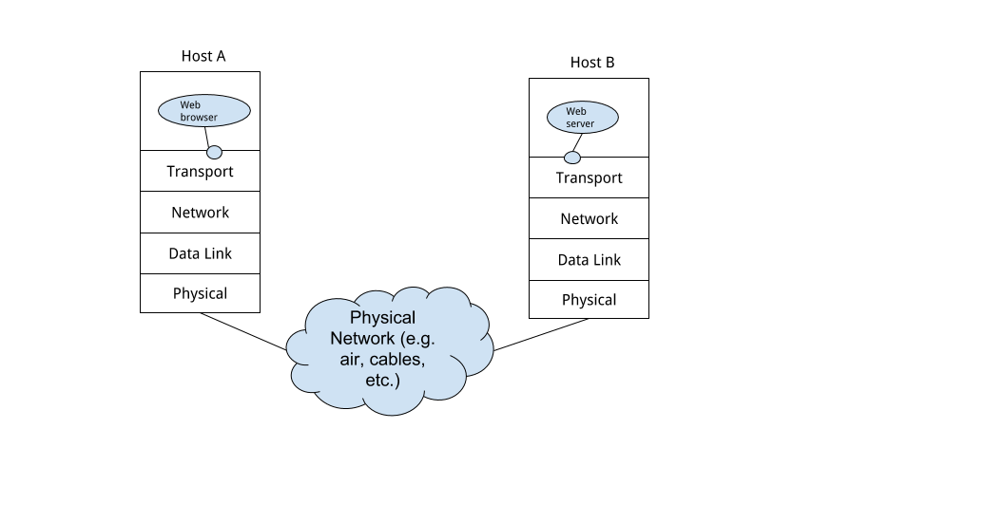

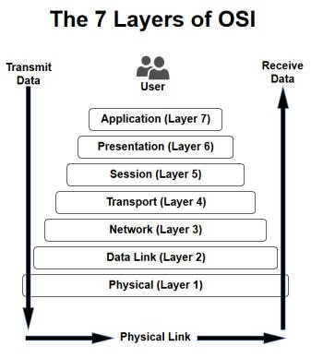

**Satellite**

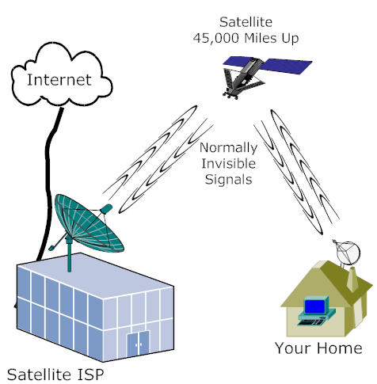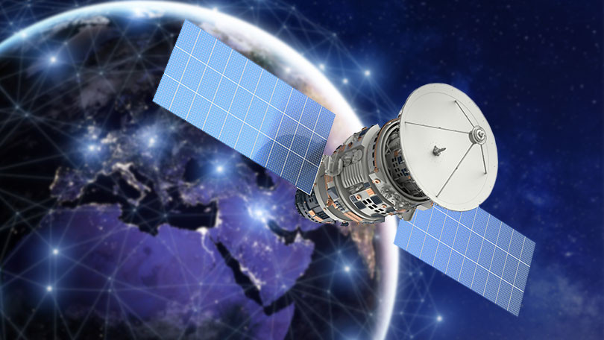

**Fiber Optics**

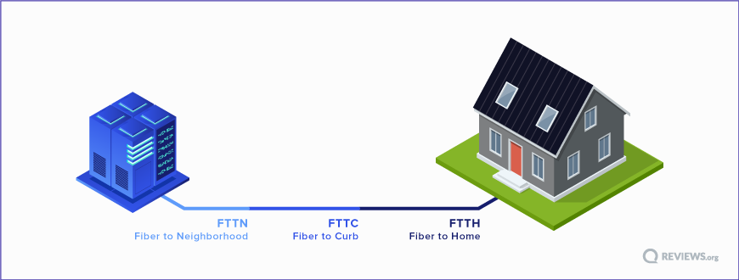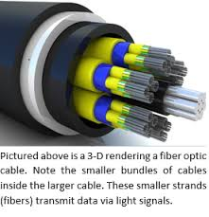

**DSL Internet Connections**

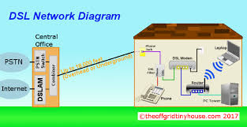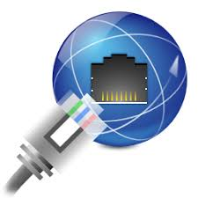

**Cable Internet Connection**

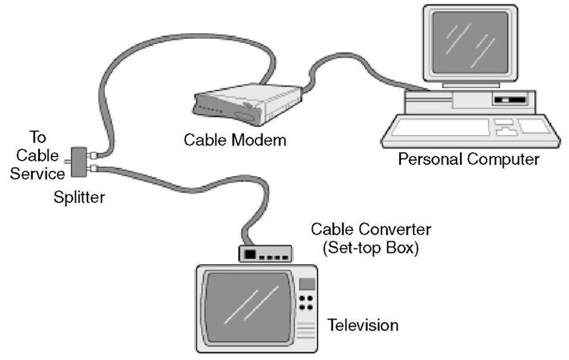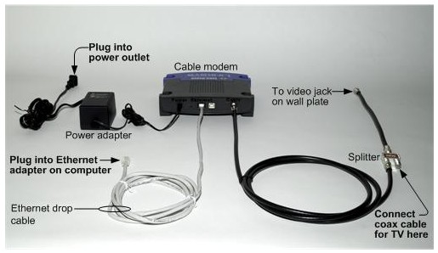

**WiFi Internet Connection**

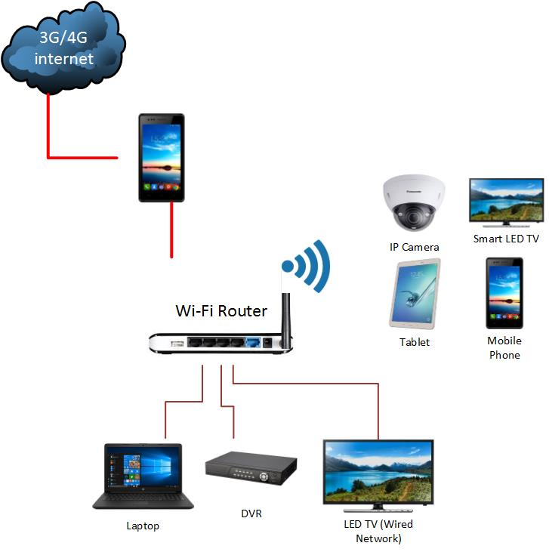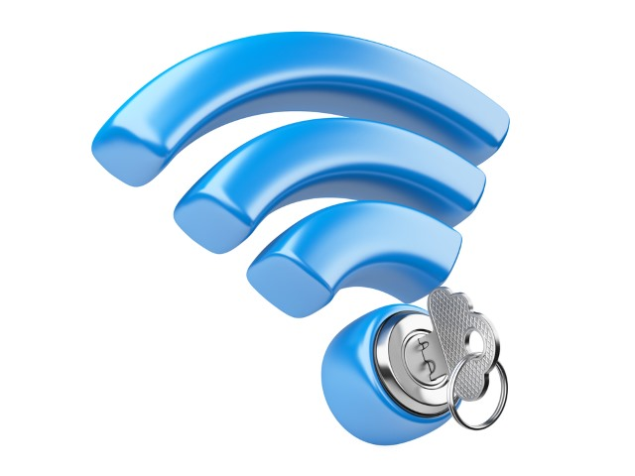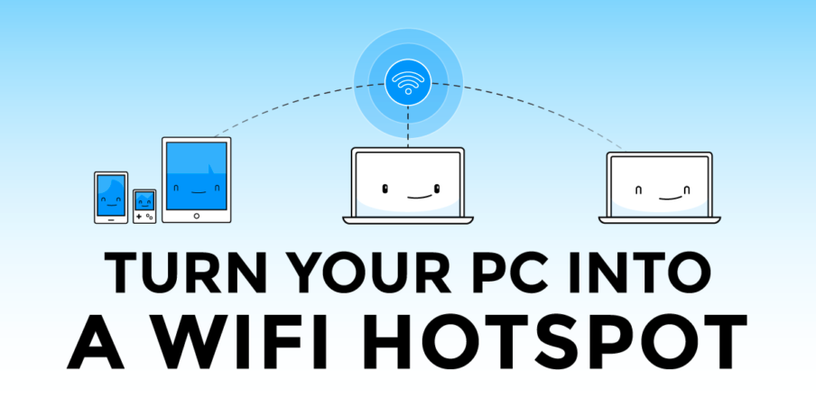

**Experiment Proper**

1. Using the COSMOS Toolkit, the students will perform the experiment by sending the data along the different types of internet connections and observe the different trends.
2. They will record the information gathered in the table below.

**Data Collection Sheets:**

**Fiber Optics**

|  |  |  |
| --- | --- | --- |
| **Type of Applications** | **Data File Size** | **Time** |
| Email |  |  |
| Text |  |  |
| Websites |  |  |
| Instagram |  |  |
| Video call |  |  |
| Video Upload |  |  |
| Pictures Upload/Download |  |  |

**Cable**

|  |  |  |
| --- | --- | --- |
| **Type of Applications** | **Data File Size** | **Time** |
| Email |  |  |
| Text |  |  |
| Websites |  |  |
| Instagram |  |  |
| Video call |  |  |
| Video Upload |  |  |
| Pictures Upload/Download |  |  |

**WiFi**

|  |  |  |
| --- | --- | --- |
| **Type of Applications** | **Data File Size** | **Time** |
| Email |  |  |
| Text |  |  |
| Websites |  |  |
| Instagram |  |  |
| Video call |  |  |
| Video Upload |  |  |
| Pictures Upload/Download |  |  |

**DSL**

|  |  |  |
| --- | --- | --- |
| **Type of Applications** | **Data File Size** | **Time** |
| Email |  |  |
| Text |  |  |
| Websites |  |  |
| Instagram |  |  |
| Video call |  |  |
| Video Upload |  |  |
| Pictures Upload/Download |  |  |

**Satellite**

|  |  |  |
| --- | --- | --- |
| **Type of Applications** | **Data File Size** | **Time** |
| Email |  |  |
| Text |  |  |
| Websites |  |  |
| Instagram |  |  |
| Video call |  |  |
| Video Upload |  |  |
| Pictures Upload/Download |  |  |

**To Graph each table above:**

1. Use the graph below to show the differethat comparisons you wanted to show.
2. Label your x-axis as Data File Size (MBps) and your y-axis as your Time (seconds).
3. Put specific titles of each graph to differentiate the different connections used.
4. Plot the points correctly and analyze the relationship shown between the two variables you are observing at a time.



**Guide Questions:**

1. What have you noticed about the trend in your table and graphs?
2. Which two variables show a proportional relationship? Why or why not?
3. Can you explain possible reasons why they don’t come out proportional?
4. What have you noticed about the trend of the different internet connections?
5. What trend have you observed when you plotted the points on the Cartesian Plane?
6. Using regression analysis, can you tell the specific function that will fit each of the given data? Why or why not?
7. Is there a strong correlation between the variables you compare? Is it strong, medium, low or no correlation at all? Justify your thinking. Support your reasons with possible factors affecting each phenomenon.

(Middle School students can use those questions above to discuss the results among themselves. This will help them organize, record, analyze and present the data gathered for class or group presentation.)

**Think about your experiment!!**

Your discussion must be detailed and include answers to the following questions:

* What are some factors that could’ve led to precision or mistakes in this experiment?
* Do you feel the data is valid (reliable and accurate)? Why or Why not?
* What were the sources of error in this experiment (factors that may have affected your results)? Explain.
* If you had the opportunity to redo the experiment, what changes would you make? How would you improve it? Explain.
* What new questions did the experiment generate? Explain.
* What did you learn from the experiment? Explain or justify your reasoning.

**EXTENSIONS for PROJECTS:**

**Middle School (Grade 6-8 )**

* **The teacher can modify this experiment depending on the grade level.**
* **6th-7th Grade can organize the tables and graphs and see proportional relationships or not.**
* **8th Grade/Algebra 1 can perform the entire project.**

1. Check your internet connections at home/school and find out what factors affected the delay or the speed of your data flow on over the line of communication. Share this observations and findings in your group/class or Google Classroom discussions.
2. Group yourselves with 3-5 members and organize the data that you have gathered at home. Specify each of your internet connections at home.
3. Look for similarities and differences and discuss them in your report.
4. Organize your data in graphs and tables and see the regression models fit your own data.
5. Interpret the possible reasons behind the speed of your data upload/download given the type of internet connection you have at home/school.
6. Create a Lab report using Prezzi, Powerpoint or Powtoons animated video.

**High School**

1. Part A will be to perform what the middle school section of the extension.
2. Part B will be for the high school students to investigate about the composition of fibers, cables and other connections and find out what factors or chemical properties involved that actually facilitate the speed of the data upload or download along the layers of communication.
3. Create a Lab report using Prezzi, Powerpoint or Powtoons animated video.