

Analyzing Relationship of the Variables Involved in Airplane Routes -Worksheet

Name: _________________________ Class: _____________ Date: _______

Subject:________________ Teacher’s Name:___________________

Problem
How can you analyze different airplane routes and find out the relationship of these variables and apply them to Pythagorean Theorem as well as other concepts involving altitude, distance, time and rate?

Hypothesis
What do you think will happen?
Write your hypothesis in the “If…(independent variable), then…(dependent variable)” format?
If __________________________________________________________________________________________________________________________________
then __________________________________________________________________________________________________________________________________

Materials
- COSMOS Toolkit
- SDR receiver (500 hz -1.7 Ghz)
- Pencil (colored)
- Ruler
- Clip board
- Post-it Chart Paper
- Markers
- Graph Paper
- Graphic Organizer to record data
- Vocabulary Sheet for the students

PROCEDURE:

Pre-lab preparations
In each group, decide which job each person will have:
- Facilitator-help the team in making sure that each one performed their job functions and work together to accomplish the experiment.
- Data Recorders-responsible for data gathering and make sure that all details needed are recorded for the team to discuss and analyze later.
- Program Runner/Operator-follow the instructions on how to run the terminal and the local host from the computer browser for the group to have the program running smoothly for the entire experiment.
- Time Keeper-collaborate with the group for proper time allotment of each section of the experiment so that no time is wasted.

NOTE:
- Each one in the team should work well together to ensure that the whole experiment is done well despite your individual job descriptions.
- If it is the first time for students to use the COSMOS Toolkit, the teacher should introduce the different parts of kit as part of the Pre-lab preparations. They have to know how to put it on and how to run a terminal and find the local host from a browser in order to run this experiment before conducting this on their own.
*Ensure that students are running the COSMOS program correctly*

Vocabulary:
Math
Angle of Elevation of an object as seen by an observer is the angle between the horizontal and the line from the object to the observer's eye (the line of sight).
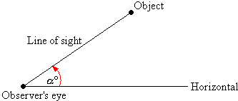

Angle of Depression
If the object is below the level of the observer, then the angle between the horizontal and the observer's line of sight is called the angle of depression.
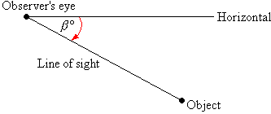

Line of Sight-a straight line along which an observer observes an object. It is an imaginary line that stretches between observer's eye and the object that he is looking at. ... If the object is below the horizontal, then the angle between the line of sight and the horizontal is called the angle of depression.
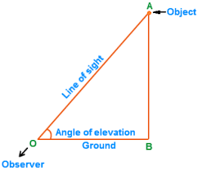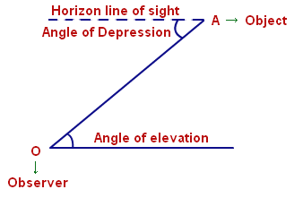

Pythagorean Theorem
One of the best known mathematical formulas is Pythagorean Theorem, which provides us with the relationship between the sides in a right triangle. A right triangle consists of two legs and a hypotenuse. The two legs meet at a 90° angle and the hypotenuse is the longest side of the right triangle and is the side opposite the right angle.
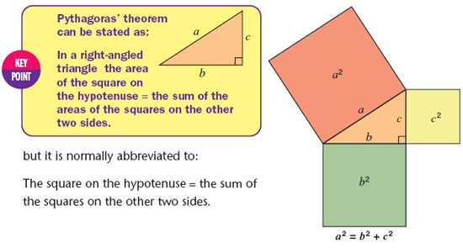

Altitude-is a line which passes through a vertex of a triangle, and meets the opposite side at right angles. A triangle has three altitudes. ... The length of a perpendicular from a side of the triangle to the opposite vertex. Any triangle has three altitudes and three bases. You can use any one altitude-base pair to find the area of the triangle, via the formula A = (1/2)bh.
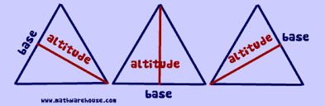

Distance formula is derived from the Pythagorean theorem. To find the distance between two points (x1,y1) and (x2,y2), all that you need to do is use the coordinates of these ordered pairs and apply the formula pictured below.
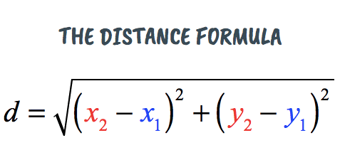

Distance, Rate and Time Formula
You can use the equivalent formula d = rt which means distance equals rate times time.
To solve for speed or rate use the formula for speed, s = d/t which means speed equals distance divided by time.

To solve for time use the formula for time, t = d/s which means time equals distance divided by speed
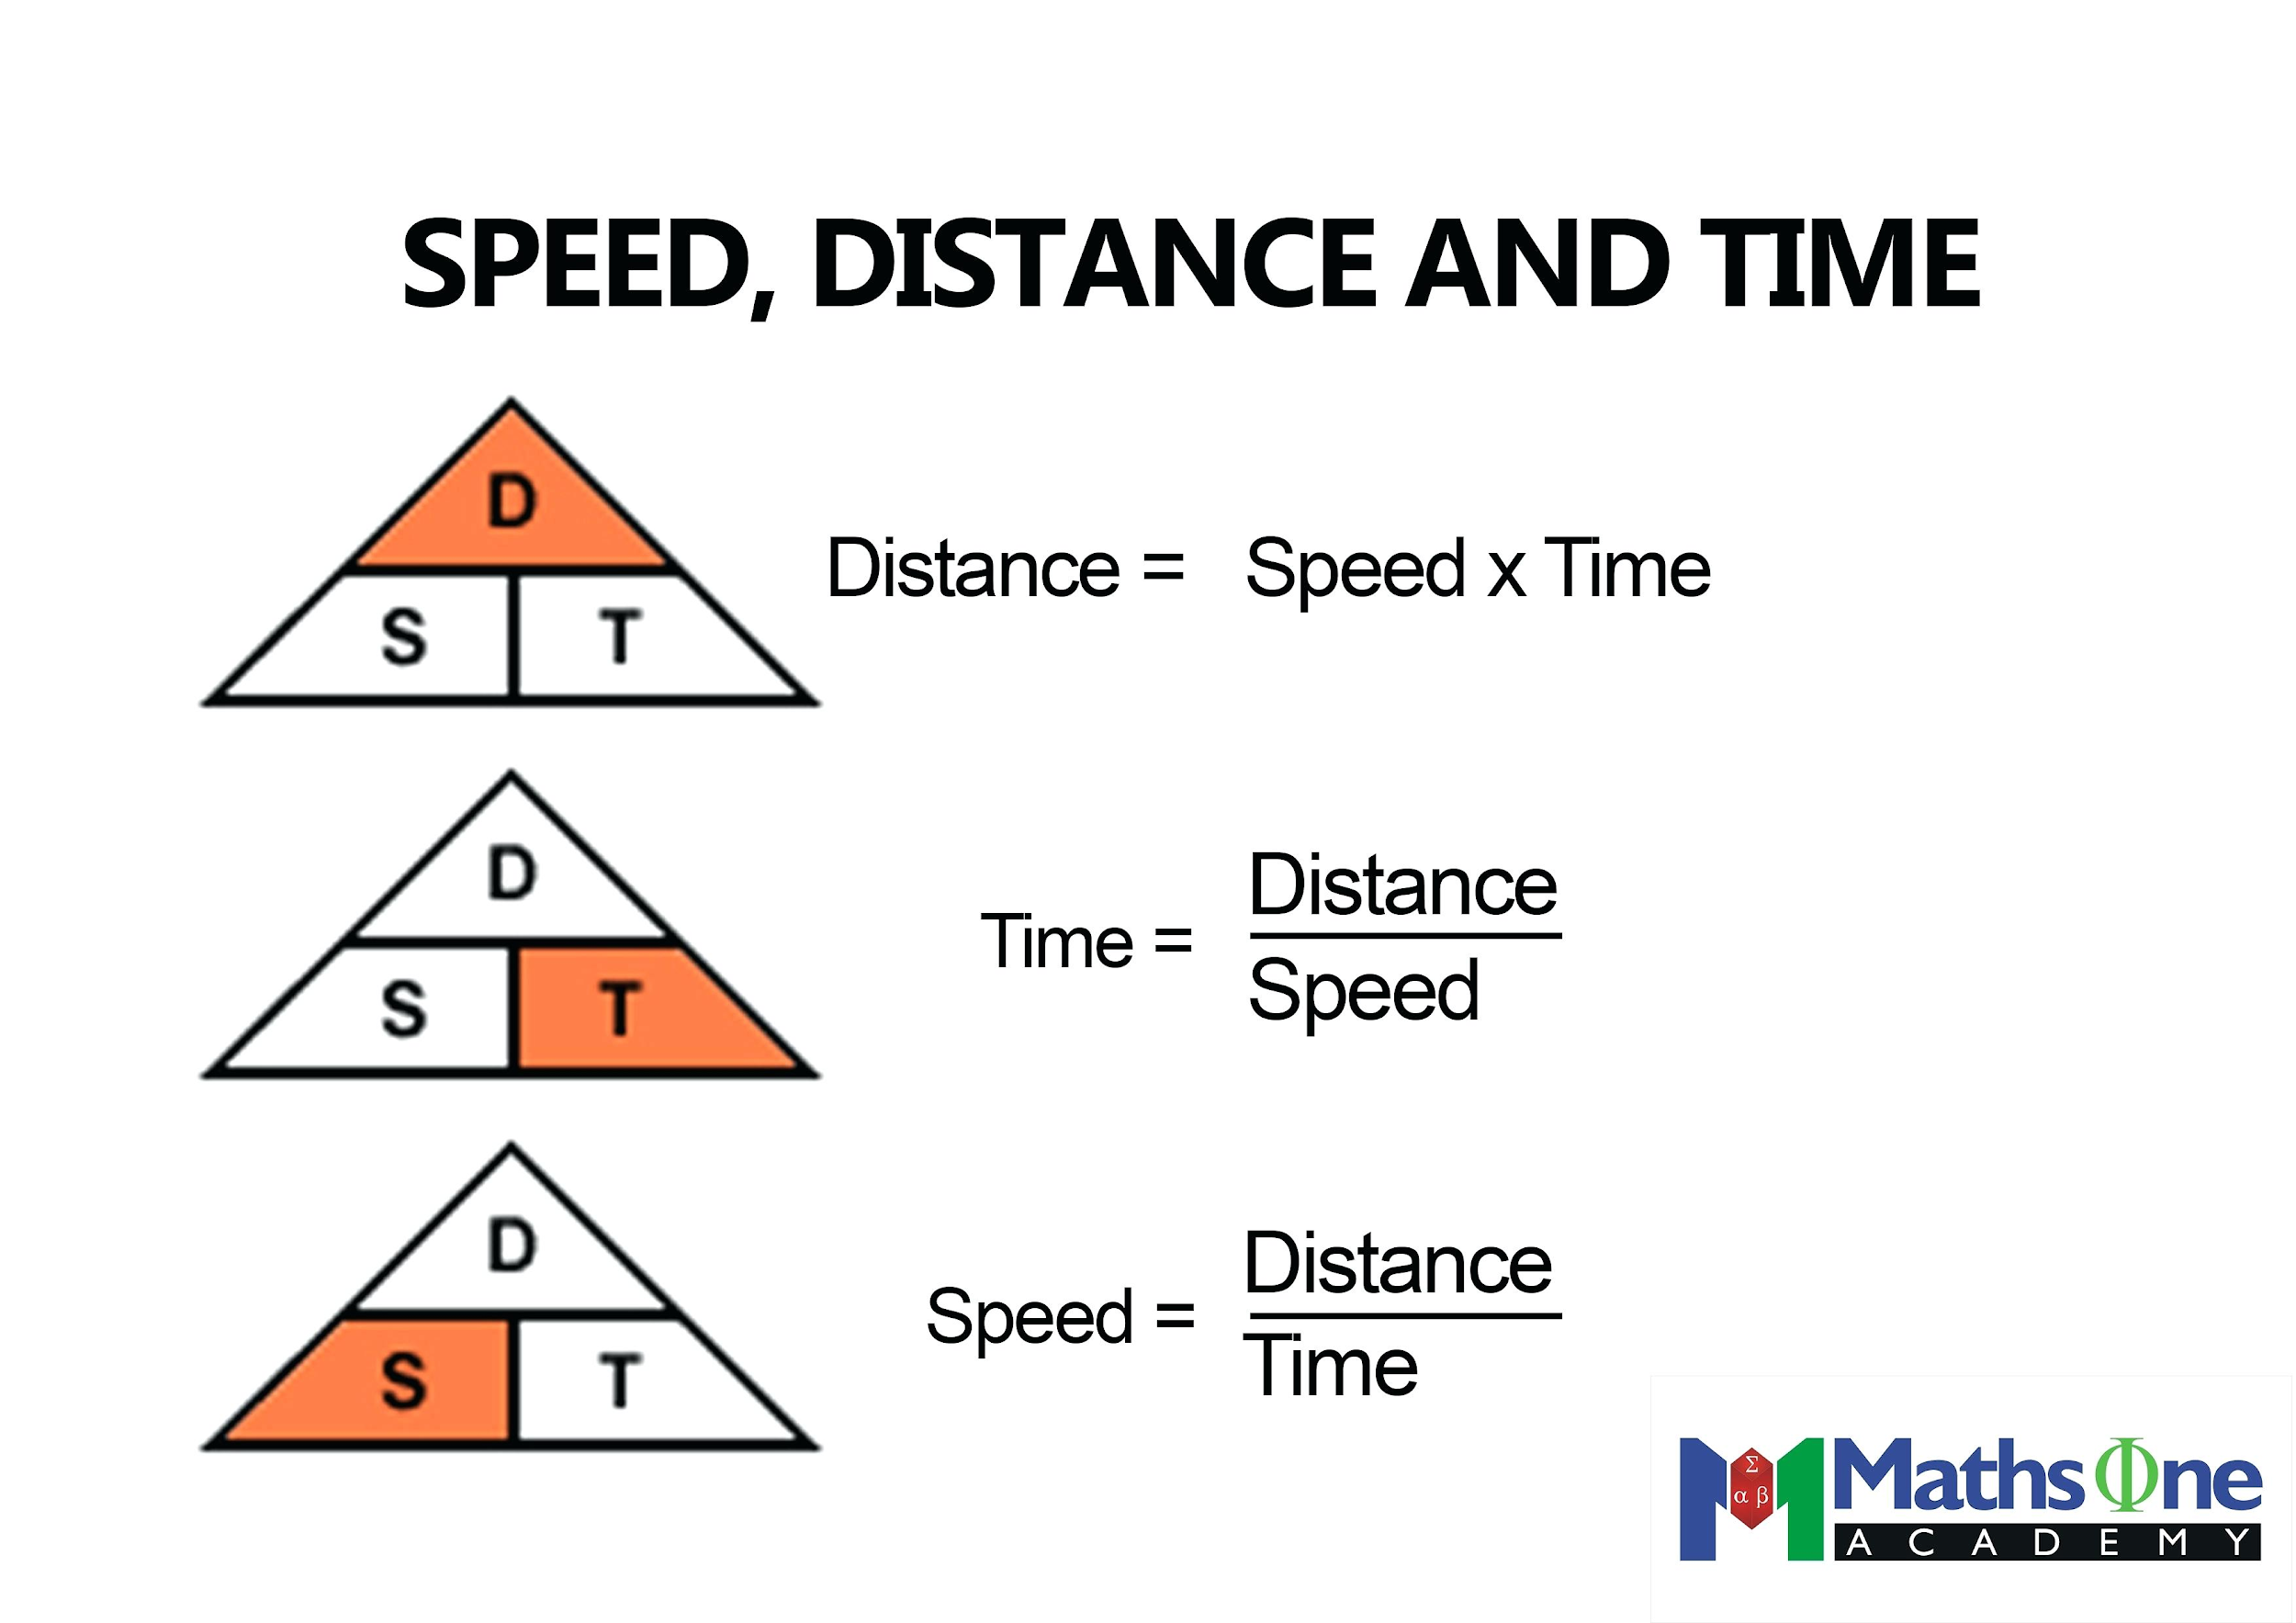

Slope-is the 'steepness' of the line, also commonly known as rise over run. We can calculate slope by dividing the change in the y-value between two points over the change in the x-value.

Proportional relationship-is one in which two quantities vary directly with each other. We say the variable y varies directly as x if: y=kx. for some constant k , called the constant of proportionality.

Percent is a ratio whose second term is 100. Percent means parts per hundred. The word comes from the Latin phrase per centum, which means per hundred. In mathematics, we use the symbol % for percent.

Rate-is a ratio that is used to compare different kinds of quantities.

Unit rate-describes how many units of the first type of quantity corresponds to one unit of the second type of quantity. Some common unit rates are miles (or kilometers) per hour, cost per item, earnings per week, etc.

Independent variable is a variable that represents a quantity that is being manipulated in an experiment. A dependent variable represents a quantity whose value depends on those manipulations.

Constant of Proportionality-constant value of the ratio of two proportional quantities x and y; usually written y = kx, where k is the factor of proportionality.
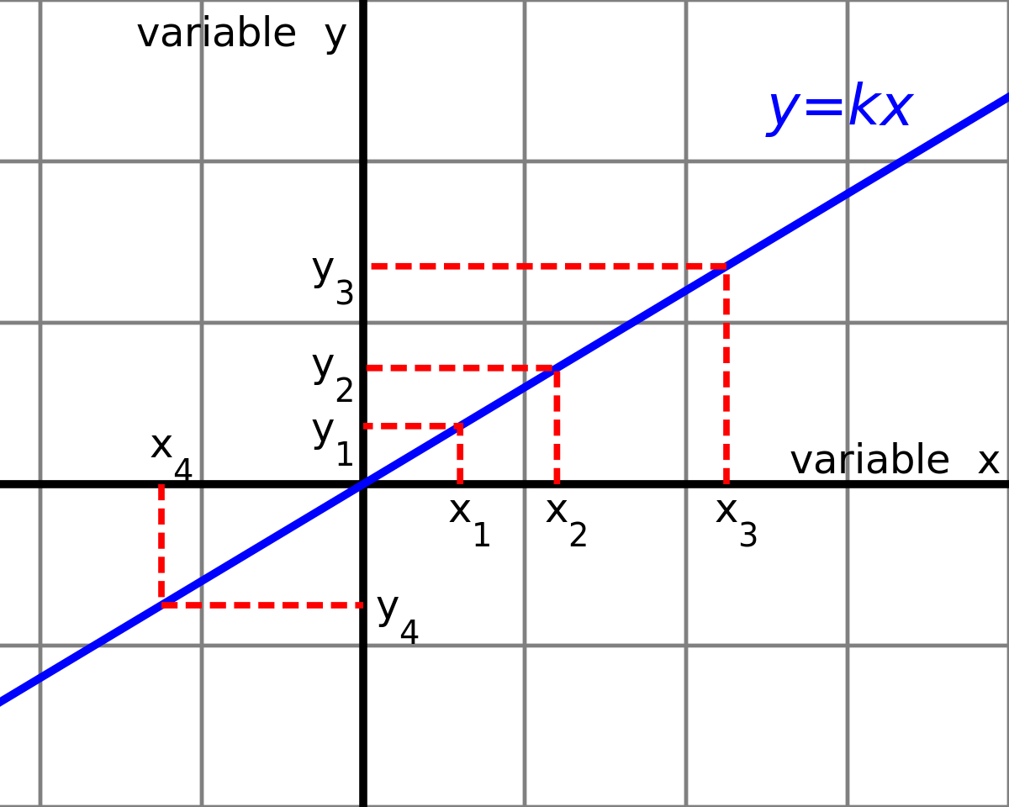
Ordered Pair-A pair of numbers used to locate a point on a coordinate plane is called an ordered pair. An ordered pair is written in the form (x, y) where x is the x-coordinate and y is the y-coordinate.

Cartesian Coordinate System-is a system that specifies each point uniquely in a plane by a set of numerical coordinates, which are the signed distances to the point from two fixed perpendicular oriented lines, measured in the same unit of length. Each reference line is called a coordinate axis or just axis (plural axes) of the system, and the point where they meet is its origin, at ordered pair (0, 0). The coordinates can also be defined as the positions of the perpendicular projections of the point onto the two axes, expressed as signed distances from the origin.

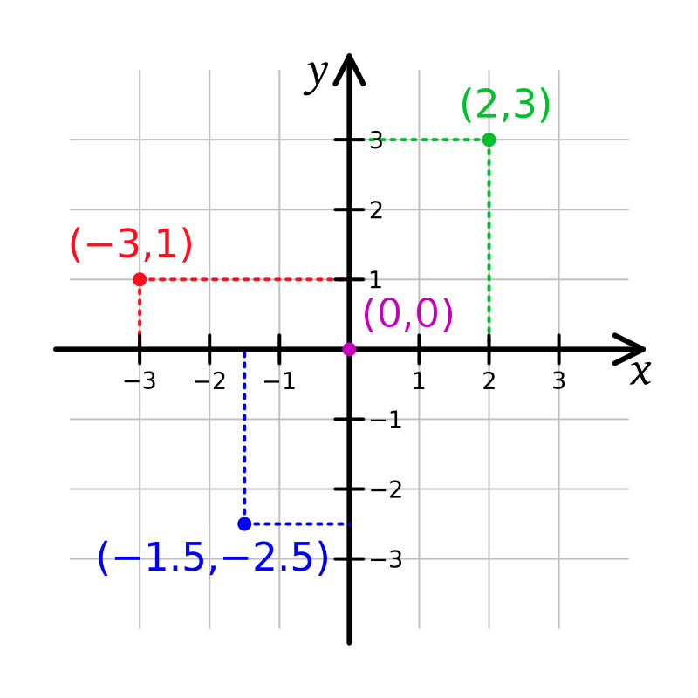
Regression Analysis- is a process of creating a mathematical model that can be used to predict the values of a dependent variable based upon the values of an independent variable. In other words, we use the model to predict the value of Y when we know the value of X. (The dependent variable is the one to be predicted).

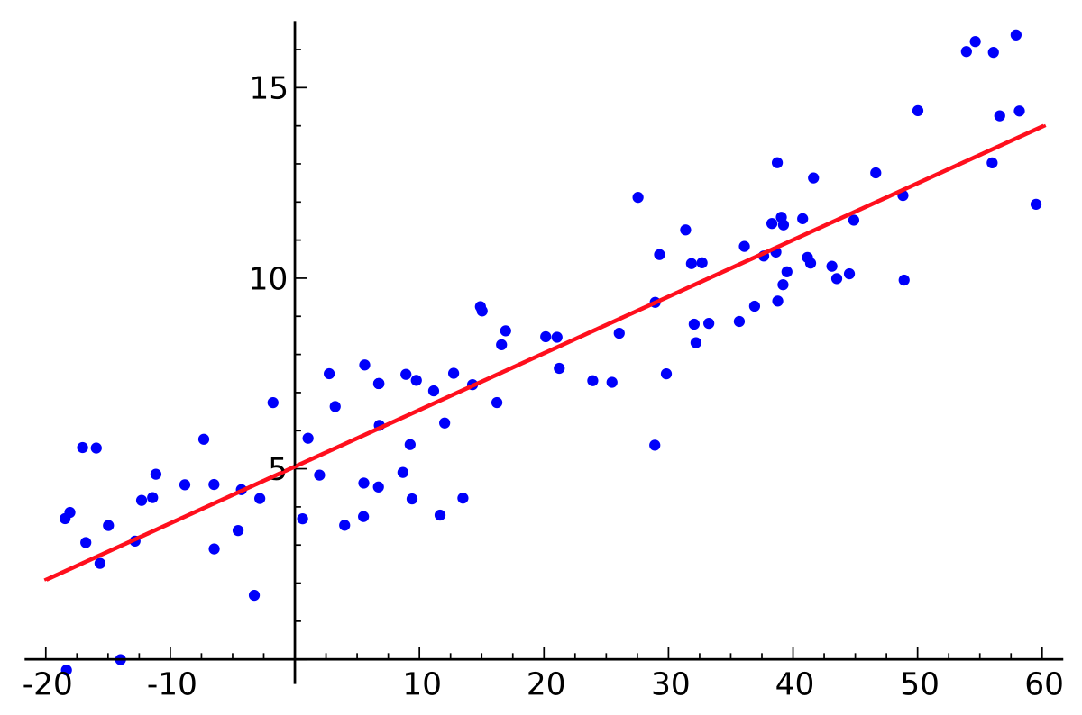

Scatter Plot- a graph of plotted points that show the relationship between two sets of data..

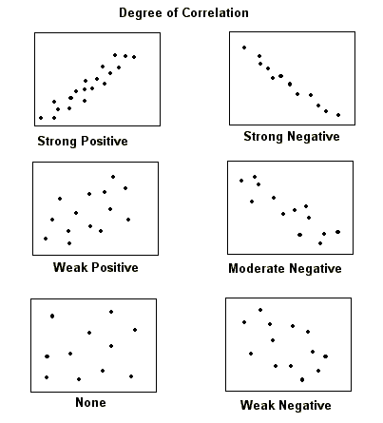
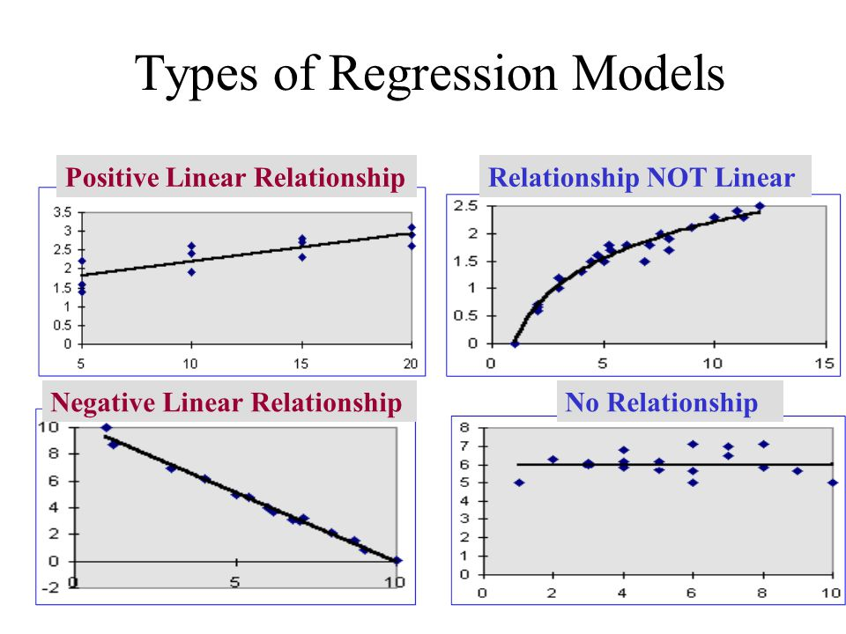
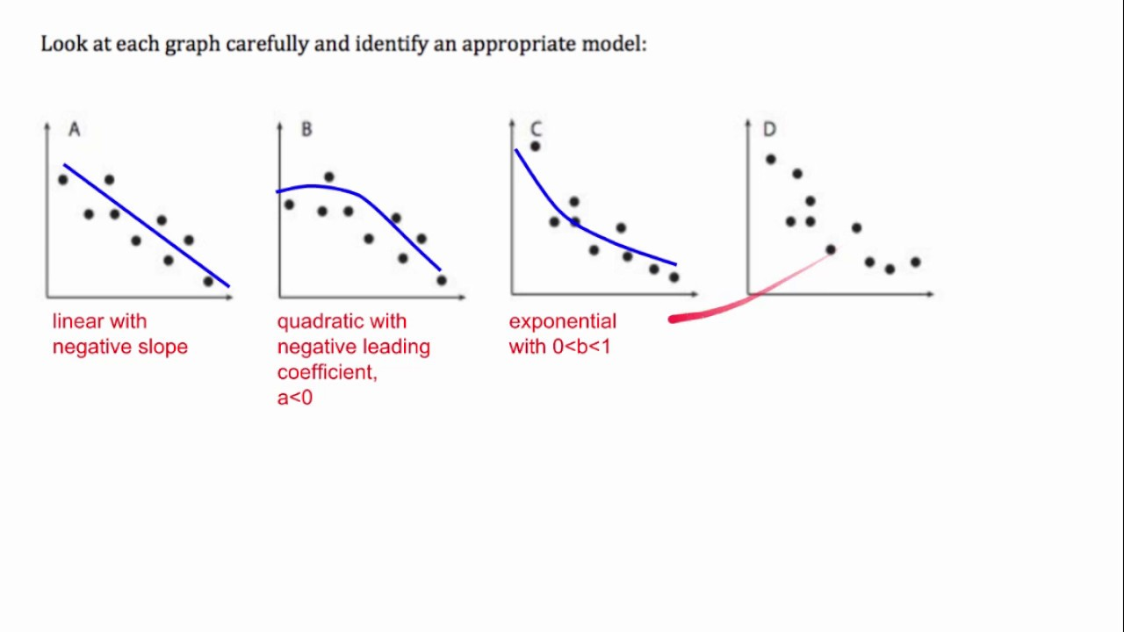
Wireless Technology
Web browser-is a software program that allows a user to locate, access, and display web pages. In common usage, a web browser is usually shortened to "browser." Browsers are used primarily for displaying and accessing websites on the internet, as well as other content created using languages such as Hypertext Markup Language (HTML) and Extensible Markup Language (XML).

Wireless Signal- refers to technology that allows us to communicate without using cables or wires. With wireless technologies, people and other entities can communicate over very long distances. Wireless technology includes RF and IR waves.


Terminal Window-referred to as a terminal emulator, is a text-only window in a graphical user interface (GUI) that emulates a console. ... The console and terminal windows are the two types of command line interfaces (CLI) in Unix-like systems.
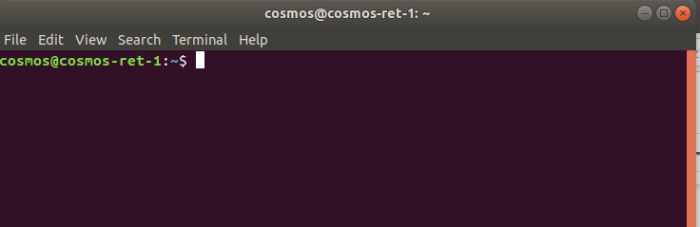
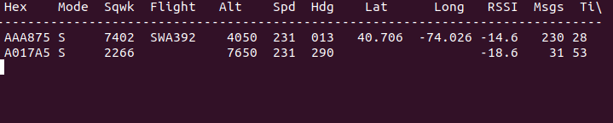
Antenna- is a transducer that converts radio frequency (RF) fields into alternating current or vice versa. There are both receiving and transmission antennas for sending or receiving radio transmissions. Antennas play an important role in the operation of all radio equipment. They are used in wireless local area networks, mobile telephony and satellite communication.
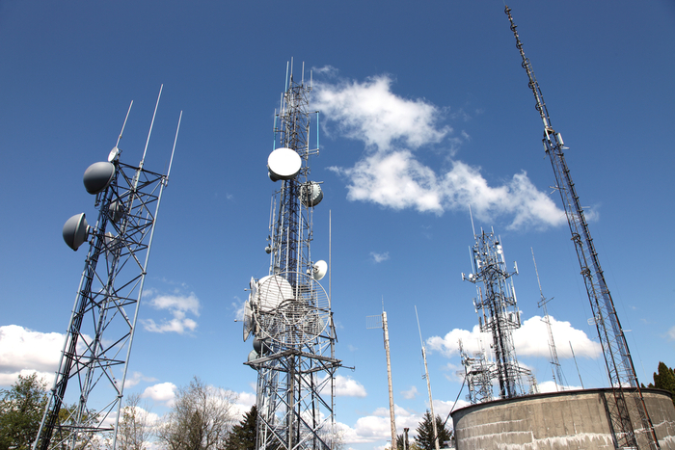


Airplane Route-designated route for aircraft flying between particular ground locations at specified minimum/maximum altitudes.
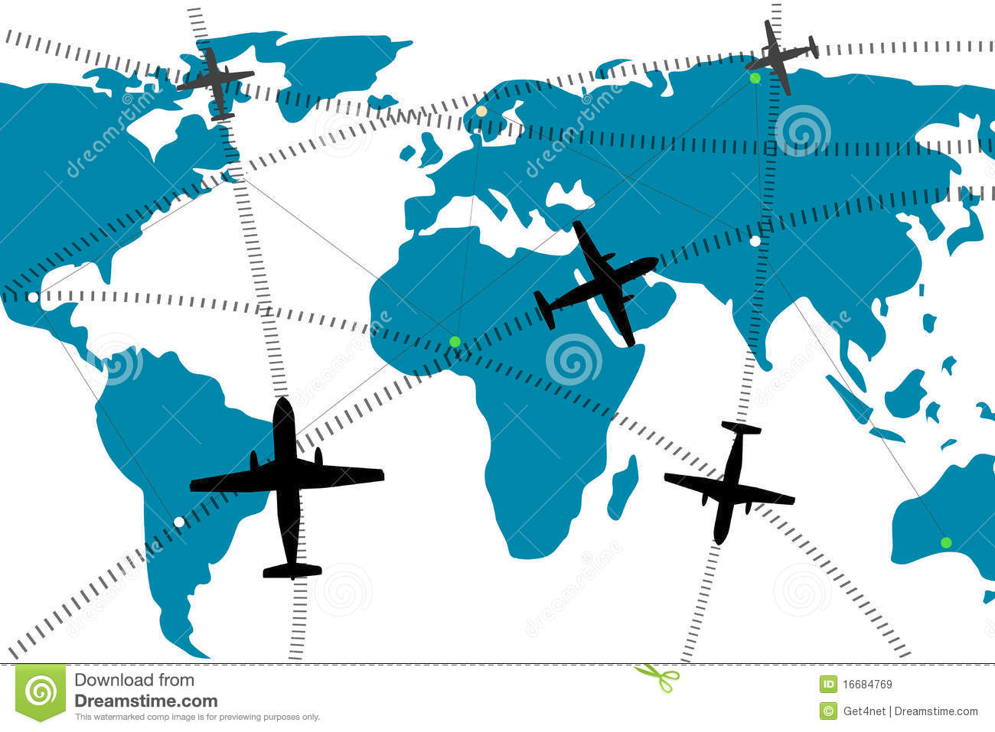
Departure (take-off) -is the act of leaving somewhere. Think about an airport that has departure gates for outgoing passengers and an arrival area for people flying in. Since departing means to leave, a departure is an act of leaving. There are many type of departures, such as when you go to the store or take an airline flight as shown below.
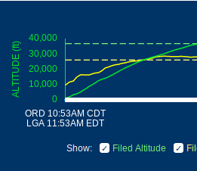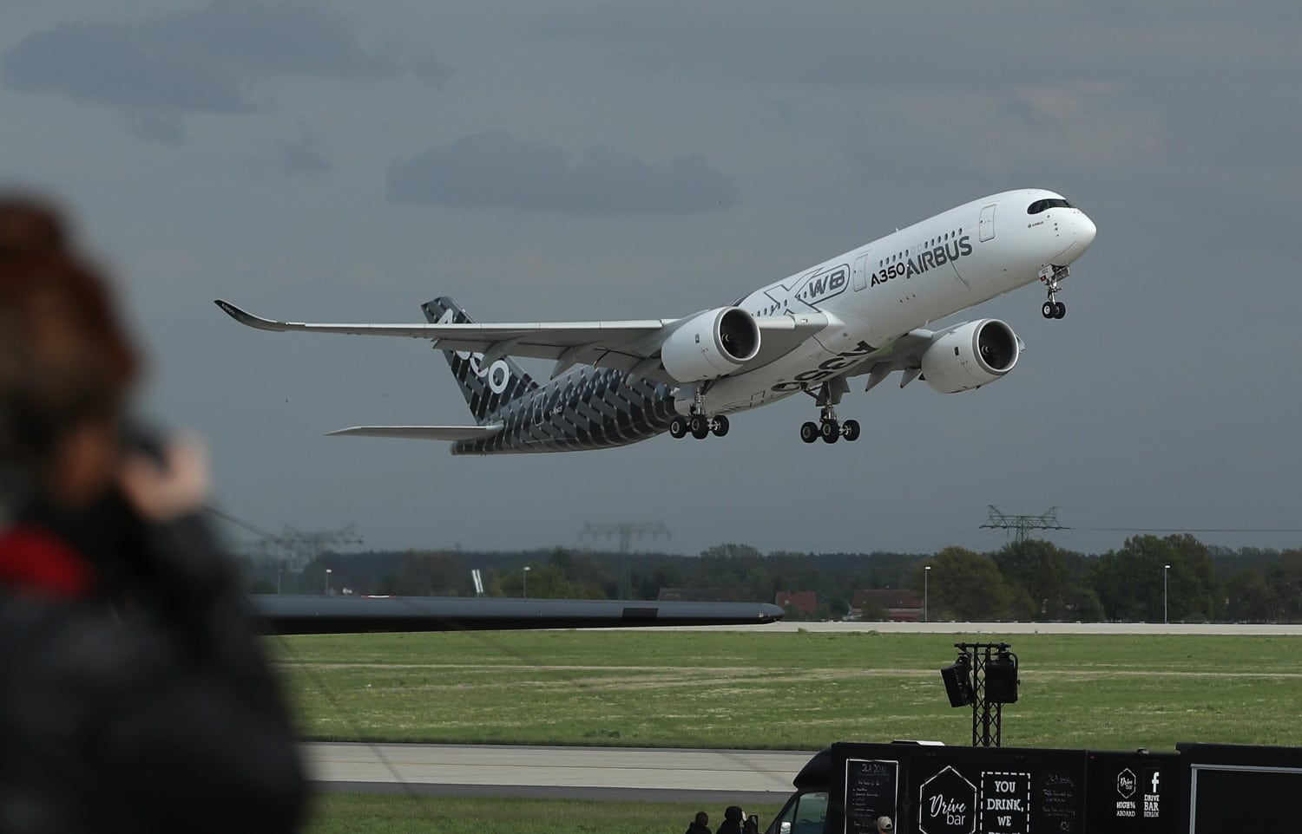
Arrival (landing)-time when the aircraft wheels touch the ground; arrival for people flying in

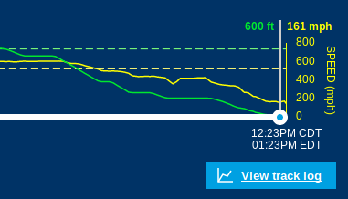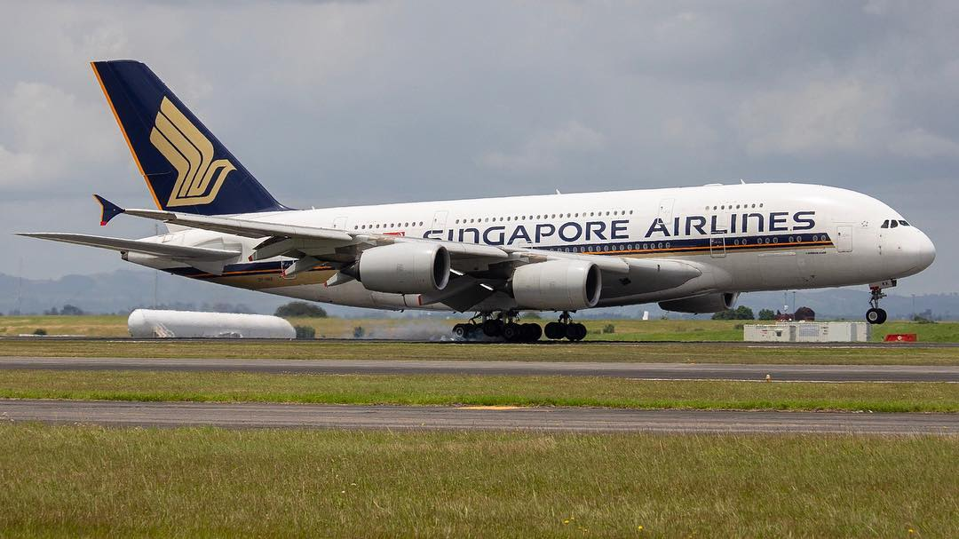

Experiment Proper
Instructions:
- Using the COSMOS Toolkit, make sure you attached all the cables, the antennae and put on the power of the whole system.
- Open a terminal and copy paste the command on the terminal.
cd ~/Documents/dump1090; ./dump1090 --net --interactive
3. After you opened the terminal, then open a browser and copy paste the link below.
http://localhost:8080
4. You will see something like this:

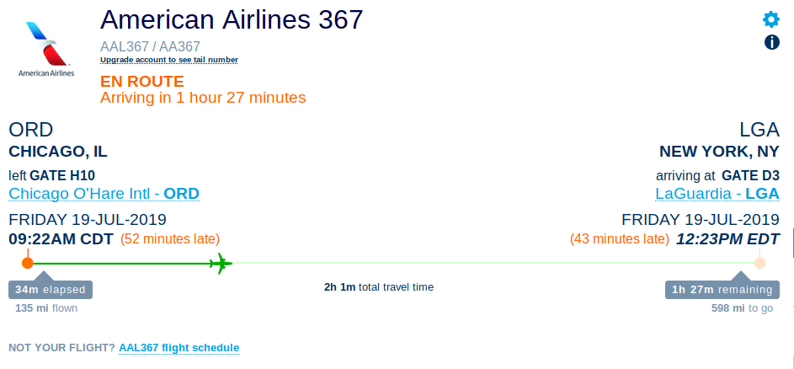
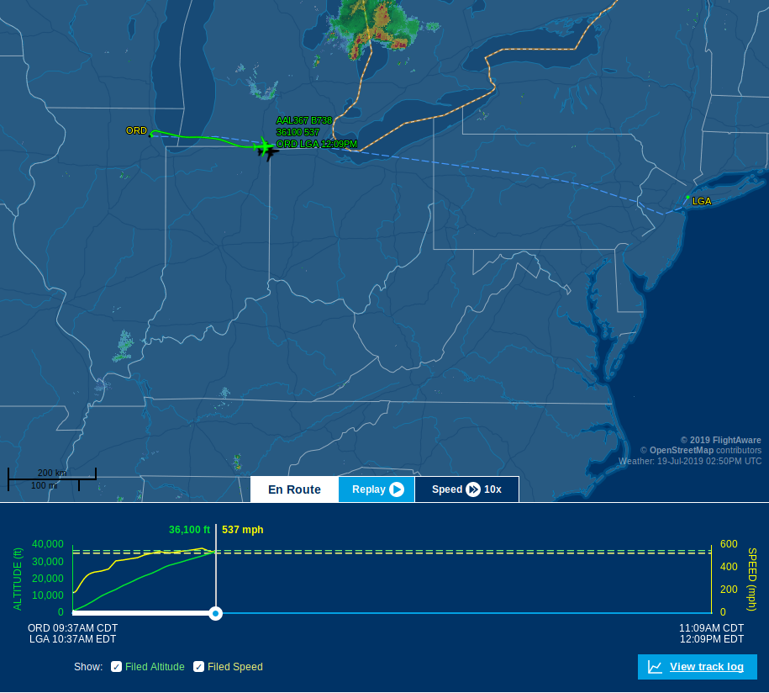

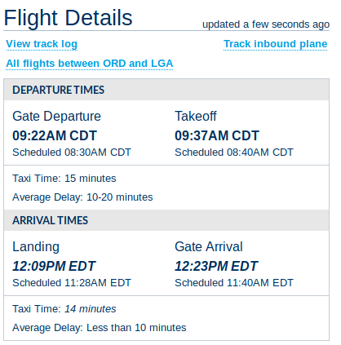

5. Looking at the sample above, track a specific airline flight of your choice.
6. Observe the different variables like altitude, distance, time and speed.
7. Choose and record in the graphic organizer/table your two chosen variables and plot the points on the Cartesian Coordinate Plane.

Grade 6-8 will do Day 1 & Day 2
High School students will extend it to Day 3 exploration.

Day 1
- Teacher will give the rationale of the experiment to the class and the relevance of this to wireless technology.
- Students will play around following some airplane routes by group after the teacher showed an example on the large screen during the mini-lesson.
- Students will record specific observations from this Day 1 of the experiment and post their observations in their notebook or Google Classroom. They can discuss what they see and observe during the entire experiment as shown on the large screen.

Day 2
- Students by group will follow an airplane route of their choice and they will analyze the different statistics of the flight such as altitude, distance, rate and time of the given flight and find out the trend.
- They will organize their data on the table and plot the graph of the variables involved. 6th and 7th Graders can analyze if the two chosen variables are showing proportional relationship or not. Then discuss the reasons why they are not proportional based on the results of their data.

- Students in 8th Grade can analyze the correlation of these variables and describe the relationship as strong, medium, low or no correlation.

Data Collection Sheets:
Name of the Airline________________
Place of Departure:________________
Place of Arrival: __________________

Time | Altitude | Distance | Rate

Replicate the graph below for other comparisons that you wanted to show. This will allow the group to analyze and show the relationship of the two variables you are observing at a time.

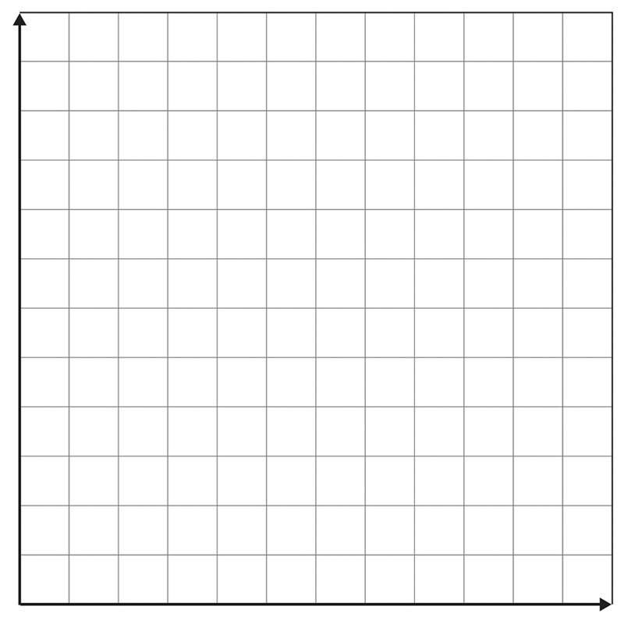
Guide Questions:
- What have you noticed about the trend in your table and graphs?
- Which two variables show a proportional relationship? Why or why not?
- Can you explain possible reasons why they don’t come out proportional?
- What is the slope of the airplane’s pathway after take-off? Upon arrival? Is there a specific difference?
- What is the trend that you have noticed when you plotted the points on the Cartesian Plane?
- Using regression analysis, can you tell the specific function that will fit each of the given data?
- Is there a strong correlation between the variables you compare? Is it strong, medium, low or no correlation at all? Justify your thinking. Support your reasons with possible factors affecting each phenomenon.
(Middle School students can use those questions above to discuss the results among themselves. This will help them organize, record, analyze and present the data gathered for class or group presentation.)

Day 3-5
High School students will proceed to exploration for Day 3-5.
8th Grade/Algebra 1 students who are advanced
- Students will track a specific plane with their team
- Find out from a specific location after take-off the angle of elevation and the angle of depression few minutes before the arrival.
- Draw these points using your graphing paper.
- Using their knowledge on Pythagorean Theorem as well as the Law of Sines and Cosines, students will find out the missing sides or angles as the case may apply.
- Each group should have graphing paper/s, pencils and rulers that will help them in this section of the experiment.
- You can replay the flight by pressing the replay mode and pause when you are computing for the angle of elevation after take-off or with the angle of depression upon arrival.
- Is the angle of elevation the same after take-off with the angle of elevation of the plane upon arrival to the destination?
- What about the angle of depression? How do you know?Explain the difference.
- You need to do this also when you calculate specific details of the missing parts of the triangle created by the line of sight, the ground and the altitude of where the airplane is at the moment.

- Using the Flight Tracker (sample below), you can derive more details of the experiment’s data by using the longitude and latitude locations of the airplane at a specific time and discuss among the group.
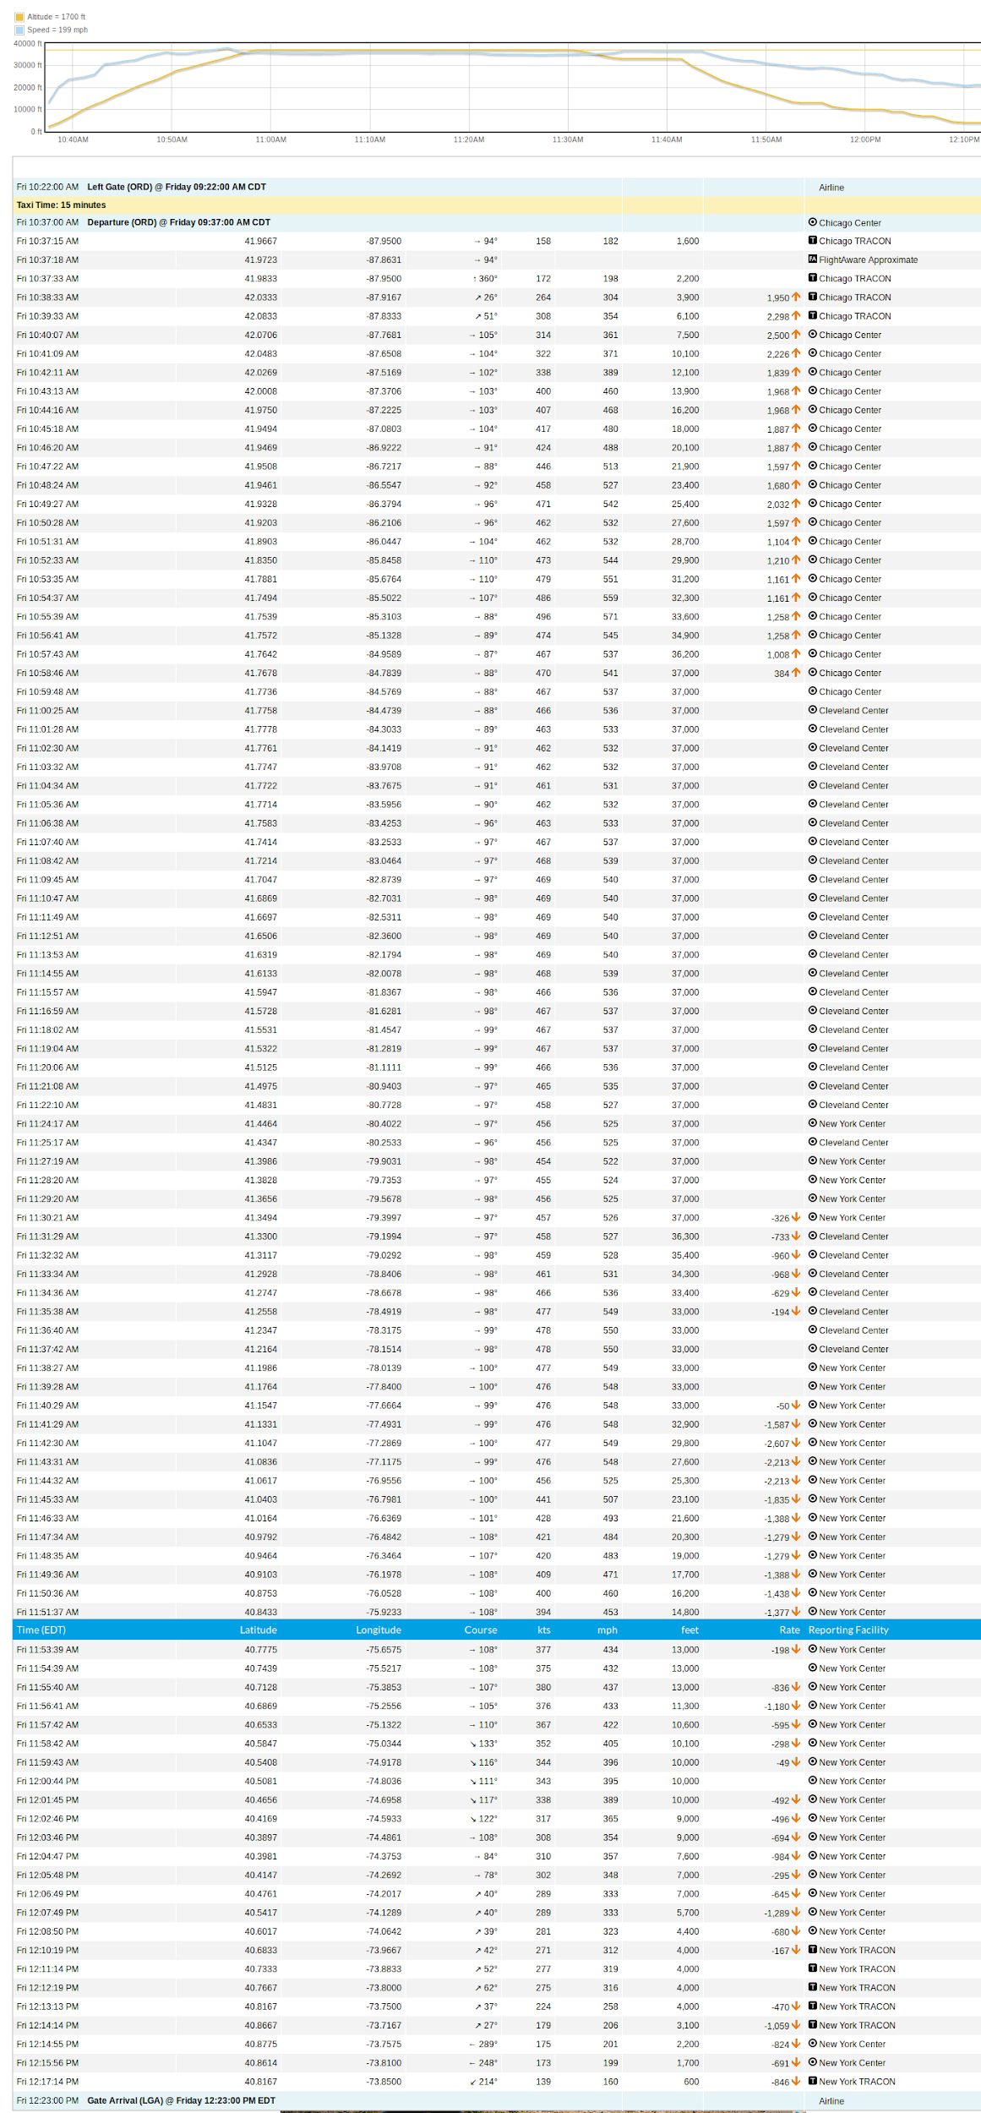

NOTE:
Students will discuss the details of this section of the experiment within their group and find out the factors affecting their results. They need to present all data in a powerpoint presentation and show all the mathematical calculations involved.

RULES:
Use the data/facts gathered from experiments as basis of your discussion.

Think about your experiment!!
Your discussion must be detailed and include answers to the following questions:
- What are some factors that could’ve led to precision or mistakes in this experiment?
- Do you feel the data is valid (reliable and accurate)? Why or Why not?
- What were the sources of error in this experiment (factors that may have affected your results)? Explain.
- If you had the opportunity to redo the experiment, what changes would you make? How would you improve it? Explain.
- What new questions did the experiment generate? Explain.
- What did you learn from the experiment? Explain or justify your reasoning.

EXTENSIONS for PROJECTS:
Middle School
- Students in teams of 3-5 can explore the flight details of 5 planes from 5 different locations.
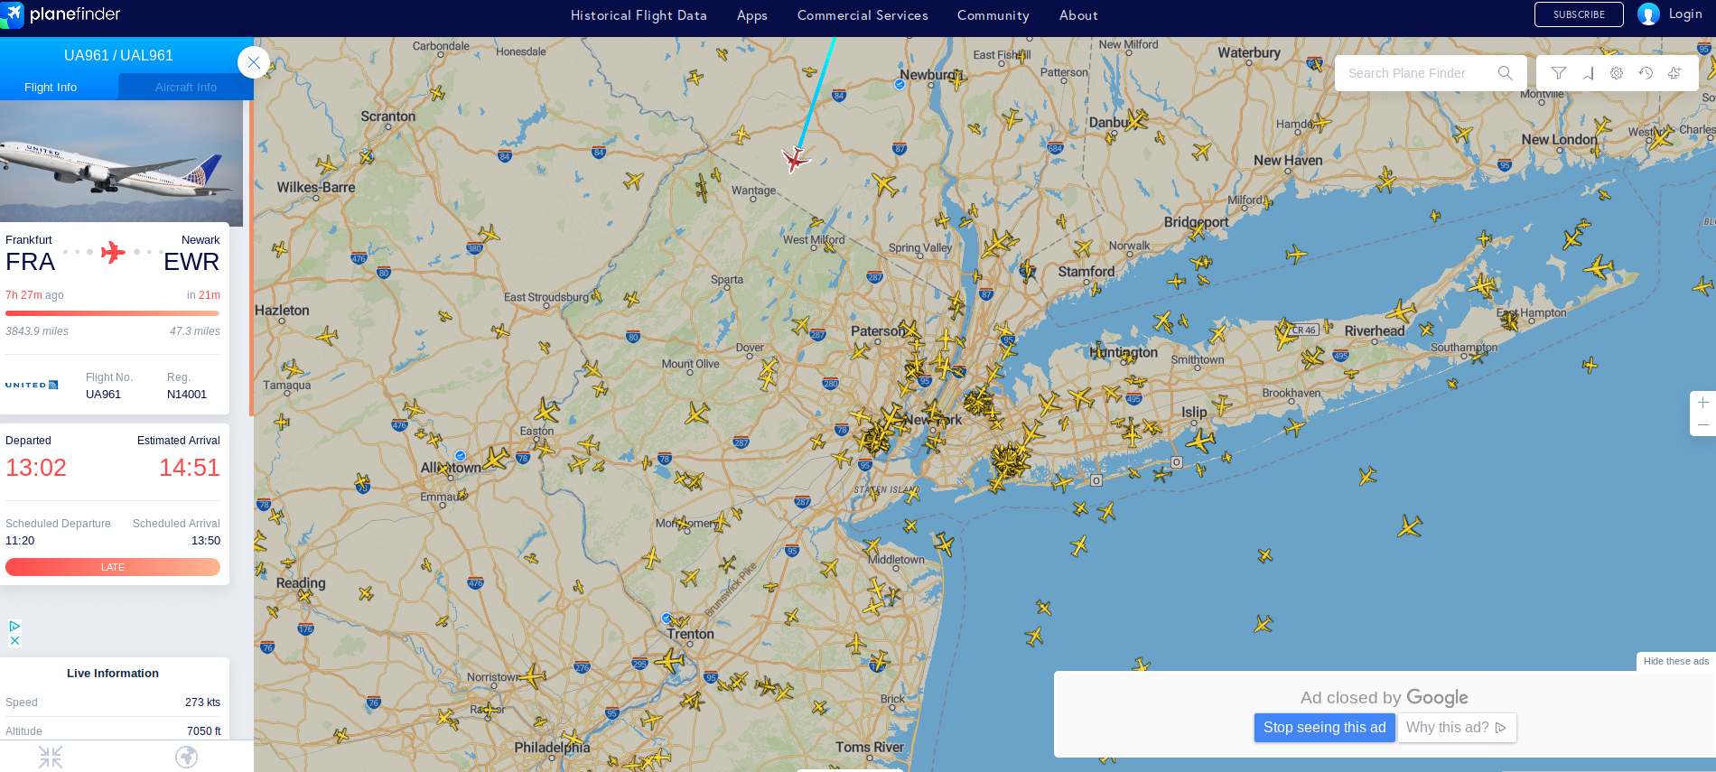

- They can investigate the weather conditions of the place of departure and arrival and how these factors affect the airplane’s flight conditions.
- Using their ideas from Social Studies on Longitude and Latitude, they can describe the specific locations of these planes in terms of these two parameters.
- After tabulating the data of each airplane, they will compare the rate, distance, time and the highest altitude each plane was able to reach.
- They will create a creative powerpoint presentation or powtoons to present the result of the experiment.

High School
- Explore the Middle School project ideas as part of the High School project.

- Students can explore the flight details of 2 airplanes from two different locations.
- They will observe planes from departure to arrival, students will create a linear regression of each route and solve for the point of intersection using any algebraic solution methods/strategies.

- They can explore the 2 planes’ angle of elevations and depressions of both departure and arrival and see what’s the difference. Discuss factors affecting the delay or the early arrival of the plane to the destination.

