Directions
- Step# 1 , Find the shortest path from A to C for the three graphs below. Underline the path and make a note of the total distance. When you’re done, compare with a partner to see if you found the same things.
  - Note: we’re interested in finding the fastest, cheapest, most efficient way to route information from one place to another.
- NEXT, after you have identified the shortest path from A to C, go back and find the shortest path from A to B, D, and E
- compare with a partner to see if you found the same things.
- In your notebook, write down a few ideas for how an algorithm to find the shortest path might work. Maybe make a few notes about what’s potentially tricky: what things do you want to be sure to remember?

Graph | Notes
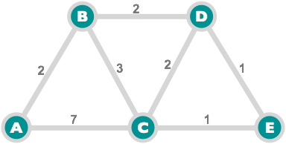

Initial Node: A
Destination Node: E

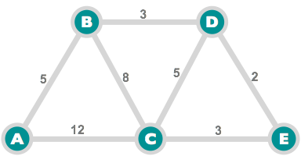

Initial Node: A
Destination Node: E
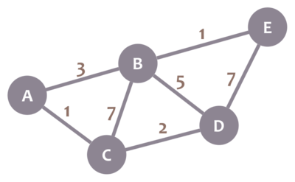

Initial Node: A
Destination Node: E
