Name______________________

Part I:

Aim: How does data gets transmitted through air accurately?

How do we evaluate the probability of error?

We learned from the previous lesson that data gets converted to bits of “0” and “1”.

Now let's examine at how “0” and “1” gets transmitted through air by electromagnetic waves at *one bit at a time*.

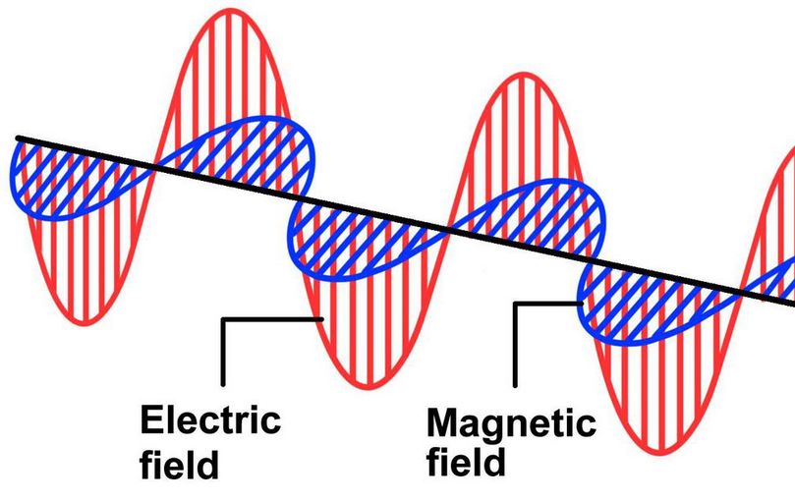

Electromagnetic waves are a form of energy waves that have both an electric and magnetic field as shown to the left.

Since there are only two options we can map the “0” and “1” as follow.

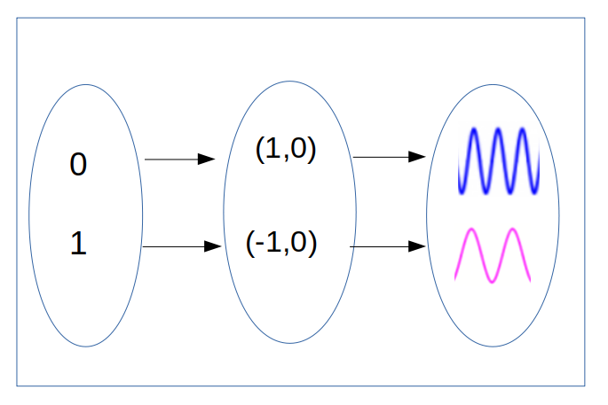

Where else have you seen this type of diagrams?

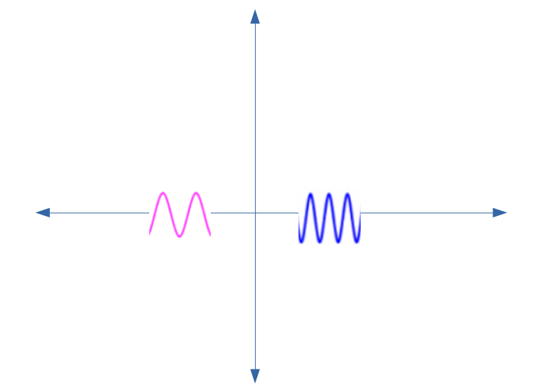

Hence there are only two symbols being transmitted, the symbols can be received in a coordinate plane along the x-axis only.

Diagram below illustrates how the data is transmitted. Describe in your own words in details as how the process is done Use the terminologies that are shown in the diagram, such as transmitter and receiver. Share your with group. Explanation of BPSK will follow.

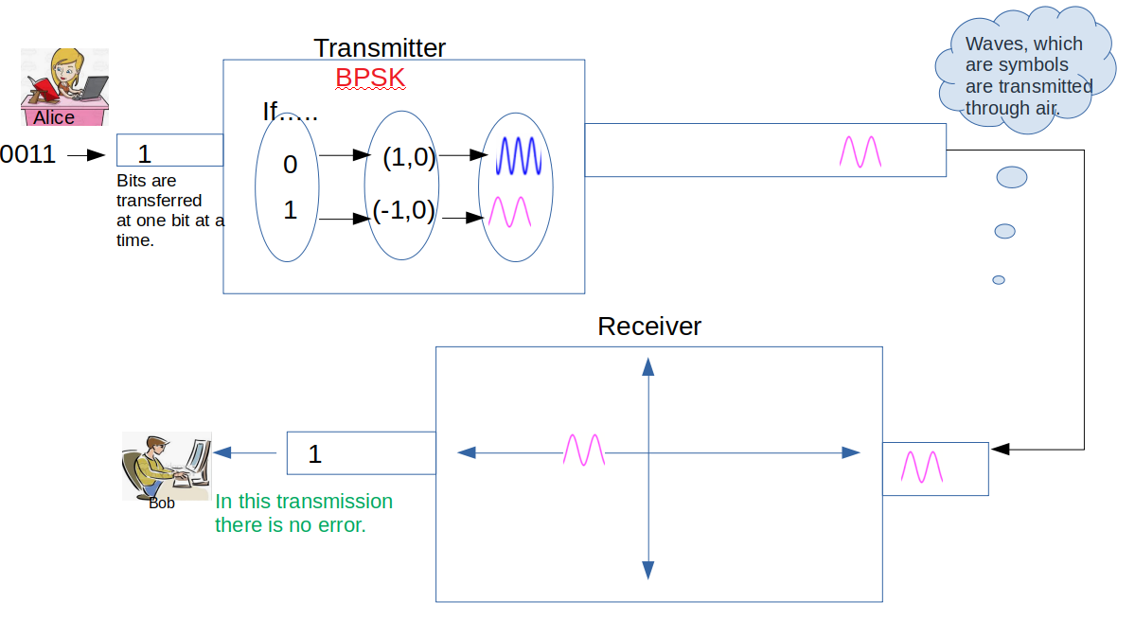

________________________________________________________________________________________________________________________________________________________________________________________________________________________________________________________________________________________________________________________________________________________________________________________________________________________________________________________________________________________________________________________________________________________________________________________________________________________________________________________________________________________________________________________________________________________________________________________

____________________________________________________________________________

Name________________________

**Part II: Binary Phase Shift Keying aka BPSK**

As it was mentioned before, when data bits “0” and “1” are being transfer one bit at a time, this process is called binary *Phase Shift Keying aka BPSK.* ***Binary Phase Shift Keying (BPSK)*** is a two phase modulation scheme. Modulation is the process of converting data into radio waves. In two phase modulation means that there are only two symbols.



In the process Binary Phase Shift Keying - BPSK, “0” and “1” gets converted to “(1,0)” and “(-1,0)” which gets converted to different symbols - which are waves. Each symbol travels through air and it is received by the receiver at on symbol at a time. Since there are only two symbols, we can visualize the receiver receiving the symbols along the *x-axis one symbol at a time*. Then the receiver converts the symbols into digital values “0” and “1” which gets converted to the original message.

In this **ideal** scenario, the data received is the same data sent, which results in **no error.**

Why do you think that this is an **ideal** scenario? Share your thoughts with your group.

____________________________________________________________________________________________________________________________________________________________________________________________________________________________________

What do you think it could happen in a **not an ideal** scenario? Share your thoughts with your group.

____________________________________________________________________________________________________________________________________________________________________________________________________________________________________

How does the *Noise* affect the transmission?

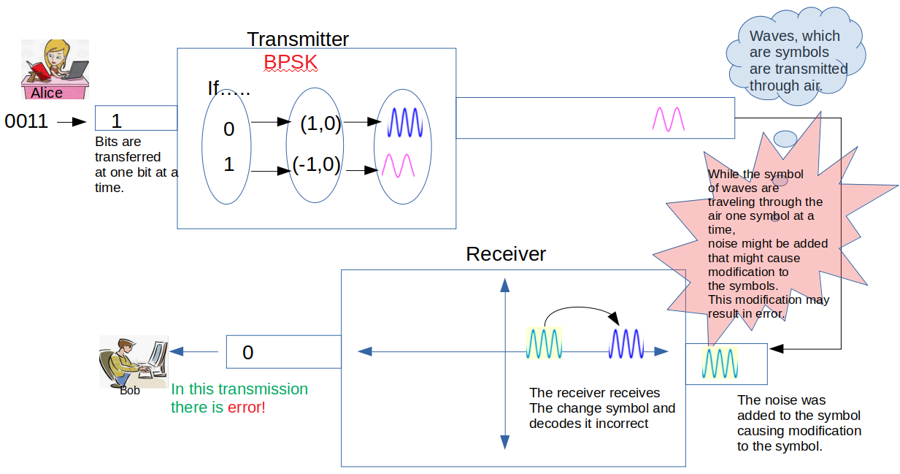

By looking at the diagram above, describe the similarities and the differences between the when the data is transferred with noise vs. without noise. Share and discuss your answers with your group.

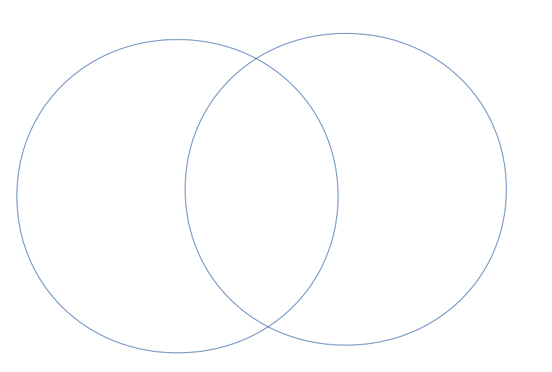



In real life situation, there is noise. Since the symbols are traveling through the air, noise may be added that might cause some modifications which might result in error. In the diagram, the added noise caused the symbol to change. It is important to stress that in BPSK, that symbols land on the x-axis.

What is BPSK?

________________________________________________________________________________________________________________________________________________________

How many symbols are in BPSK?

________________________________________________________________________________________________________________________________________________________

How are symbols transferred?

________________________________________________________________________________________________________________________________________________________

What is in the air that might cause and error?

________________________________________________________________________________________________________________________________________________________

How is the receiver exception to receive the symbols? Be specific and give an example.

________________________________________________________________________________________________________________________________________________________________________________________________________________________________________________________________________________________________________________When does the error occur?

________________________________________________________________________________________________________________________________________________________

*Note to teachers: This is a good time to assess their understanding and clarify any misconceptions.*

Name______________________

**Part III: Quadrature Phase Shift Keying aka QPSK**

From part 1 and 2, we learned how a computer transfer data at one bit at a time.

In order to transmit more bits at once we will look into a process called *Quadrature Phase Shift Keying (QPSK)*. In QPSK, two bits are modulated at once by one symbol, instead of one bit being represented by one symbol (as in BPSK). Modulation is a process of converting 0 and 1 into symbols. Since two bits are modulated at once, QPSK allows the signal to carry twice as much information as BPSK. All four quadrants are utilized.

Let's look at Quadrature Phase Shift Keying aka QPSK modulation:

Before we look at the symbol data representation try the question.

If binary bits of “0” and “1” are grouped as two, how many combinations of “0” and “1” can you have? List all the possibilities?

___________________________________________________________________________

________________________________________________________________________________________________________________________________________________________

Below is the symbol data representation of when two bits are being transferred at once.

Symbols data is shown in the table below and they are predetermined by experts. Notice these symbols are written as coordinate pairs.

|  |  |
| --- | --- |
| Original data bits  are grouped of two’s | Symbol data: y |
| 00 | (-1,1) |
| 01 | (1,1) |
| 10 | (-1, -1) |
| 11 | (1,-1) |

As you can see they are 4 possibilities which maps to four different symbols. Each symbol has a predetermined location in a coordinate plane.

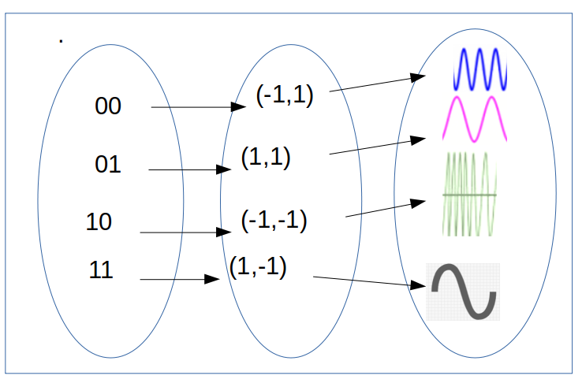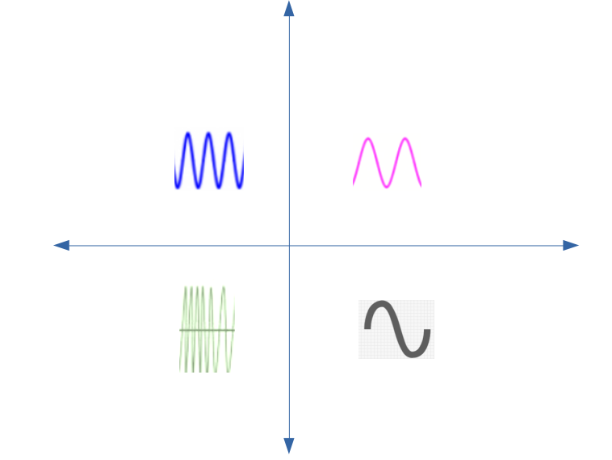

Diagram below illustrates how the data is transmitted. Describe in your own words in details as how the process is done Use the terminologies that are shown in the diagram, such as transmitter and receiver. Share your with group.

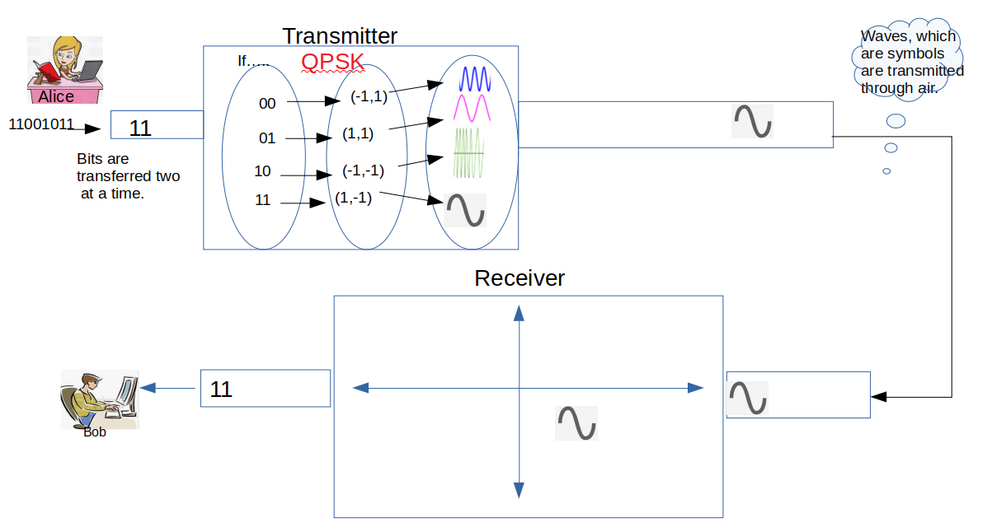

________________________________________________________________________________________________________________________________________________________________________________________________________________________________________________________________________________________________________________________________________________________________________________________________________________________________________________________________________________________________________________________________________________________________________________________________________________________________

In the process Quadrature Phase Shift Keying - QPSK, two bits are transmitted at once, which results in four possibilities, The four outcomes gets converted to different symbols - which are waves. Each symbol travels through air and it is received by the receiver at one symbol at a time. Since there are four symbols, we can visualize the receiver receiving the symbols on the four quadrants.Then the receiver converts the symbols into digital values “00” ,”10”, “01” and “11” which gets converted to the original message.

In this **ideal** scenario, the data received is the same data sent, which results in **no error.**

Let's take a look at this scenario:

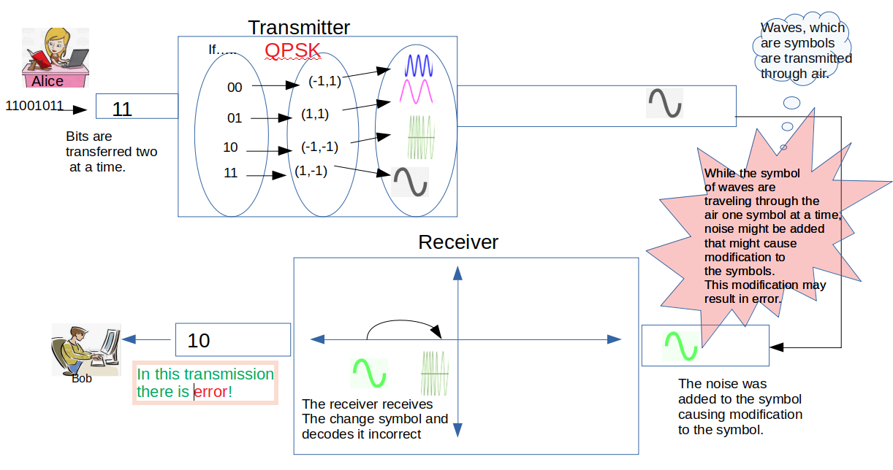

What is happening in the diagram above?

**____________________________________________________________________________________________________________________________________________________________________________________________________________________________________________________________________________________________________________________________________________________________________________________________**

Can you describe how the noise affect the data being sent?

____________________________________________________________________________________________________________________________________________________________________________________________________________________________________________________________________________________________________________________________________________________________________________________________

Before you proceed to the next activity, write and define to your best knowledge of new terminologies that you encountered and learned. For example, Modulation - a process of converting 0 and 1 into symbols (waves). Share your words with your group.

________________________________________________________________________________________________________________________________________________________________________________________________________________________________________________________________________________________________________________________________________________________________________________________________________________________________________________________________________________________________________________________________________________________________________________________________________________________________________________________________________________________________________________________________________________________________________________________

List the similarities and the differences between BPSK and QPSK. Use the proper terminologies to write your thoughts. If you are not sure, go over the explanations and/or ask your group.



Name_____________________________

**Part IV: Probability of error**

In the BPSK, there are ______ symbols are presented after the modulation. Therefore, only two predetermined locations where receiver is expecting the symbols. We can say the symbols have a 50% chance of landing on the correct predetermined location. In other words, we can also say the symbols have a 50% chance of landing incorrectly on the predetermined locations.

However, in the QPSK, there are _______ symbols are presented after the modulation. Therefore, there were ______ predetermined locations where receiver can expect the symbol to land. We can say the symbols have a 25% chance of landing on the correct predetermined locations but we can also say the symbols have a 75% chance of landing incorrectly on the predetermined locations.

Fill in the rest of the table:

|  |  |  |  |  |  |
| --- | --- | --- | --- | --- | --- |
|  | 1 bit - BPSK | 2 bits - QPSK | 3 bits | 4 bits | 5 bits |
| Number of bits modulated at once | 1 | 2 | 3 |  |  |
| Possible symbols needed | 21 | 22 | 23 |  |  |
| Probability of success | 1/2 | 1/4 | 1/8 |  |  |
| Probability of error | 1/2 | 3/4 |  |  |  |

What can you conclude by looking at the table as you increase the number of bits being modulation at one your chances of error is increasing or decreasing? Justify your answer.

________________________________________________________________________________________________________________________________________________________________________________________________________________________________________________________________________________________________________________