COSMOS EDUCATIONAL TOOLKIT: Presentation of IP Address
Grade/ Grade Band: 8-12 | Topic Presentation of IP address | Lesson # _____ in a series of _____ lessons
Brief Lesson Description:
Students will learn what the IP address is and discover the binary representation of IPv4 address.

Specific Learning Outcomes: Different representation of IP address
Narrative / Background Information
Prior Student Knowledge Required: Evaluating exponents
Problem Solving Practices (Ex: Standards for Mathematical Practice):  CCSS.Math.Content.HSF.IF.C.9  Compare properties of two functions each represented in a different way (algebraically, graphically, numerically in tables, or by verbal  descriptions). | Main Content Ideas:  Different presentation of IP address | Possible Multidisciplinary Concepts:  Computer Science: Purpose of IP address  Math: Conversion of decimal into binary code
Possible Preconceptions/Misconceptions: IP address are represented from 4-12 digits.
LESSON PLAN – 5-E Model
ENGAGE: Opening Activity – Access Prior Learning / Stimulate Interest / Generate Questions:
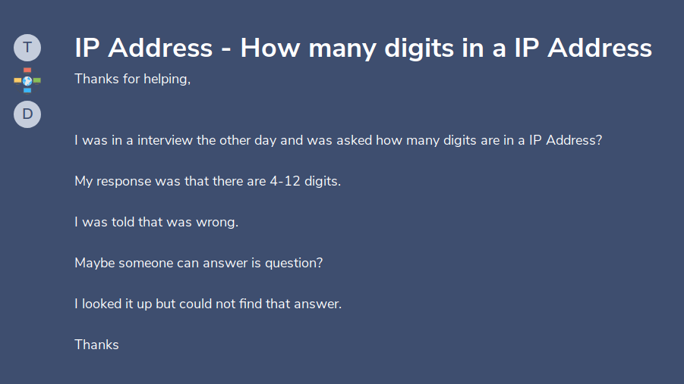
Why was the person told that he was wrong? Did Interviewer make a mistake?
EXPLORE: Lesson Description – Materials Needed / Probing or Clarifying Questions:
Worksheets, COSMOS toolkits
EXPLAIN: Concepts Explained and Vocabulary Defined:

Key Vocabulary: IP (Internet Protocol) address, Binary presentation
ELABORATE: Applications and Extensions:
EVALUATE:

Formative Monitoring (Questioning / Discussion): What would be the correct answer for the question above?
Correct answer is 32 binary digits with correct explanation.

Summative Assessment (Quiz / Project / Report): Students research and calculate how many more address can be added with IPv6 than IPv4.

Elaborate Further / Reflect: Enrichment:
- IPv6 has how many binary bits to create a unique address?
- What is the significance of having the IPv6 address?

