Name______________________________

**IP Address: Binary Representation**

Reading the following article and answer the questions below.

**What is an IP address?**

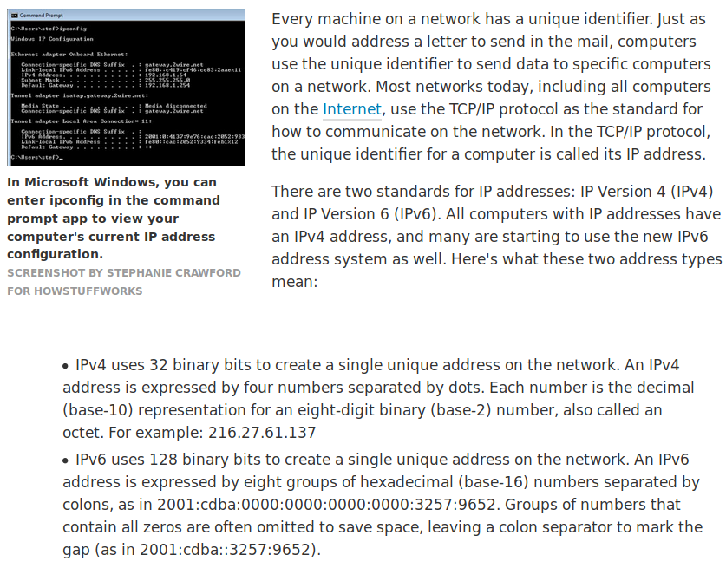

<https://computer.howstuffworks.com/internet/basics/what-is-an-ip-address.htm>

1. What is an IP address?
2. Why do you think that IP address is needed?
3. What are the 2 types of IP addresses?
4. What are the differences between the 2 types of IP addresses?

**How many digits in IP address?**

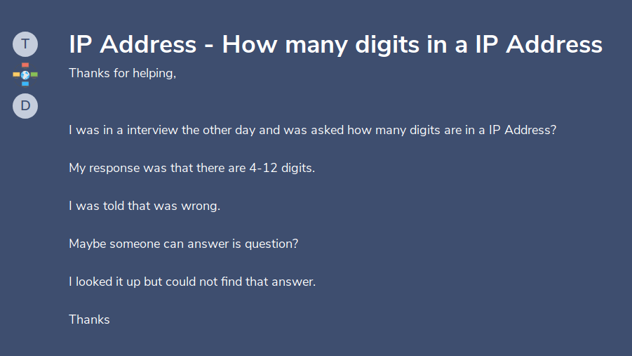

<https://www.experts-exchange.com/questions/28039733/IP-Address-How-many-digits-in-a-IP-Address.html>

Here is an example of an IP address from a computer: **102.167.212.223**

Why was the person told that he was wrong? Did Interviewer make a mistake?

________________________________________________________________________________________________________________________________________________________________________________________________________________________________________________________________________________

Share your answer with your group.

In order to understand why the answer was ***wrong***, we need to understand how to convert decimal presentation into binary presentation.

Binary is a numeric system that only uses two digits, 0 and 1. We represent binary numbers the same way we represent numbers in our traditional base 10 system. However, instead of the 1's column and 10’s column, 100’s column, binary have

1’s column, 2’s column, 4’s column n, 8’s column, and so on.

Lets see the example below:

Convert 203 into binary code.

|  |  |  |  |  |  |  |  |  |
| --- | --- | --- | --- | --- | --- | --- | --- | --- |
| Base 2 | 27 | 26 | 25 | 24 | 23 | 22 | 21 | 20 |
| decimal | 128 | 64 | 32 | 16 | 8 | 4 | 2 | 1 |
| binary | 1 | 1 | 0 | 0 | 1 | 0 | 1 | 1 |

That equates to 27 + 26 + 23 + 21 + 20

= 128 + 64 + 8 + 2 + 1

= 203

**203 as binary representation is 11001011**

**Note: It takes 8 binary digits to represent 203.**

Now, you try……..

Convert 135 into binary code:

|  |  |  |  |  |  |  |  |  |
| --- | --- | --- | --- | --- | --- | --- | --- | --- |
| Base 2 | 27 |  |  |  |  |  |  |  |
| decimal |  |  |  |  |  |  |  | 1 |
| binary |  |  |  |  |  |  |  |  |

Binary code for 165 is: ___ ___ ___ ___ ___ ___ ___ ___

Let’s talk about IP address since you understand the conversion of decimal into binary representation. For this activity, we will be referring to IPv4 address.

**Representation of IP Address**

When you retrieve the IP address from your device, it will be presented as a decimal form:

For example: 192.168.17.10 is the IP address on a computer

Convert the three digit number into binary digits.

192 can be converted to ___ ___ ___ ___ ___ ___ ___ ___

27 26 25 24 23 22 21 20

168: ___ ___ ___ ___ ___ ___ ___ ___

17: ___ ___ ___ ___ ___ ___ ___ ___

10: _______________________________

Now, write all the binary digits together.

What is the binary presentation of the IP address of 192.168.17.10?

__________________________________________________________________

__________________________________________________________________

Let's take a look at this question again:



**Activity**

1. What would be the correct answer to this question? Justify your answer.

2. Write a response in detail as why his answer is incorrect?

Extension: Going back to the article we read before,

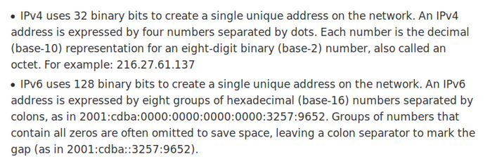

1. IPv4 has how many binary bits to create a unique address?

2. IPv6 has how many binary bits to create a unique address?

3. What is the significance of having the IPv6 address?

4. Why do you think we need to implement IPv6 addresses?