**Measuring Signal Strength**

**Vocabulary**

* Decibel - a unit used to measure the intensity of a sound or the power level of an electrical signal by comparing it with a given level on a logarithmic scale.
* Hertz - The SI unit for wave frequency, where 1 hertz equals 1 wave passing a fixed point in 1 second
* Wave Amplitude - The maximum distance of displacement of a particle on the medium from its rest position.
* Wavelength - The distance between two corresponding points on adjacent waves
* Wave Frequency - The number of waves that pass a fixed point in a given amount of time.
* Conductivity - the degree to which a specified material conducts electricity, calculated as the ratio of the current density in the material to the electric field that causes the flow of current. It is the reciprocal of the resistivity.
* Interference - a property that modifies a signal in a disruptive manner, as it travels from a source to the receiver

The height of a wave is its amplitude. Another measure of wave size is wavelength. Wave amplitude is the maximum distance the particles of a medium move from their resting position when a wave passes through. The resting position is where the particles would be in the absence of a wave.

* In a transverse wave, wave amplitude is the height of each crest above the resting position. The higher the crests are, the greater the amplitude.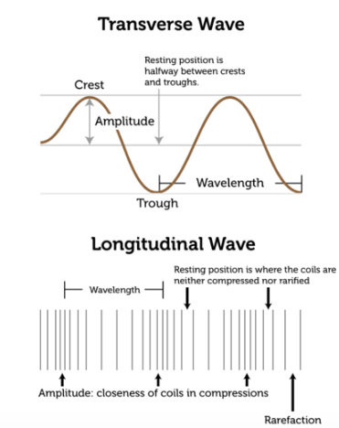
* In a longitudinal wave, amplitude is a measure of how compressed particles of the medium become when the wave passes through. The closer together the particles are, the greater the amplitude.

What determines a wave’s amplitude? It depends on the energy of the disturbance that causes the wave. A wave caused by a disturbance with more energy has greater amplitude. Another important measure of wave size is wavelength. Wavelength is the distance between two corresponding points on adjacent waves. Wavelength can be measured as the distance between two adjacent crests of a transverse wave or two adjacent compressions of a longitudinal wave. It is usually measured in meters. Wavelength is related to the energy of a wave. Short-wavelength waves have more energy than long-wavelength waves of the same amplitude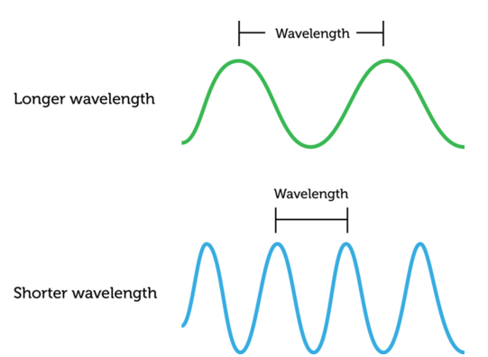

The number of waves that pass a fixed point in a given amount of time is wave frequency. Wave frequency can be measured by counting the number of crests or compressions that pass the point in 1 second or other time period. The higher the number is, the greater is the frequency of the wave. The SI unit for wave frequency is the **hertz (Hz)**, where 1 hertz equals 1 wave passing a fixed point in 1 second.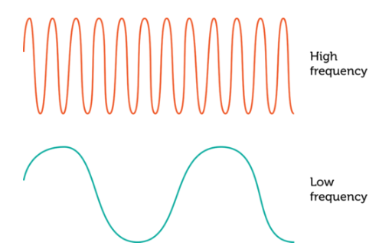

The frequency of a wave is the same as the frequency of the vibrations that caused the wave. For example, to generate a higher-frequency wave in a rope, you must move the rope up and down more quickly. This takes more energy, so a higher-frequency wave has more energy than a lower-frequency wave with the same amplitude.

When measuring the strength of a frequency using the GNU Radio, you will see similar readings to the one below.

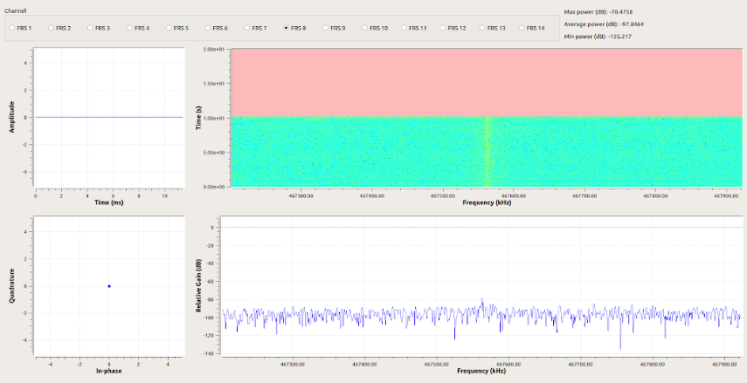

**Indicate something you see, something you think, and a question you may have about wave measures and frequency.**

|  |  |  |
| --- | --- | --- |
| **See - That helped you understand this lesson.** | **Think - What do think you understand about this topic? Or What do you already know about this topic.** | **Wonder - What is one question you have about this topic?** |

**Measuring Signal Strength**

**Be sure to show all of your work and ask for help when needed.**

**Part 1**

Step 1: Use the Raspberry Pi (Mobile Node) to run GNU Radio Companion Software to measure the signal strength between two walkie talkies from the front of the school steps to the following various places listed under Location.

**Table 1**

|  |  |  |  |
| --- | --- | --- | --- |
| Location | Distance between the Transmitter and the Receiver | Signal Strength  Decibels (Db) | Possible Interference / Obstacle  What could be interfering with the transmission? |
| In Front of the School Building | 1 meter |  |  |
| School Yard | 12 meters |  |  |
| Harlem River Drive | 16 meters |  |  |
| Grocery Store | 76 meters |  |  |
| Subway Station | 148 meters |  |  |

Step 2: Use the data found in Table 1 to answer the following questions.

1. Complete the table below:

**Table 2**

|  |  |  |  |  |  |
| --- | --- | --- | --- | --- | --- |
| Signal Strength, ***Db*** |  |  |  |  |  |
| Distance, ***m*** | 0 | 12 | 16 | 76 | 148 |

1. What is the rate of the signal strength when in the subway? ___________________
2. What is the rate of the signal strength when close to the highway? ________________
3. What is the rate of the signal strength near the grocery store? _____________________
4. Are these rates equivalent? Why or why not? ________________________________________________________________________________________________________________________________________________________________________________________________________________________________________________________________________________________________________________________________________________________
5. Do the ratios in Table 2 form a proportion? Explain your answer.

________________________________________________________________________________________________________________________________________________________________________________________________________________________________________________________________________________________________________________________________________________________

1. Calculate the unit rate for the locations below. Be sure to show your work.

|  |  |  |
| --- | --- | --- |
| School Yard | Grocery Store | Subway Station |

**Measuring Signal Strength**

**Be sure to follow each step, show all of your work, and ask for help when needed.**

**Part 2**

1. Students will open the COSMOS Node and open the GNU Radio Companion software.
2. Students will put one walkie-talkie in a ziplock bag, close the bag then place that bag into another zip lock bag to ensure walkie-talkie does not get wet. (Be sure to tightly close both bags)
3. Measure out 10 inches of string and tie the string around the top of the ziplock bag to ensure the bag is closed tightly.
4. Students will measure out 3 gallons of water to put into each bucket.
5. Students will place the ruler inside both buckets.
6. Students will pour ¼ cup of salt in bucket A. Wait for complete saturation. (2-5 minutes)
7. Divide students into groups of 4 and assign the following tasks. One task per student.
   1. Student A will hold the walkie-talkie bag by the string and place the bag into the water. (Do not allow the bag to touch the bottom of the bucket or the sides of the bucket.
   2. Student B will push the PTT button on the walkie-talkie and hold it while the bag is in the water (do not open the bag)
   3. Student C will take the maximum decibels to measure the signal strength showing on the GNU Radio
   4. Student D will write their findings in the table and answer any procedural questions or comments from group members.
8. Student C will add another ¼ cup of salt to bucket A.
9. Students will repeat steps 7a-7d
10. Student C will add another ¼ tof salt to bucket A.
11. Students will repeat steps 7a-7d
12. Student C will add another ¼ cup of salt to bucket A.
13. Students will repeat steps 7a - 7d
14. Student A will submerge the walkie-talkie bag in water in bucket B (fresh water) while holding the string to ensure the top of the bag (the seal) does not go underwater. (Do not allow the bag to touch the bottom of the bucket or the sides of the bucket.
15. Student B will push the PTT button on the walkie-talkie and hold it while the bag is in the water (do not open the bag)
16. Student C will take the maximum decibels to measure the signal strength showing on the GNU Radio
17. Student D will write their findings in the appropriate space and answer any procedural questions or comments from group members.
18. Students will complete their tables and graph their findings.
19. Students will decide if the graph is proportional.

**Measuring Signal Strength - Data Collection**

1. Complete the following table with your findings.

|  |  |  |  |  |  |
| --- | --- | --- | --- | --- | --- |
| **Amount of Salt, c** | 0 cups | ¼ cup | $\frac{2}{4}$ cup | $\frac{3}{4}$ cup | 1 cup |
| **Signal Strength, db** |  |  |  |  |  |

1. Graph your findings. Use different colored pencils for each line and label your axis.



1. Is the graph proportional why or why not?

___________________________________________________________________________________________________________________________________________________________________________________________________________________________________________________

**Part 3**

**Extension Activity: Essay Response**

1. From your experiment, we found that there was a difference in signal strengths between fresh water and salt-water. Research what limits transmission of radio waves in the ocean and write a 500-word essay on your findings. Be sure to cite your sources.

_______________________________________________________________________________________________________________________________________________________________________________________________________________________________________________________________________________________________________________________________________________________________________________________________________________________________________________________________________________________________________________________________________________________________________________________________________________________________________________________________________________________________________________________________________________________________________________________________________________________________________________________________________________________________________________________________________________________________________________________________________________________________________________________________________________________________________________________________________________________________________________________________________________________________________________________________________________________________________________________________________________________________________________________________________________________________________________________________________________________________________________________________________________________________________________________________________________________________________________________________________________________________________________________________________________________________________________________________________________________________________________________________________________________________________________________________________