Lesson Planning Template
COSMOS EDUCATIONAL TOOLKIT: LESSON NAME
Grade/ Grade Band: Algebra ( 8-12) | Topic: Destructive Interference | Lesson # _____ in a series of _____ lessons
Brief Lesson Description:
What is the real life application of destructive interference?
Specific Learning Outcomes:
How does BOSE use the concept of destructive interference to make the noise cancelling headphones?
Narrative / Background Information
Prior Student Knowledge Required:
- Graphing linear and quadratic functions with constraints- for MS, Algebra I and II
- Evaluating and writing piecewise functions
- Understanding the notation of constraints
- Reflecting functions over of x- axis.
- Notation of functions
- Adding and subtracting functions
- Graphing sinusoidal functions with constraints - for algebra students.

Problem Solving Practices (Ex: Standards for Mathematical Practice):  Model periodic phenomena with trigonometric functions.  CCSS.Math.Content.HSF.TF.B.5  Choose trigonometric functions to model periodic phenomena with specified amplitude, frequency, and midline.*  CCSS.Math.Content.HSF.TF.B.6  (+) Understand that restricting a trigonometric function to a domain on which it is always increasing or always decreasing allows its inverse to be constructed.  CCSS.Math.Content.HSF.TF.B.7  (+) Use inverse functions to solve trigonometric equations that arise in modeling contexts; evaluate the solutions using technology, and interpret them in terms of the context. | Main Content Ideas:  Any sound wave can be cancelled by an inverse wave. | Possible Multidisciplinary Concepts:  Physics: Sound waves can be cancelled by an inverse wave.  Algebra: Adding and subtracting and reflection functions over the axis. Able to graph sinusoidal functions.
Possible Preconceptions/Misconceptions:
Any sound wave can be cancelled by an inverse wave. Wave inversion occurs when a traveling wave is flipped upside down when being reflected back into the old medium. Inverse wave is not equivalent to inverse function in mathematical sense. The sinusoidal function is reflected over x- axis, not reflected over y=x.

LESSON PLAN – 5-E Model
ENGAGE: Opening Activity – Access Prior Learning / Stimulate Interest / Generate Questions:
Note to teachers: The worksheets of this lesson consists of 4 parts and it is optional for teacher to do 1 or all 3 parts of the lesson. The activities are scaffolded such that it can be done by Middle School students up to High School students. It is up to the Instructor to complete one or all activities. it is advised that teacher can conclude the activities by completing part IV

1. In your own words, describe what this person is doing?
- Where is she?
- What do you think she is listening?
- What do you think she is feeling?
- What kind of apparatus does she have around her ears?
These prompts can be used to start a discussion about noise - cancelling headphones and how math is used to design this apparatus.
EXPLORE: Lesson Description – Materials Needed / Probing or Clarifying Questions:
In this lesson, students will explore how the concept of destructive interference is used by Bose to make noise- cancelling headphones.

Students will graph functions indicated. Then they will graph the same function reflected over the x- axis and determine the values of min and max. When the values of min and max are added - students should get the resultant of zero which demonstrates destructive interference.

Materials: Worksheets attached - 3 parts, GNU - Radio simulation
EXPLAIN: Concepts Explained and Vocabulary Defined:
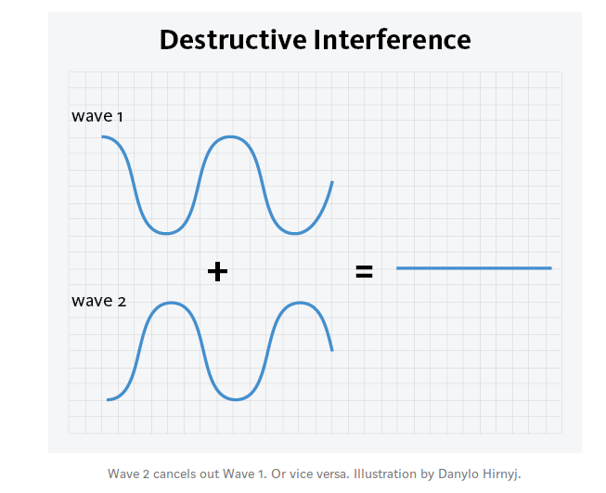
This simple mathematical concept is used by Bose to create noise- canceling headphones that are used by people all over the world.
Key Vocabulary: Reflection over the x-axis
Evaluating and graphing piecewise functions
Inverse wave vs. inverse function
Sinusoidal waves - sine and cosine
Resultant
Destructive interference
ELABORATE: Applications and Extensions:

EVALUATE:

Formative Monitoring (Questioning / Discussion):
Explain how do you think Bose uses this simple mathematical concept to cancel out noise?

Summative Assessment (Quiz / Project / Report):
What does destructive interference look/feel like in wireless connection?

Elaborate Further / Reflect: Enrichment:
Project: Have students construct their own piecewise functions and students can write and graph the same function that would reflect over the x-axis that would give the resultant of zero. This lesson can also be extended by introducing the concept of constructive interference.

