Name_________________________

**Math behind Bose *noise - cancellation* headphones**



**1. In your own words, describe what this person is doing?**

* **Where is she?**
* **What do you think she is listening?**
* **What kind of apparatus does she have around her ears?**

______________________________________________________________________________________________________________________________________________________________________________________________________________________________________________________________________________________________________________________________________________________________________________________________________________________________________________________________________________________________________________________________________

2.  **What is a noise - cancellation headphone?**

____________________________________________________________________________________________________________________________________________________

3. **How is the noise cancellation headphones differ from the regular headphones?**

________________________________________________________________________________________________________________________________________________________________________________________________________________________________________________________________________________________________________

4.  **Share what you wrote your group.**

**Part I**

Lets see how **Bose** used a simple mathematical concept to create the noise cancellation

headphone.

**Graph the following piecewise functions on the same coordinate plane.**

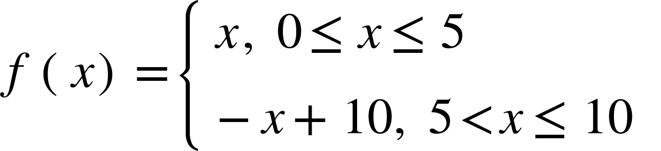 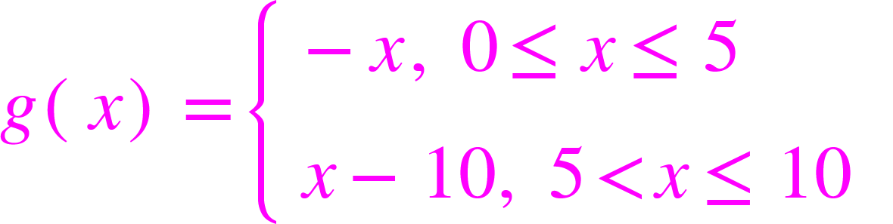

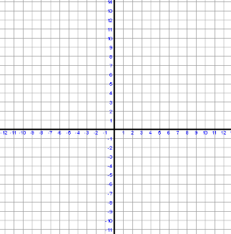

**3. Evaluate f(2) and g(2).**

**_______________________________________________________________**

**_______________________________________________________________**

**4. Determine the sum of f(2) and g(2).**

**_______________________________________________________________**

**_______________________________________________________________**

**5. Evaluate f(8) and g(8). Determine the sum.**

**_______________________________________________________________**

**_______________________________________________________________**

**6. Approximate the value of f(3.5) and g(3.5) and determine the sum.**

**_______________________________________________________________**

**_______________________________________________________________**

**7. At what value of x does f(x) is maximum? At what value of x does g(x) is minimum?**

**_______________________________________________________________**

**7. Determine the sum of f(x) and g(x) at points that are max and min.**

**_______________________________________________________________**

**_______________________________________________________________**

**8. What can you conclude about the sum of f(x) and g(x) at any point?**

**Justify your answer.**

**_______________________________________________________________**

**_______________________________________________________________**

**9. Can you explain graphically the reason why the sum of two functions are equal to a constant?**

**_______________________________________________________________**

**_______________________________________________________________**

**Note: In mathematics, the sum of two vectors is called the resultant.**

**Vector is an object that has both a magnitude and a direction. Geometrically. We can draw a vector as a line segment with an arrow indicating the direction and length is the magnitude.**

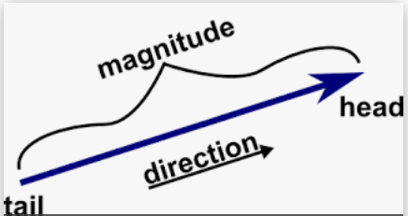

***https://mathinsight.org/vector_introduction***

**10. What is the result when you combine r(x) = f(x) + g(x)**

**r(x) = _______**

**11. Graph r(x) on the same coordinate plane.**

**12. What is the slope of r(x)?**

*Note to teachers: If you are* ***not*** *continuing with part 2 and part 3, try the part 4 as a conclusion of this lesson.*

**Name____________________________**

**Part II:**

**Graph the following piecewise functions on the same coordinate plane.**

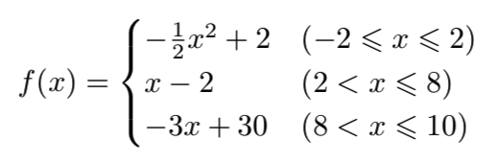

**1. Graph f(x)**

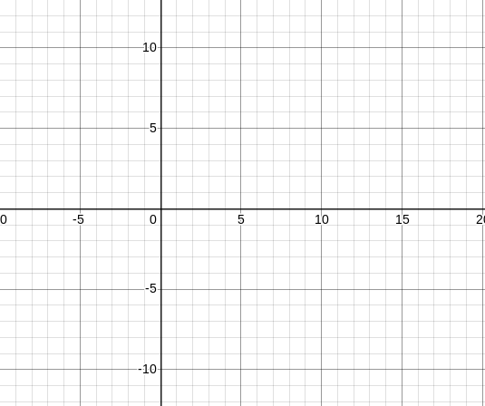

**2. Reflect the graph over the x-axis.**

**3. How would you rewrite any functions to reflect over x-axis? For example, y = x+1, rewrite this function so it will be reflected over the x-axis.**

**______________________________________________________________________________________________________________________________________________________________________________________________________________________________**

**4. Write a piecewise function called g(x) with proper constraints, that would be applicable to the graph below the x-axis.**

**________________________________________________________________________________________________________________________________________________________________________________________________________________________________________________________________________________________________________**

**5. Identify relative min and max between** -2 $≤x≤2$**and determine the value of resultant at that point.**

**______________________________________________________________________________________________________________________________________________________________________________________________________________________________**

**6. Identify the absolute min and max between $2≤x≤10$**

**Determine the value of the resultant.**

**__________________________________________________________________________**

**__________________________________________________________________________**

**__________________________________________________________________________**

**7. What could you say about the value of the resultant when you add the min and the max**

**when a function is reflected over the x-axis?**

**____________________________________________________________________________________________________________________________________________________**

**__________________________________________________________________________**

**8. Graph r(x) on the coordinate plot.**

**9. What is the slope of r(x)?**

________________________________________________________________________________________________________________________________________________________________________________________________________________________________________________________________________________________________________

Note to te*achers: If you are not continuing with part 3, try the part 4 as an extension of this lesson.*

Name________________________

**Part III**

**Graph the following functions on the same coordinate plane.**

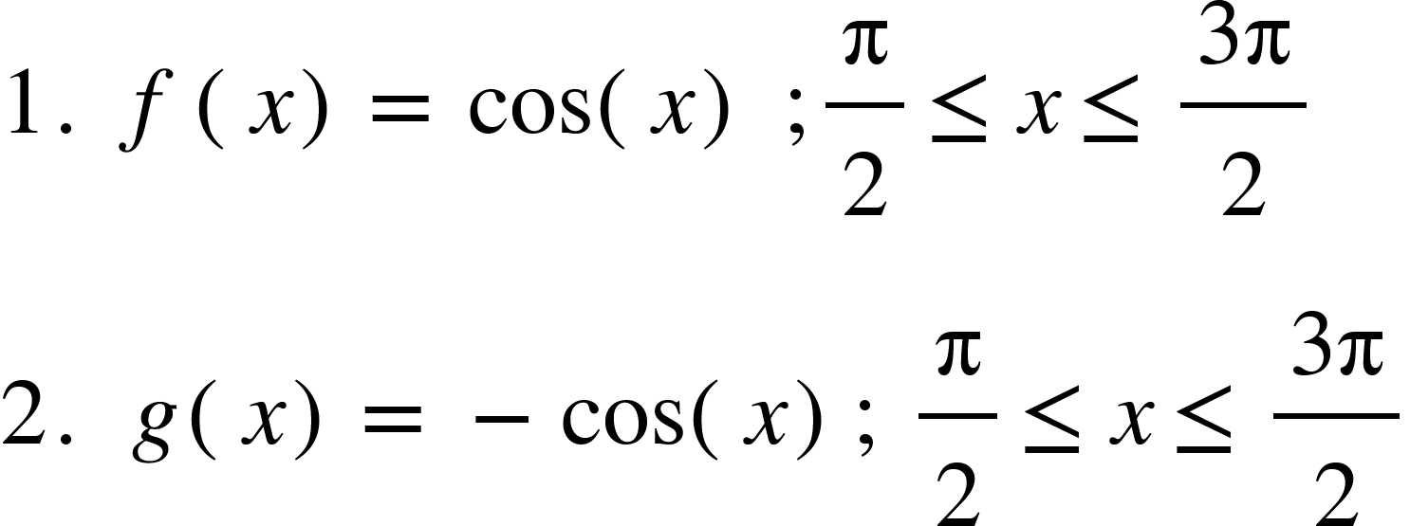

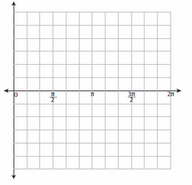

3. Find the value of the resultant r(x) by adding the min and the max value between

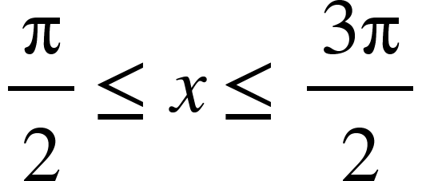

______________________________________________________________________  
______________________________________________________________________

______________________________________________________________________

______________________________________________________________________

4. **r(x) = f(x) + g(x)**

**6. Graph R(x) on the same coordinate plane.**

**7. What is the value of R(x)?________ therefore the resultant is __________________**

**8. Explain how do you think Bose uses this simple mathematical concept to cancel out noise?**

__________________________________________________________________________________________________________________________________________________________________________________________________________________________________________________________________________________________________________________________________________________________________________________

Name______________________

**Part IV**

**What is the application of what we’ve just learned?**

Any sound wave can be cancelled by an inverse wave. Wave inversion occurs when a traveling wave is essentially flipped upside down. Inversion must happen at the same time, otherwise the destructive interference would not occur, or could occur only partly. Inverse wave is not equivalent to inverse function in mathematical sense. The sinusoidal function is reflected over the x- axis, not reflected over y=x.

This simple mathematical concept is used by Bose to create noise- cancelling

headphones that are used by people all over the world.

[**https://www.brightstorm.com/science/physics/vibration-and-waves/wave-inversion/**](https://www.brightstorm.com/science/physics/vibration-and-waves/wave-inversion/)

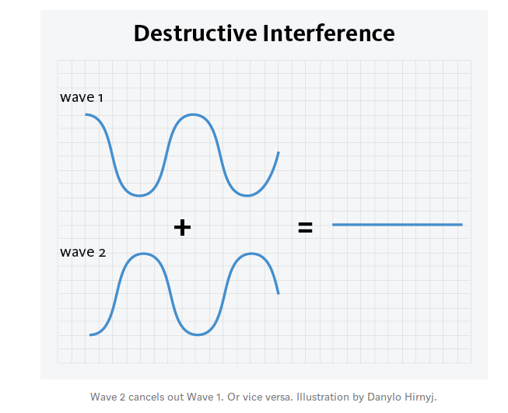

**10. The diagram above shows the demonstration of destructive interference.**

**Explain how this diagram is related to the graphing activity you just completed.**

**_______________________________________________________________________________________________________________________________________________________________________________________________________________________________________________________________________________________________________________________________________________________________________________________**

11. **What does destructive interference look/feel like in wireless connection?**

__________________________________________________________________________________________________________________________________________

__________________________________________________________________________________________________________________________________________