**Extension Activity**

Complete the following problems. Use your answers as your password to gain clues for solving the next problem. Be sure to write your answers for each problem on the password line. Remember to show your work!

Complete the following Function table.

1. Lou and Gene purchase new video games every week for 10 weeks. The input-output tables below show the total number of video games they each own.

|  |  |  |  |  |  |
| --- | --- | --- | --- | --- | --- |
| Number of weeks, x | 0 | 1 | 3 | 5 | 10 |
| Lou’s video games, y | 10 | 12 | 16 | 20 | 30 |

|  |  |  |  |  |  |
| --- | --- | --- | --- | --- | --- |
| Number of weeks, x | 0 | 1 | 3 | 5 | 10 |
| Gene’s video games, y | 2 | 5 | 11 | 17 | 32 |

Password (4-digits): __1732___________

* 1. Draw a mapping diagram for each person.

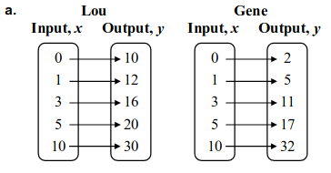

* 1. ***For each person, write an equation that describes the function shown by the table. Be sure to label each equation for each person.***

Equation for Lou: ___y=2x+10__________ Password: _____y = 2x+10_____

Equation for Gene: __y+3x+2__________ Password: _____y = 3x+2_____

* 1. Use the equations in part (b) to determine how many video games they would each have if ***they continued the same pattern for ten additional weeks.***

Lou: 50 Video Games

Gene: 62 Video Games

* 1. Graph both functions. Which graph is steeper? Explain.

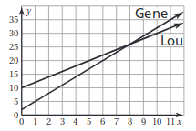

Gene’s graph is steeper because he buys 3 video games each week and Lou only

buys 2 video games each week.

* 1. What does the intersection of the two graphs represent?

The intersection point (8, 26) means that after 8 weeks, Lou and Gene each have 26

video games.

* 1. After 15 weeks, Gene claims to have 46 video games, and Lou claims to have 40 video games. Use your equations in part (b) to explain whether or not each person is correct.

Lou: 2(15) + 10 = 40; Lou is correct.

Gene: 3(15) + 2 = 47; Gene is incorrect.

* 1. Sam’s video game purchases over the same 10 weeks are shown in an input-output table. Use the first three input values to write an equation for the function shown by the table. Then find the missing input.

|  |  |  |  |  |
| --- | --- | --- | --- | --- |
| Number of weeks, x | 0 | 2 | 4 | 13 |
| Sam’s video games, y | 12 | 22 | 32 | 77 |

y = 5x + 12; The missing input is 13 weeks. Password: 13 weeks

* 1. ***Create an input-output table and write an equation that represents a person starting with 20 video games and buying 4 new video games each week. **Remember to give your person a name.***

Equation: ______y = 4x + 20_______

|  |  |  |  |  |
| --- | --- | --- | --- | --- |
| Number of weeks, x | 0 | 1 | 2 | 6 |
| _____________ video games, y | 20 | 24 | 28 | 44 |