Name: __________________________ Class: ______

Factors Affecting an EM Wave Signal

Do Now: What is the relationship between wavelength, frequency, and energy? Fill in the blanks.

2.4 Gigahertz (GHz) and 5 GHz are both frequencies of waves used to send WiFi signals. A 2.4 GHz wave has

a ______________ wavelength, a _______________ frequency, and __________ energy than a 5 GHz wave.
(longer / shorter) (higher / lower) (more / less)

Remember, electromagnetic radiation can be described in terms of a stream of particles called photons. Photos have no mass. Each photon travels in a wave-like pattern at the speed of light. Each photon contains a certain amount of energy. The amount of energy found in the photons defines the different types of radiation. Radio waves have photons with low energies and microwave photons have a little more energy than radio waves. Infrared photons have even more energy, then visible, ultraviolet, and X-rays. Gamma ray photons are the most energetic of all.
Electromagnetic radiation can be expressed in terms of energy, wavelength, or frequency. Frequency is measured in cycles per second, or Hertz (Hz). Wavelength is measured in meters (m). Energy is measured in electron volts (eV). (Adapted from https://imagine.gsfc.nasa.gov/science/toolbox/emspectrum1.html)
Electromagnetic energy travels in waves. Electromagnetic energy ranges from very long radio waves to very short gamma rays. Electromagnetic waves do not need a medium in order to propagate (continue traveling). They can travel through air, solid materials, and also through the vacuum of space.
Different parts of the electromagnetic spectrum have travel in characteristic ways depending on their wavelength and frequency. Different wave signals carry different amounts of information. In general, signals sent using the higher frequencies have shorter wavelengths but a higher data-carrying capacity (i.e. they can carry more information). However, waves with shorter wavelengths and higher frequencies attenuate (lose signal) faster. Wavelength and frequency limit the possible applications (uses) of any particular part of the spectrum. Thus, using waves radio waves versus microwaves to carry an information signal is a trade-off between how much information the wave can carry and how far it can go before something interferes with its travel. (Adapted from https://www.nasa.gov/directorates/heo/scan/spectrum/overview/index.html)
As you know, WiFi signals are information carried on an electromagnetic wave (specifically, a microwave--but not the type you cook your food in!). According to our background information, waves can travel through many different materials. Think about all of the different materials the microwaves carrying WiFi signals have to travel through in our school building - the metal door, concrete walls, wooden closets, linoleum floor tiles, etc. The infographic below shows information about how EM waves travel through different materials. What do you notice about microwaves?
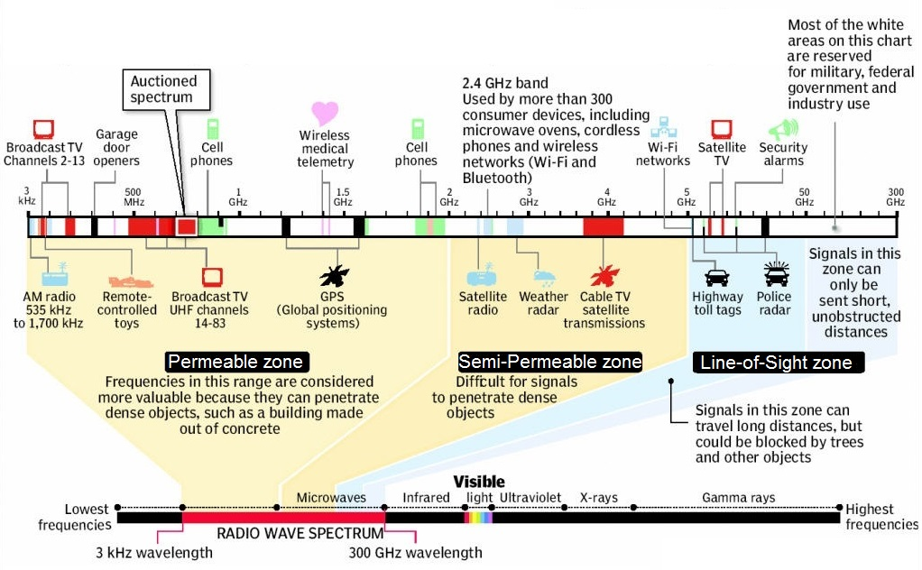

This leads us to a scientific question - do waves travel equally well through different materials? In other words, is the signal strength the same through different materials, or do certain materials cause it to be attenuated (weakened) more than others? We will use the COSMOS Toolkit to test this.
Materials:
- COSMOS Node (receiver)
- Walkie Talkie (transmitter - will send radio wave signals)
- Cardboard frame surrounded by sound/wave dampening foam (will direct radio waves from the walkie talkie towards the obstacle and eliminate possible interference)
Brainstorm at least three possible Independent Variables (materials we could test--if you are stuck, look around the room for ideas!):

Dependent variable (what are we measuring?): _________________________________________
Talk with your group - what do you think we need to keep constant (e.g., what should we keep the same for every trial, even when we different materials)?

Data:
Obstacle | Trial | Max peak (dB) | Other observations
 | 1
 | 2
 | 3
 | Average

Obstacle | Trial | Max peak (dB) | Other observations
 | 1
 | 2
 | 3
 | Average

Obstacle | Trial | Max peak (dB) | Other observations
 | 1
 | 2
 | 3
 | Average

Obstacle | Trial | Max peak (dB) | Other observations
 | 1
 | 2
 | 3
 | Average

Analysis:
What trends or patterns do you see in your data?
Use statistics to explain your data:
  - Range (lowest to highest values)
  - Mean (average)
________________________________________________________________________________________________________________________________________________________________________________________________________________________________________________________________________________________________________________________________________________________________________________________________________________________________________________________________________________________________________________________________________________________________________________________________________________________________________________________________________________________________________________________________________________________________________________________________________________________________________________________________________________________________________________________________________________________________________________________________________

Conclusion:
- What did you learn in this experiment?
- How does the experiment relate to a real life situation?
- What could have affected your results? (human errors, limitations)
- What future research would you like to conduct? (Future Changes + Importance + New Ideas?)

________________________________________________________________________________________________________________________________________________________________________________________________________________________________________________________________________________________________________________________________________________________________________________________________________________________________________________________________________________________________________________________________________________________________________________________________________________________________________________________________________________________________________________________________________________________________________________________________________________________________________________________________________________________________________________________________________________________________________________________________________

Reflection:
What comments or suggestions do you have about this experiment?
________________________________________________________________________________________________________________________________________________________________________________________________________________________________________________________________________________________________________________________________________________________________

