Student Name____________________________________ Class_________

**Indoor Air Pollution** Lesson

A **pollutant** is any substance that contaminates the environment. Substances in the **air** that makes it impure are called **Air Pollutants**. Air pollutants include ***smoke, ash, soot****, and* ***poisonous gases like carbon dioxide, carbon monoxide, nitrogen oxides and sulfur oxides*.** The burning of fossil fuels, exhaust from motor vehicles, airplanes, smoke from factories, power plants, and homes all cause air pollution. Volcanic eruptions, forest fires, and the evaporation of paints and some chemicals also contribute to air pollution.

**Indoor air pollution** is mainly caused by cigarette smoke, faulty air conditioning systems, paint emissions (yes there is such a thing), and poor ventilation. In a school several rooms are likely to have more polluted air than others. For example, the ***lunch room***, ***science labs***, ***computer labs***, ***home economics room***, and ***gym*** are likely to have more air pollution than regular classrooms.

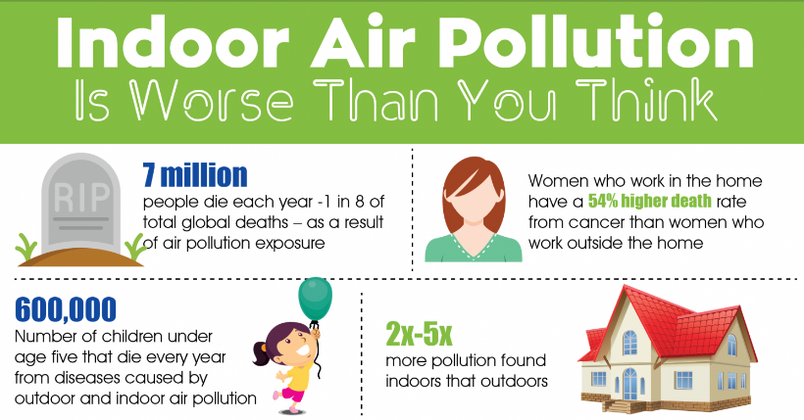

For our school we will use the following rooms: **lunch room**, **science lab**, **computer lab** and **gym**.

**Materials**: COSMOS Technology Toolkit, COSMOS mobile node, IoT sensors for CO**2**, dust, humidity

We are now going to perform an activity in which we will use our COSMOS Technology Toolkit, the COSMOS mobile node and COSMOS IoT sensors to detect the levels of carbon dioxide (CO**2**), dust, humidity and temperature of the air in different rooms in our school. The materials and equipment are arranged on your tables. Wait for your teacher to tell you to begin.

**Prediction**:

**Which room you think will have the highest**:

* Carbon dioxide (CO**2**) level _____________________________

* Humidity ___________________________________
* Dust ______________________________

* Temperature ________________________________

**Procedure**

1. Students are arranged in 4 groups each with a COSMOS mobile node and sensors. Ensure that the sensors are connected to the mobile node and functioning properly.
2. Students will go with the functioning mobile node and sensors to the prescribed rooms and take the readings. Each of the 4 groups will go to a different room initially but will continue on to the other rooms so as to take readings in them as well.
3. Students will also observe and take physical observations/readings about their perception about the quality of the air quality in the rooms they visit. *i.e. does it feel hot, stuffy, dusty, moist, dry, cold etc. or does it feel normal.*
4. Students will record their readings and observations in the tables below for the different rooms they visit.

**LUNCH ROOM**

|  |  |  |
| --- | --- | --- |
| **Air Pollutants** | **Sensor Readings** | **Physical Observations**  *(Does the room feel hot, stuffy, dusty, moist, dry, cold etc. or does it feel normal)* |
| Carbon Dioxide CO**2** |  |  |
| Humidity |  |  |
| Dust |  |  |
| Temperature |  |  |

**SCIENCE LAB**

|  |  |  |
| --- | --- | --- |
| **Air Pollutants** | **Sensor Readings** | **Physical Observations**  *(Does the room feel hot, stuffy, dusty, moist, dry, cold etc. or does it feel normal)* |
| Carbon Dioxide CO**2** |  |  |
| Humidity |  |  |
| Dust |  |  |
| Temperature |  |  |

**COMPUTER LAB**

|  |  |  |
| --- | --- | --- |
| **Air Pollutants** | **Sensor Readings** | **Physical Observations**  *(Does the room feel hot, stuffy, dusty, moist, dry, cold etc. or does it feel normal)* |
| Carbon Dioxide CO**2** |  |  |
| Humidity |  |  |
| Dust |  |  |
| Temperature |  |  |

**GYM**

|  |  |  |
| --- | --- | --- |
| **Air Pollutants** | **Sensor Readings** | **Physical Observations**  *(Does the room feel hot, stuffy, dusty, moist, dry, cold etc. or does it feel normal)* |
| Carbon Dioxide CO**2** |  |  |
| Humidity |  |  |
| Dust |  |  |
| Temperature |  |  |

**Questions**

1. Which room had the highest level of CO**2**? ________________________ Was this what you predicted? _____________

Give a reason why you think your prediction was correct/not correct _______________________________________________________________________________________________________________________________________________________________________________________

1. Which room had the highest level of humidity? ____________________ Was this what you predicted? _____________

Give a reason why you think your prediction was correct/not correct _______________________________________________________________________________________________________________________________________________________________________________________

1. Which room had the highest level of dust? ________________________ Was this what you predicted? _____________

Give a reason why you think your prediction was correct/not correct _______________________________________________________________________________________________________________________________________________________________________________________

1. Which room had the highest temperature? ________________________ Was this what you predicted? _____________

Give a reason why you think your prediction was correct/not correct _______________________________________________________________________________________________________________________________________________________________________________________

1. Of the 4 factors: *carbon dioxide*, *humidity*, *dust*, and *temperature* which one do you think causes the most difficulties and health problems for humans? Give details to support your answer _____________________________________________________________________________________________________________________________________________________________________________________________________________________________________________________________________________________________________________________________________________________________________________________________________________________________________________________________________________________________________________________________________________________________________

1. Based on your knowledge of how *CO****2***, *humidity*, *dust* and *temperature* can affect the air quality in rooms what measures do you think could be put in place to improve the air quality in your schools locker rooms? Give reasons to support your answer __________________________________________________________________________________________________________________________________________________________________________________________________________________________________________________________________________________________________________________________________________________________________________________________________________________________________________________________________________________________________________________________________________________________________________________________________________________________________

1. Which room in your house do you think has the highest humidity? What could you do to improve the humidity levels in that room in your house so as not to cause health problems for you and your family? Give reasons to support your answer __________________________________________________________________________________________________________________________________________________________________________________________________________________________________________________________________________________________________________________________________________________________________________________________________________________________________________________________________________________________________________________________________________________________________________________________________________________________________