**AM/FM - Signals from a Microphone**

Recall that the difference between **amplitude modulation (AM)** and **frequency modulation (FM)** is as follows:

* **AM**: we vary the *amplitude* of the carrier wave according to the value of the information signal
* **FM** we vary the *frequency* of the carrier wave according to the value of the information signal

For example:

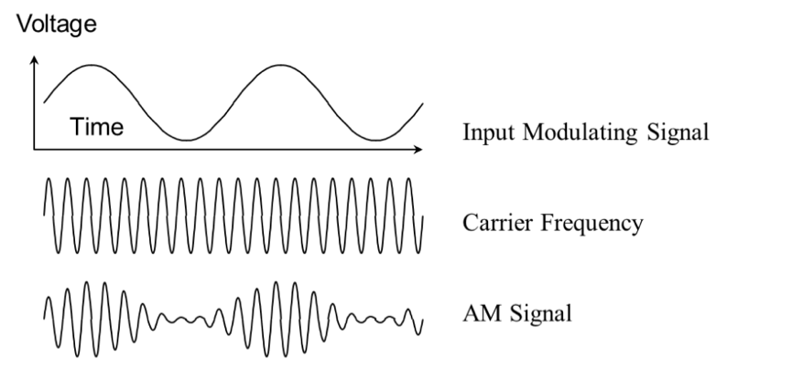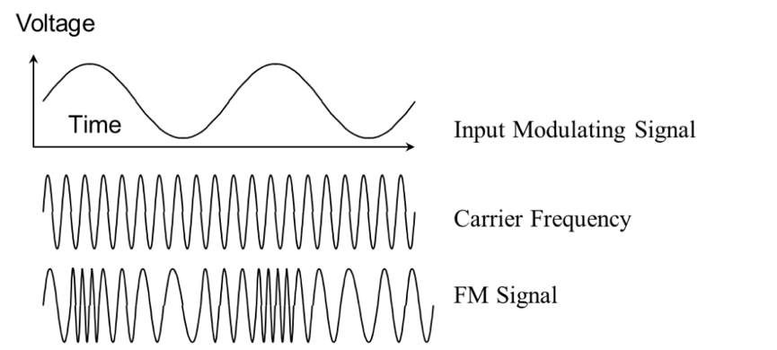

Briefly describe the difference between AM and FM: ______________________________________________

________________________________________________________________________________________

________________________________________________________________________________________

In this activity we are going to generate *information signals* by speaking/clapping into the microphone and observing AM and FM wave signals in frequency and time. Then we are going to compare the two signals.

We will be using the same equipment we used for visualizing AM and FM signals before.

**AM**

We will use the same program as yesterday, GNU Radio.

1. Navigate to the COSMOS Toolkit website (link on Google Classroom) and press the button that says “Start Experiment.”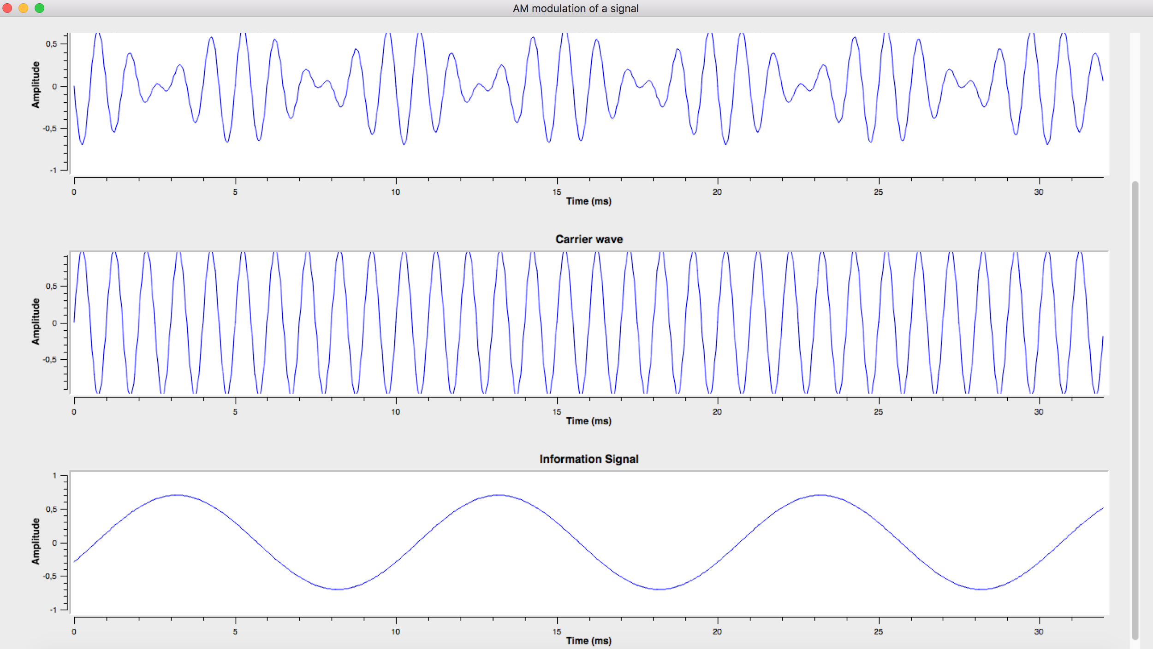
2. A new window will open that looks a bit like this → :
3. Let's see now what happens if the information signal is an actual voice signal that is captured from the microphone of your laptop. On the top of the window there are two radio buttons that allow you to select between a sinusoidal information signal, and an audio information signal from the laptop microphone. This part of the tool looks like the following:

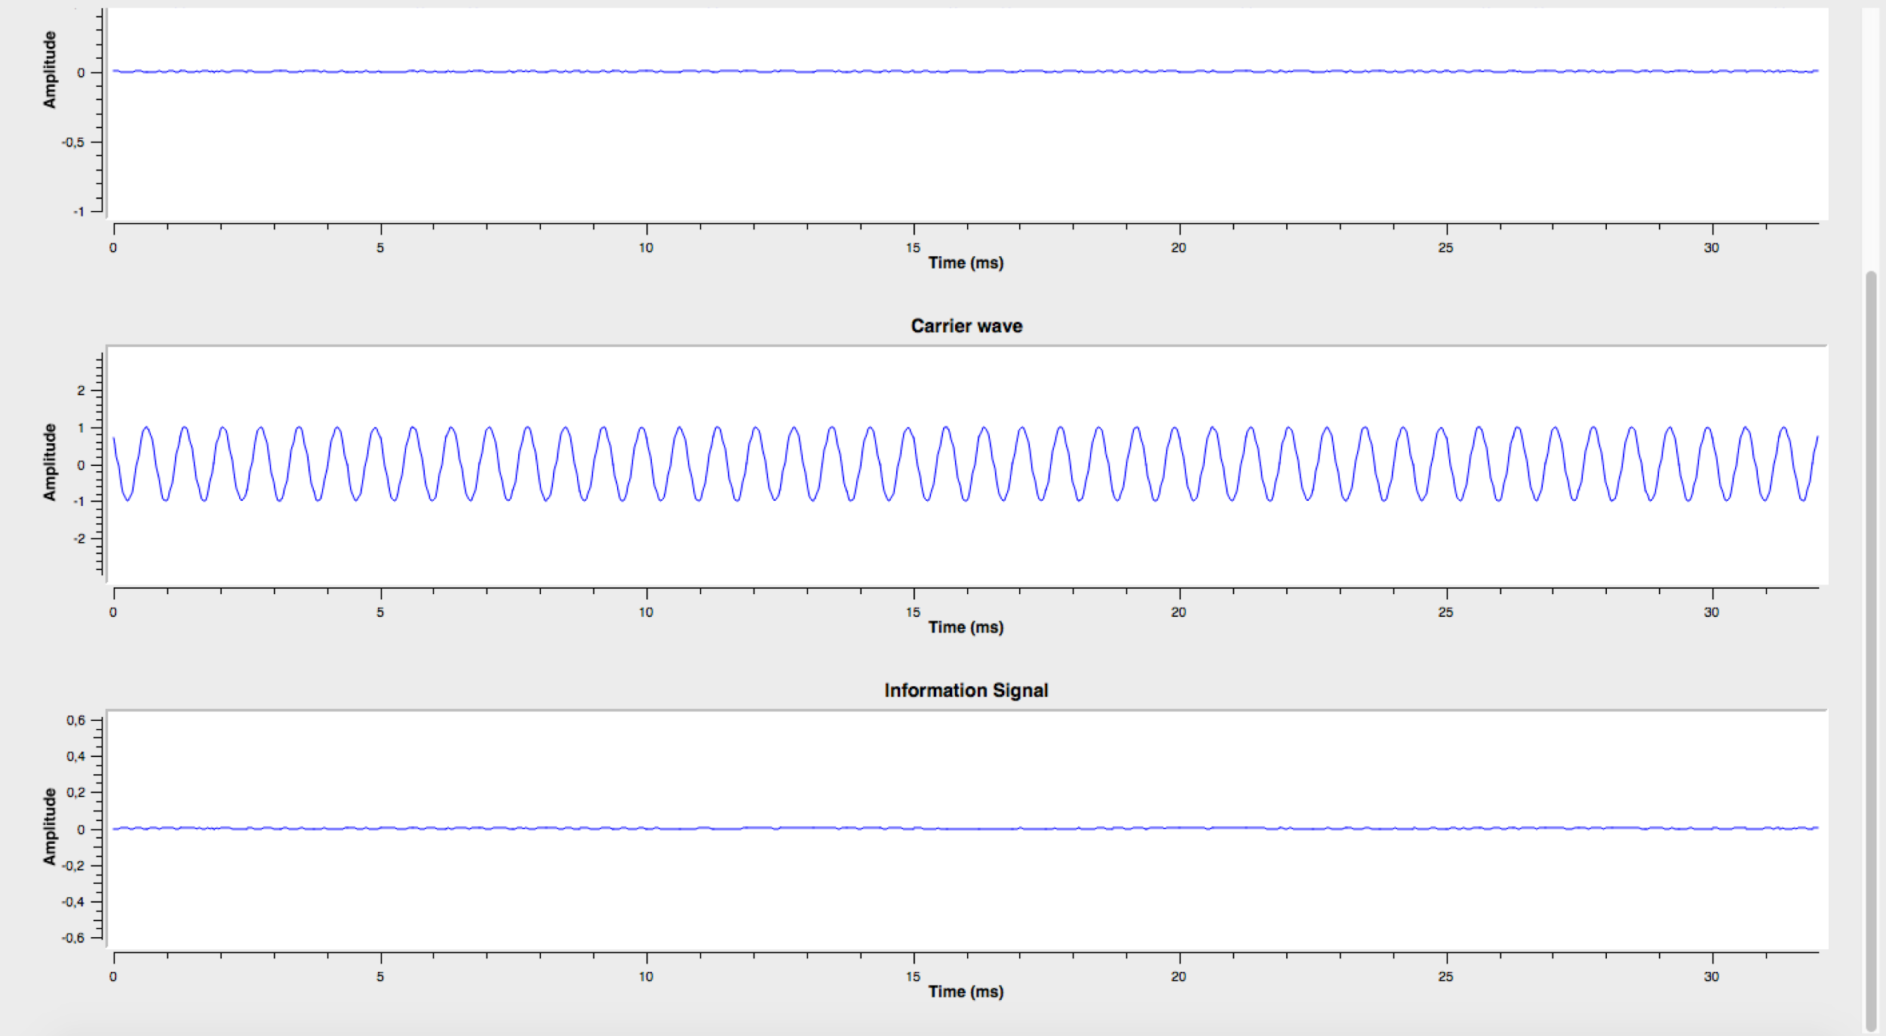

1. Switch the information signal source so that it comes from **the laptop microphone**. In a quiet environment, with no noise, your output should look like the image on the left:
2. See that the information signal (at the bottom) is around 0, and thus the modulated signal is also 0.

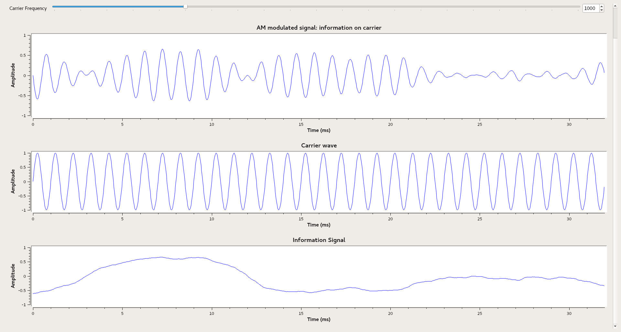

1. Try speaking close to the microphone. You will see that the information signal is being depicted at the bottom, whereas the AM modulated signal is on the top. Your output should look similar to the image on the right:
2. Now try speaking close to the microphone. Experiment with sudden changes in volume - e.g. clap your hands right next to the computer microphone. What kind of interesting AM modulated signals can you generate? Record your observations in the table below.

|  |  |  |
| --- | --- | --- |
| Sound | Distance from Microphone | Sketch of the Wave |
| Clap | Close |  |
|  |  |  |
| Sound | Distance from Microphone | Sketch of the Wave |
|  |  |  |
|  |  |  |

1. Choose one of your plots to share with the class. Take a screenshot of your plot by hitting Ctrl + Shift + window switch key, then click and drag your cursor to select the area you'd like to capture. (Note: the window switch key is typically located in the top row, in between the *Full-screen* and *Brightness down* buttons, and looks like a rectangle followed by two lines.)
2. Upload your screenshot to Google Classroom. Include a caption that explains what type of sound you make to generate the screenshotted signal.

**FM**

1. Navigate to the COSMOS Toolkit website (link on Google Classroom) and press the button that says “Start Experiment.” A new window will open with a graph, as in AM Step #2.
2. On the top of the tool, find the radio buttons for selecting the input of our information signal:



1. Change the source of the signal to the laptop mic. Try speaking close to the microphone and see how the information signal and the output modulated signal are changing.
2. Experiment with sudden sounds - what kind of interesting FM signals can you create? Record your observations in the table below.

|  |  |  |
| --- | --- | --- |
| Sound | Distance from Microphone | Sketch of the Wave |
| Clap | Close |  |
|  |  |  |
|  |  |  |
|  |  |  |

1. Choose one of your plots to share with the class. (It is helpful, but not required, to choose the same Sound + Distance from Microphone as you chose in AM Step #8.) Take a screenshot of your plot by hitting Ctrl + Shift + window switch key, then click and drag your cursor to select the area you'd like to capture. (Note: the window switch key is typically located in the top row, in between the *Full-screen* and *Brightness down* buttons, and looks like a rectangle followed by two lines.
2. Upload your screenshot to Google Classroom. Include a caption that explains what type of sound you make to generate the screenshotted signal.

Refer back to your screenshots. What conclusions can you draw from your observations of an AM voice signal and an FM voice signal? ________________________________________________________________________________________________________________________________________________________________________________________________________________________________________________________________________________________________________________________________________________________________________________________________________________________________________________________________________________________________________________________________________________________________________________________________________________________________________________________________________________________________________________________________________________________________________________________________________________________________________________________________________________________________________________

**3-2-1 Reflection**

* 3 things you learned about AM, FM, and voice signals

__________________________________________________________________________________

__________________________________________________________________________________

____________________________________________________________________________________________________________________________________________________________________

__________________________________________________________________________________

__________________________________________________________________________________

* 2 things you noticed about AM, FM, and voice signals

__________________________________________________________________________________

____________________________________________________________________________________________________________________________________________________________________

__________________________________________________________________________________

* 1 question you still have about AM, FM, and voice signals

__________________________________________________________________________________

__________________________________________________________________________________