Student Name__________________________________ Class_________

How Does Physical Activity Affect the Pulse Rate Lesson

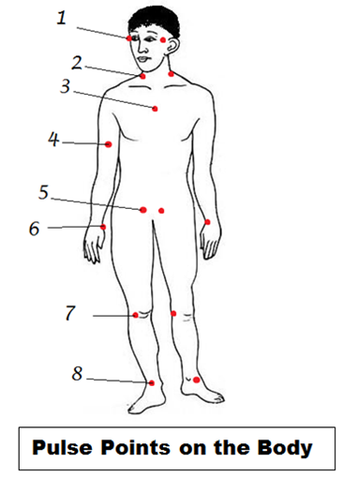The heart is a pumping organ. Blood is forced through the arteries as the heart muscles contract and relaxes. This creates a series of waves in the blood as it flows through the arteries. These waves are called the ***pulse***. Your pulse rate is the number of times your heart beats in one minute. Your pulse can be felt reasonably well at 8 points on your body (including the center of your chest). They are:

1. your temples (upper sides of your head),
2. the sides of your neck,
3. the center of your chest
4. the inside of your upper arms,
5. the upper part of your legs at your groin,
6. your wrists,
7. the back of your knees, and
8. At the sides of your foot near your ankle.

Normal pulse rate (heart rate) varies from person to person but a normal range for adults is 60 – 100 beats per minute. However, normal pulse rate depends on several factors like the individual’s age, body size, heart condition, medical drug use, if the person is sitting or moving, how fit they are, and even the air temperature. Athletes who engage in regular physical activity can have their heart become more efficient and thus reduce their heart rate (pulse rate). This will allow these athletes to engage in physical activity for longer periods of time.

|  |  |
| --- | --- |
| **AGE** | **Normal Pulse Rate** |
| Neonatal (< 28 days old) | 100 – 205 |
| Infant (1 month – 1 year old) | 100 – 190 |
| Toddler (1 – 2 years old) | 98 – 140 |
| Pre-school (3 – 5 years old) | 80 – 120 |
| 6 – 8 years old | 75 – 118 |
| 12 – adult | 60 – 100 |
| Athletes | 40 – 60 |

We are now going to perform an activity to see how physical activity affects the pulse rate of a person. We will use the **COSMOS Technology Toolkit**, a **heart rate sensor** and a **timer**.

**Activity**

Students will be randomly placed in groups of 2 and work together. They will record their data in the table below entitled **Pulse Rate**. The COSMOS Technology Toolkit, heart sensor and timer set up on your table for you.

Procedure

1. Student 1 will sit down and have the partner attach the heart rate sensor. Check with your teacher to make sure it is attached properly.

**Heart rate sensor**

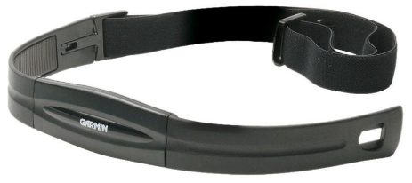

1. Once the sensor is properly attached and activated it should detect your pulse rate. Have your partner start the timer and time for 1 minute. The readings will be displayed on the COSMOS Technology Toolkit. Have your partner record the readings in the table.
2. After your partner has recorded the readings, you will stand up and jog in place for 1 minute (with the heart sensor still attached). Your partner will again time for 1 minute. The readings will be displayed on the COSMOS Technology Toolkit. Your partner will record the readings in the table.
3. The partners will now exchange roles and follow procedures 1 – 3 above and record the findings in the table.

|  |  |  |
| --- | --- | --- |
| **PULSE RATE** | | |
| **Pulse Rate** | **Yours** | **Partner’s** |
| At rest |  |  |
| After jogging |  |  |

**Questions**

1. Describe why the pulse rate changes after physical activity ____________________________________________________________________________________________________________________________________________________________________________________________________________________________________________________________________________

1. Infer what causes the pulse rate to change (mention the action of the heart before and after physical activity) __________________________________________________________________________________________________________________________________________________________________________________________________________________________________________________________________________________________________________________________________________________________________________________________________________________

1. Explain why the heart is a pumping organ? State the main function of the heart and explain why we are able to detect a pulse at different points on our body __________________________________________________________________________________________________________________________________________________________________________________________________________________________________________________________________________________________________________________________________________________________________________________________________________________

1. State 6 different factors (other than exercise) that can affect the heart rate/pulse rate ________________________________________________________________________________________________________________________________________________________________________________________________________________________________________________________________________________________________________________________________________________________________________________________________________________________________________________________________________________________________________________________________________________________________________________________________________________________________________________________________________________________________________________________________________________________________________________________________________________________________________________________________________________________________________________________________________________________________________________________________________________________________________________________________________________________________________________