Student Name____________________________________ Class_________

Photosynthesis in Plants Lesson

Photosynthesis is the process by which green plants use carbon dioxide, water and sunlight to make their own food. All green plants contain the green pigment **chlorophyll** in the cells of their leaves (this is what makes them green). Chlorophyll is able to use the energy from sunlight to combine carbon dioxide and water to form **glucose** (carbohydrate/starch) and oxygen gas. So, plants make glucose as food and release oxygen gas into the air.

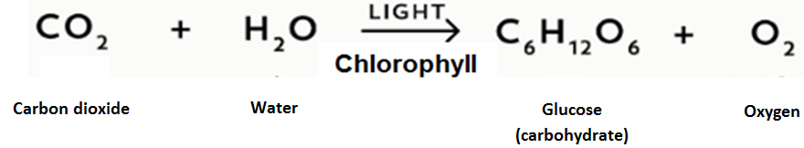 The equation above is the equation for photosynthesis. It shows that carbon dioxide and water in the presence of sunlight and with chlorophyll will combine to produce glucose (carbohydrate) and oxygen gas. If you exclude any one of the input factors of carbon dioxide, water or sunlight photosynthesis will not occur.

We are now going to perform an activity in which we will see how the process of photosynthesis in plants is affected when one of the input factors is excluded. This lab will cover 2 days.

**Materials**

* 2 identical potted plants
* 1 transparent container (open at one end and a hole in the other)
* 1 totally opaque container (open at one end and a hole in the other)
* 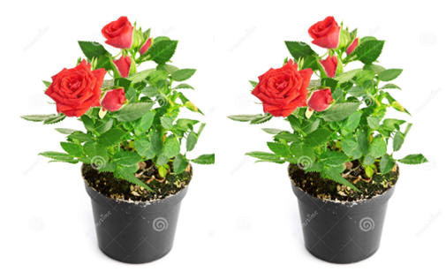Water
* Cosmos Technology Toolkit
* Carbon dioxide (CO2) sensor
* Oxygen (O2) sensor

**Procedure**

1. Place 1 plants by a window for adequate sunlight and place a CO**2** sensor close to it. Cover this plant and sensor with the transparent container with the hole in one end.
2. Place the other plant away from the window and sunlight and place a CO**2** sensor close to it. Cover this plant and sensor with the totally opaque container with the hole in one end.
3. Water both plants with equal amounts of water.
4. To begin the experiment remotely connect CO**2** sensors with both plants to the Cosmos Technology Toolkit and take the initial reading of the CO**2** level under each container (the readings will be displayed on the Toolkit monitor)
5. Arrange for students to take readings for the CO**2** levels under the containers for both plants every 2 hours throughout the school day. Record you data in the table entitled **“Carbon Dioxide (CO2) Levels”**

**Carbon Dioxide (CO2) Levels**

|  |  |  |
| --- | --- | --- |
| **Time measurement was taken** | **Plant in Sunlight**  **(CO2 Levels in ppm*)** | **Plant without Sunlight**  **(CO2 Levels in ppm*)** |
| 8:00 am |  |  |
| 10:00 am |  |  |
| 12:00 noon |  |  |
| 2:00 pm |  |  |
| Average CO**2** Levels => |  |  |

* - parts per million

Questions

1. Which plant had the smallest amount of CO**2**? __________________________

1. Which plant had the largest amount of CO**2**? ___________________________
2. **Hypothesize**. What does it mean if the level of CO**2** in the “Plant with Sunlight” is less than in the “Plant without Sunlight”? ____________________________________________________________________________________________________________________________________________________________________________________________________________________________________________________________

1. Based on the CO**2** levels observed in both plants which pant do you think was performing photosynthesis? Give reasons for your answer ___________________________________________________________________________________________________________________________________________________________________________________________________________________________________________________________________________________________________________________________
2. Compare how the plant that was in sunlight looks to plant that was not in sunlight. _____________________________________________________________________________________________________________________________________________________________________________________________

1. Explain why most trees lose their leaves during the fall and remain without them through the winter until the spring? ________________________________________________________________________________________________________________________________________________________________________________________________________________________________________________________________________________________________________________________________________________________________________________________________________________________________________________________________________________________________________________________

1. Describe how temperature influences the rate of photosynthesis in plants __________________________________________________________________________________________________________________________________________________________________________________________________________________________________________________________________________________________________________________________________________________________________________________________
2. Soil humidity describes the moisture content of the soil (how much water is in the soil). Explain how soil humidity affects the rate of photosynthesis in plants? _________________________________________________________________________________________________________________________________________________________________________________________________________________________________________________________________________________________________________________________________________________________________________________________________________________________________________________________
3. Sketch/draw and label a diagram of each plant in the space below

|  |  |
| --- | --- |
| Plant that was in sunlight | Plant that was **NOT** in sunlight |
|  |  |