Student Name____________________________________ Class_________

**Different Types of INTERNET Connections** Lesson

There are many ways a personal electronic device can connect to the INTERNET.  They all use different hardware and each has a range of connection speeds. As technology changes, faster internet connections are needed to handle those changes. Today there are 5 popular methods of connecting to the internet: **Fiber Optics, Cable, DSL, Wireless,** and **Satellite**. We are now going to perform an experiment/activity in which you will send a specific amount of data over the internet using each of the INTERNET connection methods mentioned above and see which method has the fastest and slowest speeds. We will use our **COSMOS Technology Toolkit** to perform this activity.

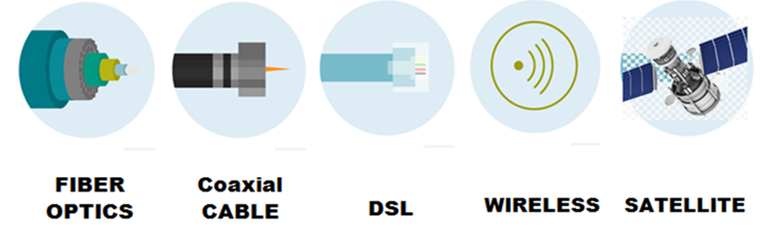

**Activity**

First, we will transmit a fixed amount of data (xxxx MB) over the internet using satellite transmission and record the time it takes to complete the transmission. You will then calculate the internet transmission rate. Record the results in the table entitled **“INTERNET Transmission Rates”**. We will then transmit the same amount of data using DSL, then Cable, then wireless, and finally Fiber Optics.

**NOTE**:

*The formula for calculating the Internet transmission rate:*

*Internet transmission rate (MB/sec) = amount of data transmitted (MB)*

*Time taken (sec)*

**INTERNET Transmission Rates**

|  |  |  |  |
| --- | --- | --- | --- |
| **Type of Transmission** | **Amount of Data Transmitted (MB)** | **Transmission Time (sec.)** | **INTERNET Transmission Rate (MB/sec.)**  (Transmission rate= data transmitted / time taken) |
| Satellite |  |  |  |
| DSL |  |  |  |
| Cable |  |  |  |
| Wireless (WiFi) |  |  |  |
| Fiber Optics |  |  |  |

**Graphing**

Construct a **bar graph** to show the different times it took for data to be transferred over the INTERNET using the different internet connection methods.

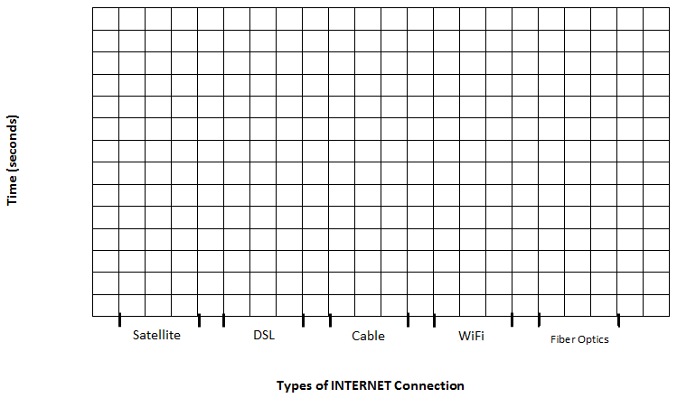

Questions

1. Which INTERNET connection speed is the fastest? ______________

Which INTERNET connection speed is the slowest?______________

1. If you are a competitive online video game player which INTERNET connection do you want? Give reasons for your answer __________________________________________________________________________________________________________________________________________________________________________________________________________________________________________________________________________________________________________________________________________________________________________________________________________________________________________________________________________________________________________________________________________

1. Wireless (WiFi) INTERNET connections are always on and you can get access from just about anywhere. Again, if you are a competitive online video game player would you choose **fiber optics** internet connection or **wifi**? State why or why not giving **detailed** reasons for your answer __________________________________________________________________________________________________________________________________________________________________________________________________________________________________________________________________________________________________________________________________________________________________________________________________________________________________________________________________________________________________________________________________________________________________________________________________________________________________________________________________________________________________________________________________________________________________________________________________________________________________________________________________________________________________________________________________________________________________________________________________________________________
2. DSL and wireless internet connections are known as “always on” connections. Explain why each one is called an “always on” connection? __________________________________________________________________________________________________________________________________________________________________________________________________________________________________________________________________________________________________________________________________________________________________________________________________________________________________________________________________________________________________________________________________________

1. Many people use the INTERNET to do just about every transaction in our daily lives. Recently, many companies have had breaches where criminals hack into their network and steal the personal and financial information of their clients. What do you think needs to be done to secure INTERNET networks so that these kinds of breaches do not happen? ________________________________________________________________________________________________________________________________________________________________________________________________________________________________________________________________________________________________________________________________________________________________________________________________________________________________________________________________________________ ________________________________________________________________________________________________________________________________________________________________________________________________________________________________________________________________________________________________________________________________________________________________________________________________________________________________________________________________________________