Student Name____________________________________ Class_________

What Blocks Radio Waves Lesson

Radio waves are a type of electromagnetic radiation, a kind of energy that also includes visible light. They are part of the electromagnetic spectrum.

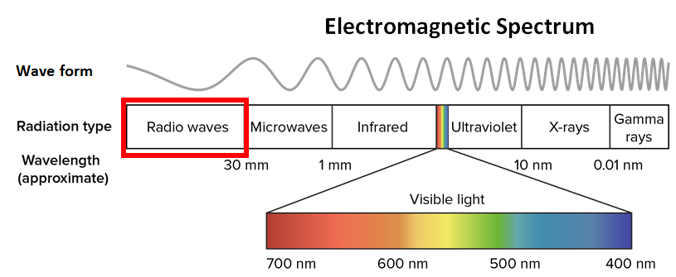

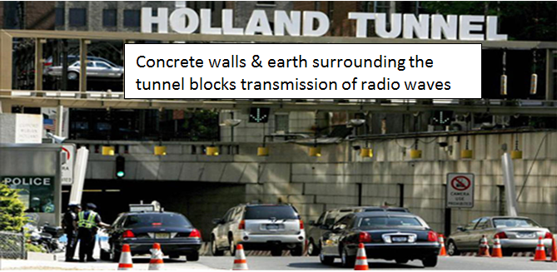Radio waves are not harmful but are in fact extremely useful for communicating across long distances. To send information using radio waves, a transmitting antenna sends out a radio wave at a certain frequency (which can tell us the size of the wave), and this is picked up by a receiving antenna. However, some materials can block, or interfere with, radio waves. That is why you lose reception on a car radio or cell phone when you drive into a tunnel or an underground parking garage.

We are now going to perform an activity in which we will use our **COSMOS Technology Toolkit** to transmit a radio signal to a receiver and use several different materials to see which one will block the radio waves, and which will allow the waves to easily pass through.

**Materials**

**COSMOS Technology Toolkit**, walkie-talkies, small sound maker, 4 medium paper bags, 3 pairs of rubber gloves, 2 dark colored plastic two-liter bottles, aluminum foil, , cardboard box, copper fabric.

**Procedures**

**PART 1**

Set up COSMOS Toolkits so that one is the transmitter and the other is the receiver. Start transmitting the radio signal and make sure that it is being received by the receiver Toolkit.

1. Cover the antenna on the receiver Toolkit with the 4 medium paper bags and observe whether it is still able to receive the radio signal. Record your observations in the table entitled “Part 1: Using COSMOS Toolkit”
2. Repeat procedure #2 using the *rubber gloves*, *dark colored two-liter plastic bottles*, and *aluminum foil* respectively and record your results in the table entitled “Part 1: Using COSMOS Toolkit”.

|  |  |
| --- | --- |
| **Part 1: Using COSMOS Toolkit** | |
| **Materials** | **Signal Transmission**  (good ***or*** clear ***or*** bad ***or*** not clear ***or*** no signal) |
| 4 medium paper bags |  |
| 2 rubber gloves |  |
| Dark colored 2-liter plastic bottles |  |
| Aluminum foil |  |

**PART 2**

We will now use the walkie-talkies. Identify 1 of the walkie-talkies as the transmitter. Tape down the “push-to-talk” button so that it is always transmitting. Turn the sound maker on and tape it to the transmitting walkie-talkie. Ensure that the receiver walkie-talkie is receiving the signal.

1. Place the transmitting walkie-talkie & sound maker into the 4 medium paper bags and wrap it up in it. Observe whether the receiver walkie-talkie is still able to receive the radio signal. Record your observations in the table entitled “Part 2: Using COSMOS Toolkit”
2. Repeat procedure #3 using the *rubber gloves*, *dark colored two-liter plastic bottles*, and *aluminum foil* respectively and record your results in the table entitled “Part 2: Using COSMOS Toolkit”.

|  |  |
| --- | --- |
| **Part 2: Using Walkie-Talkie** | |
| **Materials** | **Signal Transmission**  (good ***or*** clear ***or*** bad ***or*** not clear ***or*** no signal) |
| 4 medium paper bags |  |
| 2 rubber gloves |  |
| Dark colored 2-liter plastic bottles |  |
| Aluminum foil |  |

**PART 3: (Cardboard box & copper fabric with walkie-talkie)**

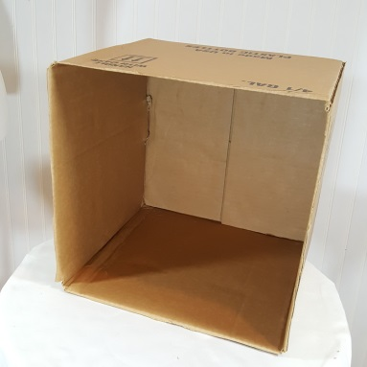Cover the entire outside of the cardboard box with copper fabric – making it, in effect a **copper box**. Put the box on its side (see diagram). Place the transmitting walkie-talkie & sound maker inside the box facing the opening direction and turn on the sound maker. Place the receiver behind the copper box and observe whether or not it is receiving the signal from the transmitting walkie-talkie. Record your results in the table entitled “Part 3: Using Copper Box”

|  |  |
| --- | --- |
| **Part 3: Using Copper Box** | |
| **Materials** | **Signal Transmission**  (good ***or*** clear ***or*** bad ***or*** not clear ***or*** no signal) |
| Copper Box |  |

**Questions**

1. For **Part 1: Using the COSMOS Toolkit** which of the materials blocked or disrupted the radio signal? _____________________________________________________________________________________________________________________________________________________________________________________________

1. For **Part 2: Using the Walkie-Talkie** which of the materials blocked or disrupted the radio signal? _____________________________________________________________________________________________________________________________________________________________________________________________
2. Of all the materials that you tested, which did you think would have blocked the radio signals but actually did not? Why do you think it did not block the radio waves? ____________________________________________________________________________________________________________________________________________________________________________________________________________________________________________________________
3. State which metal is widely used to shield electronic devices from radio waves and explain why this metal is used _____________________________________________________________________________________________________________________________________________________________________________________________
4. Of all the materials that you tested, which did you think would have blocked the radio signals but actually did not? Why do you think it did not block the radio waves? ____________________________________________________________________________________________________________________________________________________________________________________________________________________________________________________________
5. Why do you think you lose cell phone service when you go into an underground tunnel? Explain _____________________________________________________________________________________________________________________________________________________________________________________________

1. State what a Faraday Cage is and explain what it does ___________________________________________________________________________________________________________________________________________________________________________________________________________________________________________________________________________________________________________________________

1. Explain how the thickness of materials affect whether or not radio waves can pass through them. Give an example of a material that if thick enough might disrupt or block radio waves. __________________________________________________________________________________________________________________________________________________________________________________________________________________________________________________________________________________________________________________________________________________________________________________________
2. Consider a thick jungle with many green trees and a deep valley surrounded by rocky mountains. In which of these locations would it be easier for you to get a cell phone signal? Give detailed reasoning in your answer ____________________________________________________________________________________________________________________________________________________________________________________________________________________________________________________________________________________________________________________________________________________________________________________________________________________________________________________________________________________________________________________________________________________________________________________________________________________________________________________________________________________________________________________________________________________________________________________