Rate of Reaction Experiment
Grade/ Grade Band: 9-12 | Topic: Kinetic and Equilibrium | Lesson # __1___ in a series of _1____ lessons
Brief Lesson Description:

Based on the class size, students will be divided in groups of 4. Each group will work on their part of the experiment. Toward the end of the period, students will present their experiment data and see how this wireless device may help us collect and transfer data.

Group number | Experiment | Description
1&2 | Temperature Vs Rate of reaction | Students will collect the rate of reaction at cold and hot temperatures and explain how temperature affects the rate of reaction.
3&4 | Surface area Vs Rate of reaction | Students will collect the rate of reaction at large and small surface area and explain how surface area affects the rate of reaction.
5&6 | Concentration Vs Rate of reaction | Students will collect the rate of reaction at low and high concentration and explain how concentration affects the rate of reaction.
7&8 | Temperature Vs Rate of reaction with Cosmos Tool Kit | Students will use the temperature probe and CO₂ sensor to collect data and explain how temperature affects the rate of reaction.

Specific Learning Outcomes:
Based on their observation, by the end of the period, students should be able to explain that:
- The se of CO₂ level to demonstrate the rate of reaction.
- The use of collision theory to explain how increasing particle size, temperature, concentration will increase the rate of reaction.
Higher level thinking:
- Explain how using wireless devices to measure the CO₂ emission rate may be applied in other fields/research.
Narrative / Background Information
Prior Student Knowledge Required:
Collision theory: in order for a successful reaction to take place, particles must collide with each other in proper orientation and with sufficient energy.
Problem Solving Practices (Ex: Standards for Mathematical Practice):  - Plot graph of time vs temperature and find the best fit line.  CCSS.Math.Content.6.SP.B.5  Summarize numerical data sets in relation to their context, such as by:  CCSS.Math.Content.6.SP.B.5.a  Reporting the number of observations.  CCSS.Math.Content.6.SP.B.5.b  Describing the nature of the attribute under investigation, including how it was measured and its units of measurement. | Main Content Ideas:  3.4 Use kinetic molecular theory (KMT) to explain rates of reac­tions and the relationships among temperature, pressure, and volume of a substance. | Possible Multidisciplinary Concepts:
Possible Preconceptions/Misconceptions:
Adding a catalyst will increase the rate of reaction but not changing equilibrium.
LESSON PLAN – 5-E Model
ENGAGE: Opening Activity – Access Prior Learning / Stimulate Interest / Generate Questions:
Circle the correct answer and use your knowledge of collision theory to explain your answer:
The equation below represents a reaction between two molecules, X2 and Z2. These molecules form an "activated complex," which then forms molecules of the product.
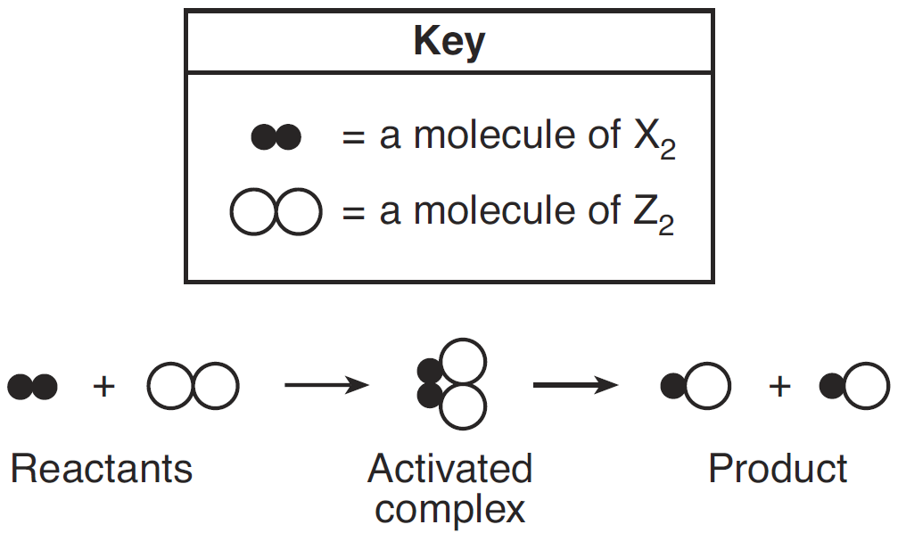
Which diagram represents the most likely orientation of X2 and Z2 when the molecules collide with proper energy, producing an activated complex?
A) B) C) D)
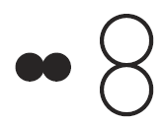
EXPLORE: Lesson Description – Materials Needed / Probing or Clarifying Questions:
- Beakers
- Hot and ice water
- Alka-Seltzer tablets
- Graduated cylinder
- Cosmos Tool kit with temperature probe and CO₂ sensor.
EXPLAIN: Concepts Explained and Vocabulary Defined:
Key Vocabulary:
Collision theory: Collision theory is a set of principles that states that the reacting particles can form products when they collide with one another provided those collisions have enough kinetic energy and the correct orientation.

ELABORATE: Applications and Extensions:
List at least 3 examples of exothermic chemical and endothermic chemical reactions that happen in your everyday life.
EVALUATE:
Formative Monitoring (Questioning / Discussion):
Post Activity questions
Summative Assessment (Quiz / Project / Report):

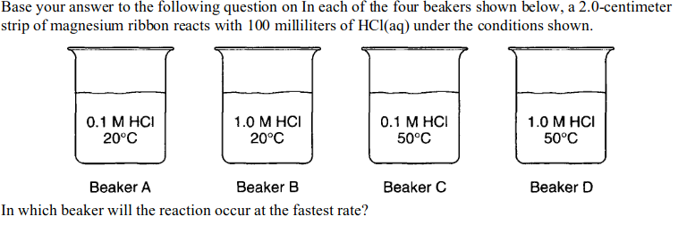
- A b) B c) C d) D
2. As the concentration of reacting particles increases, the rate of reaction generally:
- Decreases b)increases c) remains the same
3. Given the balanced equation representing a reaction:
Fe_{(s)} + 2HCl_{(aq)} → FeCl_{2 (aq)} + H_{2(g)}
This reaction occurs more quickly when powdered iron is used instead of a single piece of iron of the same mass because the powdered iron
A)acts as a better catalyst than the single piece of iron
B)absorbs less energy than the single piece of iron
C)has a greater surface area than the single piece of iron
D)is more metallic than the single piece of iron

Elaborate Further / Reflect: Enrichment:

