Alka Seltzer Reaction Rates

**Aim**: How can we use collision theory to

**Do now**: Circle the correct answer and use your knowledge of collision theory to explain your answer:

The equation below represents a reaction between two molecules, X2 and Z2. These molecules form an "activated complex," which then forms molecules of the product.

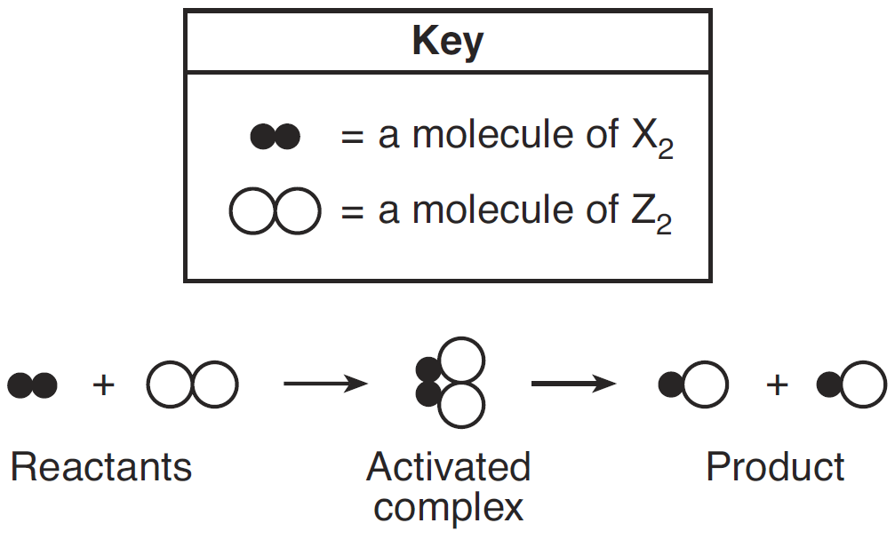

Which diagram represents the most likely orientation of X2 and Z2 when the molecules collide with proper energy, producing an activated complex?

A) B) C) D)

   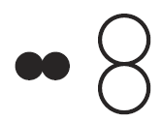

My answer is _____ because ___________________________________________________________.

**Intro**: In today’s experiment you will be studying energy exchange (exo/endothermic), and the effect of temperature and surface area on the rate of reaction. You will be using Alka-Seltzer (or a generic equivalent) dissolved in water. As the tablet dissolves and the principal components react carbon dioxide gas is released. This is due to the reaction between sodium bicarbonate (NaHCO­3) and citric acid (H3C3H5O7) in the tablet, you are also producing water and sodium citrate (Na3C3H5O7 aq.) which remain in solution..

The balanced equation is as follows:

$3NaHCO_{3}(aq)+H_{3}C_{3}H_{5}O_{7}(aq)→Na_{3}C_{3}H_{5}O_{7}(aq)+3CO_{2}(g)+3H_{2}O(l)$

|  |  |  |  |
| --- | --- | --- | --- |
|  | Temperature VS Rate of reaction | Surface area VS Rate of reaction | Concentration VS Rate of reaction |
| Material | Traditional method:  2 alka-seltzer tablets  One cup of hot water (100mL in 250mL beaker)  One cup of ice water  (100mL in 250mL beaker)  thermometer  stopwatch  Wireless method:  2 alka-seltzer tablets  One cup of hot water (100mL in 250mL beaker)  One cup of ice water  (100mL in 250mL beaker)  COSMOS Toolkit with temperature probe and CO2 sensor.  Computer | 2 alka-seltzer tablets  Mortar and pestle  two cups of room temperature water  (100mL in 250 mL beaker)  Stop watch | Graduated Cylinder  Vinegar  Baking Soda  2 x 50 mL beaker |
| Procedure | 1. In cup A with the iced water add ½ a tablet of anti-acid tablet. 2. In cup B with the hot water add ½ a tablet of anti-acid tablet. 3. Record the temperature and time for reaction to complete.   **For students who use COSMOS tool kits, see the graph of CO2 emission rate. How can you explain the graph with the rate of reaction. Record your observation of the experiment and graph. | 1. Prepare two beakers, put 10 ml of room temperature water in each beaker .  2. Drop one tablet into one beaker. Record detailed observations and record the time of the reaction until it has fully stopped.  3. Crush the other tablet into small pieces – use mortal & pestle– and add it to the other beaker. Record detailed observations and record the time of the reaction until it has fully stopped.  4. Record your observation. | 1. In cup A use pure vinegar (3mL) and place one spoonful of baking soda. 2. In cup B add pure vinegar (1.5mL) and water (1.5 mL) before you add the spoon full of baking soda. 3. Make an observation. |
| Observation |  |  |  |
| Data | |  |  | | --- | --- | | Temperature | Time for reaction to complete | |  |  | |  |  | | |  |  | | --- | --- | | Surface area | Time for reaction to complete | |  |  | |  |  | | |  |  | | --- | --- | | Concentration | Time for reaction to complete | |  |  | |  |  | |
| Post- Activity Questions | 1. Which reaction had the fastest rate? Record your observations here.   2. How can we use collision theory to explain what you just observed? Cite textual evidence to explain your answer.  3. Compare the traditional data recording procedure with the data taken by COSMOS tool kit. Which way do you think is easier? How can we apply this technology in other fields? | 1. Which reaction had the fastest rate? Record your observations here.      1. Why are smaller pieces reactions faster than larger pieces? How can you use the rate of collision to explain? Cite textual evidence to support your answer. 2. What kind of reaction is this? Physical or chemical? Explain your answer. | 1. Which reaction had the fastest rate? Record your observations here.     2. Why are high concentration reactions faster than low concentrations? How can you use the rate of collision to explain? Cite textual evidence to support your answer.    3. What kind of reaction is this? Physical or chemical? Explain your answer. |

Exit slip:

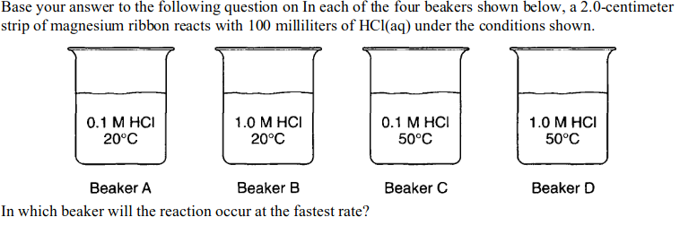

1. A b) B c) C d) D

2. As the concentration of reacting particles increases, the rate of reaction generally:

1. Decreases b)increases c) remains the same

3. Given the balanced equation representing a reaction:

Fe(s) + 2HCl(aq) → FeCl2 (aq) + H2(g)

This reaction occurs more quickly when powdered iron is used instead of a single piece of iron of the same mass because the powdered iron

A)acts as a better catalyst than the single piece of iron

B)absorbs less energy than the single piece of iron

C)has a greater surface area than the single piece of iron

D)is more metallic than the single piece of iron