Name: ________________ Period: _______________ Date: ______________ Teacher: _____________

Finding the Robot!

**Aim:** How can we use walkie-talkie to locate the robot?

**Do now:** Turn and talk with your elbow partners to complete the following questions

* What makes these devices wireless?
* What does it mean to be wireless?
* Write down at least 3 wireless communication devices that you use everyday.

**Define the Following Concepts:**

Amplifier:

Modulator:

Demodulator:

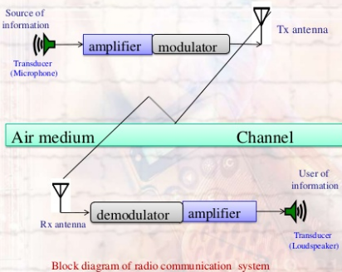

Transducer:

Modulation:

Demodulation:

Types of modulation:

|  |  |
| --- | --- |
| Amplitude Modulation (AM) | Frequency Modulation (FM) |
|  |  |

**Group Selection/Plan Description:**

Write a detailed description of your plan. As we discussed, write about how you plan to hide your robot, program the robot to run. If you are in the finder’s team; write about how you plan to search for the robot.

Group #_________, my group is the (finder/hider), my group members are ____________________

Our plan is…

________________________________________________________________________________________________________________________________________________________________________________________________________________________________________________________________________________________________________________________________________________________________________________________________________________________________________________________________________________________________________________________________________________________________________________________________________________________________________________________________________________________________