Scientific Inquiry – Using sensors to manage outdoor Brassica rapa plants

Student name: __________________________________________________________________

Overview You have spent several weeks, as a class, studying the many environmental factors that influence how well a plant germinates, grows and flowers (angiosperms). Now you will apply this knowledge to design, monitor and assess the development of Brassica rapa plants (Wisconsin fast plant) growing outside, on school grounds.

Background Literature
Germination
Lights on all the time and 5–10 cm from growing tip, room temperature ~22°C), soil moist with water all time (reservoir system), 1 oz fertilizer (Osmocote NPK pellets @N/14, P/14, K/14).

References for the optimal germination and growing conditions for the Brassica rapa plant.
1) file:///C:/Users/jason%20george%20econome/Desktop/00000%202019%20WFPgermbk!.pdf
2) http://www.fastplants.org/pdf/growing_instructions.pdf
3) https://fastplants.org/2017/09/19/physical-environment-blog/

Photosynthesis 4) http://www.biology4kids.com/files/plants_photosynthesis.html
5) https://www.khanacademy.org/science/biology/photosynthesis-in-plants/the-light-dependent-reactions-of-photosynthesis/v/conceptual-overview-of-light-dependent-reactions
6) https://www.khanacademy.org/science/biology/photosynthesis-in-plants/the-light-dependent-reactions-of-photosynthesis/v/photosynthesis-light-reactions-1
7) https://www.youtube.com/watch?v=sfihE4IuFuU

NYC weather conditions data
8) https://opendata.cityofnewyork.us/
9) https://data.ny.gov/

Brassica rapa is a biennial mustard plant that grows 1-3 feet with many branches. Leaves reach 12 inches, with bright yellow flowers at stem tops. The fruit is an elongated, two-parted capsule that splits open at the base. Seeds are round, reddish-gray to black. This very adapt-able plant, grows in sandy to heavy clay soils and tolerates a pH 5-9 range. It grows best in well-drained, moist soil with low fertility. Grows best in full sun, or less so in moderate shade.

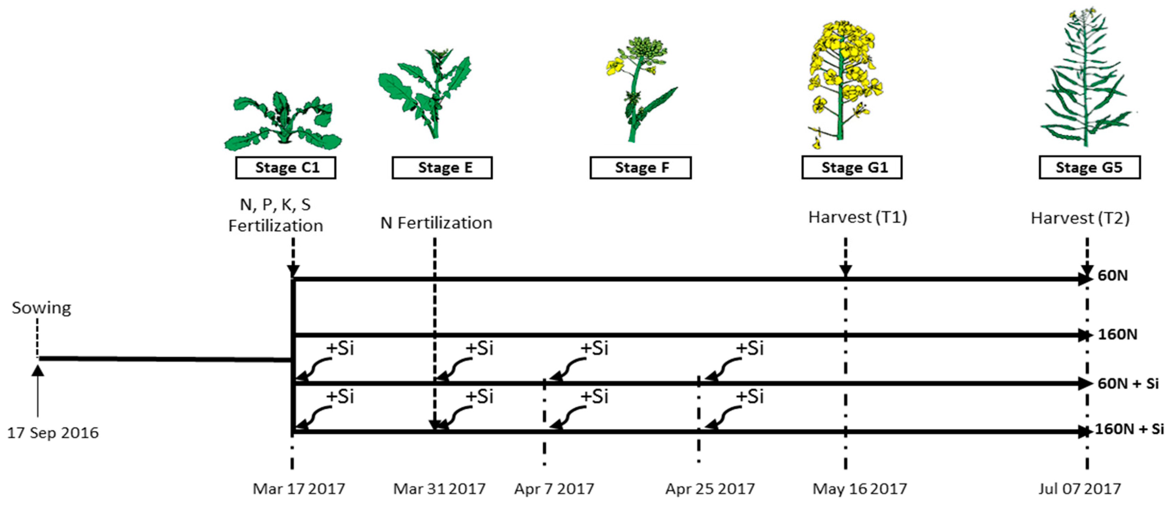
Project grading scheme (see descriptions below)
Your team will be graded in the following way:
Performance of responsibilities A/B (25%), C (25%), D (25%), E (25%)

Responsibilities
You have gathered a great deal of information regarding germination and photosynthesis of Brassica rapa plants. It’s now time to take this knowledge to the next level and apply it to the great outdoors and beautify our school grounds! This is approximately a four-week project.

A) Research which school ground’s location (east-2nd fl bridge, west-facing Hudson river park,
south-dog park, north-Hudson river docks) you want to grow the Brassica rapa.
*Be sure to cite at least 1 article that supports your choice for this location.
*Keep in mind that you will be able to monitor temperature, humidity, carbon dioxide
and polluting dust with the electronic, wireless sensors.

B) Research soil conditions (i.e. fertilizer, number of seeds, soil depth, backboard).
*Be sure to cite at least 1 article that supports your choice for this location.

C) Initial proposal: Discuss the reasons for the choices your team made in regard to the Brassica rapa garden location, growth requirements (soil), predicted key environmental factors, predicted growth rate and final growth stage characteristics

D) Data
Collecting data (3x/wk): Use sensors to record temperature, carbon dioxide, humidity and plant growth progress (number of plants, number of flowers, total leaf area, stem size, root size, total weight)

Communicating data: Upload your weekly data for days 5, 7, 9… 30 via Google drive spread sheet “2019 Econome - Using sensors to manage an outside garden.” (see example on following page)

Analyzing data: Discuss trends between environmental factors and the growth progress of your Brassica rapa garden.

E) Final report: (include photographs, number of plants, number of flowers, total leaf area, stem size, root size, total weight; conclusion – was your chosen location a good match for your plants’ requirements, what environmental factor was key to growth, what environmental factor was detrimental to growth, what would you differently in the future)

*Orally present a 5-10 minute, 1-3 MS-Powerpoint slide summary of results to class
(Highlight responsibilities A-E)

Day 0
C) Initial proposal – Using sensors to optimize seed germination conditions

Team’s names: ________________________________________________________________

After performing the suggested research (see responsibilities A & B), propose the reasons for the choices your team made in regard to Brassica rapa garden location, growth requirements (soil), predicted key environmental factors, predicted growth rate and final growth stage characteristics. Limit the discussions of your proposal to a 1-page narrative.

D) Data: Collect, Communicating and Analyzing
Visiting Times should be consistent (Mondays & Thursday or Tuesdays & Fridays (for Oct.) along with the time of day). Place your team’s name in the available slot; “first come, first serve” no two teams can occupy the same time slot.

class periods
wk-days
 | 1 | 2 | 3 | 4 | 5 | 6 | 7 | 8 | 9 | 10
M/Tr
Tu/F

Measurements involve placing a transparent bag over the plant’s light-exposed leaves and CO2 sensor and record an average carbon dioxide (CO2) value over 5 minutes.

A) CO2 levels near plants = _________________ ppm.

B) Calculate the total surface area of the plant’s leaves by tracing an outline of all the leaves onto graph paper (grid area = 1 cm²); see example below.

*Record other parameters for light-related health (stem size, root length, total mass),
one being total leaf surface area.

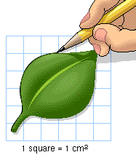
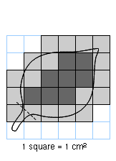

13 cm² = 3+3.5+3.5+3

Hold graph paper (1-cm² per grid) up against a leaf and trace its outline.

Count all squares within outline; include whole and half squares but nothing smaller.

Add up all of these squares from the one leaf to calculate it’s surface area (cm²).

In the example above, the leaf’s surface area = 13 cm² and the total would be 130 cm²

if there 10 similarly sized leaves altogether; if not tally all of the individual leaf area values.

Plant’s total leaf surface area = ________ cm².

DAY 30 Culminating data (for days 5, 7, 9… 30)

Upload today’s data (subsequently for days 1, 2… 30) onto Google drive spread sheet “2019 Econome - Using sensors to determine which wavelengths of light are used for photosynthesis.”

*Be sure to include any additional comments about the plant’s overall appearance.

*Be sure to record data plus calculated total values and culminating averages.

*Review classroom data and generate at least 2 line graphs demonstrating the different
effects of light’s wavelengths on overall plant health.

*Do not forget your team’s oral presentation for the following week.

Daily data (days 1-30): locations and environmental conditions

team soil-seed conditions school location & conditions
Econome | 1 in deep, 5 seeds/pot, fertilizer | north, traffic (high CO2, weak light)

carbon polluting
team day # dioxide temperature humidity dust
Econome | 1 | ___ppm | ___C | ___% | ___ppm
 | 2
 | 30

total leaf stem additional
team day # #plants surface area size observations
Econome | 1 | ___ | ___cm² | ___cm
 | 2
 | 30

Graph title:________________________________________________________________


Graph title:________________________________________________________________

Day 37 (the following week)
E) Final report
Data - photographs along with environmental and plant growth data (i.e. number
of plants, number of flowers, total leaf area, stem size, root size, total weight, etc.)

Conclusion – was your chosen location a good match for your plants’ requirements, what environmental factor was key to growth, what environmental factor was detrimental to growth, what would you differently in the future

Present a 5-10 minute, 3-5 MS-Powerpoint slides, summary of results
(highlight responsibilities A-E). All good presenters have loud, clear voices
with frequent eye contact and engaging slides

