Scientific Inquiry – Using sensors to measure temperature’s influence
on pill bug respiration

Student name: ________________________________________________________________

Overview You will be studying how the environment (i.e. temperature) can affect critical cellular processes, such as respiration, of an organism. This supplemental activity will follow the “Pill bug terrarium” experiment which involves you and your teammates to determine the optimal habitat conditions (i.e. humidity, soil wetness, soil pH) for a pill bug’s habitat (Armadillidiidae vulgare) habitat. Once these parameters have been identified you will next test how these detritivores respond to fluctuating temperatures with the use of an electric, wireless carbon dioxide (CO2) measuring sensor.
As described in the equation below, respiration is an exothermic process whereby the reactants, glucose and oxygen and processed to produce adenosine tri-phosphate (ATP) the preferred form of energy that drives endothermic reactions in your cells (i.e. protein synthesis).
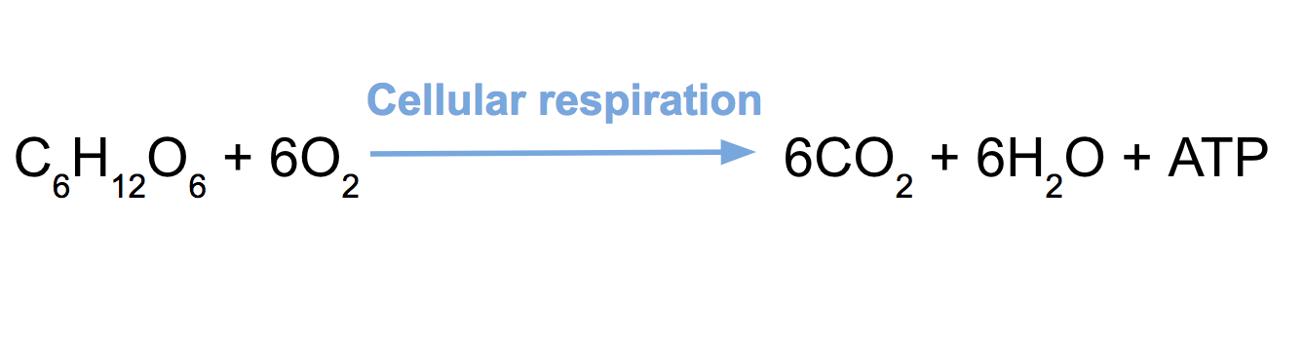
For a refresher on the principles of respiration visit these tutorials: 1) https://www.khanacademy.org/science/high-school-biology/hs-energy-and-transport/hs-cellular-respiration/v/introduction-to-cellular-respiration

2) http://www.sumanasinc.com/webcontent/animations/content/cellularrespiration.html

3) https://www.youtube.com/watch?v=7J4LXs-oDCU

4) http://www.biology.arizona.edu/biochemistry/problem_sets/energy_enzymes_catalysis/07t.html

5) http://www.worthington-biochem.com/introbiochem/tempeffects.html

Homework to submit – Name: _________________________________________

A) Visit the above tutorials (5) and summarize each one with three important facts for each.

B) Compare the respiration equation and contrast it to the photosynthetic process; what kind of observations can you make?

C) Create a concept map of cellular respiration using any 5 relevant features.

Quiz – Student name: _______________________________________________

1. List the two reactants involved in the cellular respiration reaction.

Reactant A =

Reactant B =

2. List the three products resulting from the cellular respiration process.

Product A =

Product B =

Product C =

3. What cellular structure (or organelle) produces the major amount of ATP
during the cellular respiration process?

4. Predict how changes in temperature will affect the Pill bugs’ abilities to respire.

5. Briefly propose an experiment whereby you measure temperature’s effects on respiration rate of Pill bugs (be sure to include independent variable, dependent variable, negative control group and experimental group).

Day 1 Armadillidium vulgare habitat setup Read basic behavior information: The Pillbug, Armadillidium vulgare, is an isopod, a non-insect arthropod. It has the ability to roll into a ball when disturbed, hence its name, as a defensive behavior against predators. It is nocturnal, found in soil or under debris throughout the world. As detritivores, (consuming decomposed materials), they benefit any ecosystem.

http://entnemdept.ufl.edu/creatures/MISC/Armadillidium_vulgare.htm
https://www.scientificamerican.com/article/springtime-science-whats-home-sweet-home-to-a-bug/
https://entomology.ca.uky.edu/ef439

Based on this passage and the information provided in the resources above you and your teammates should be able to construct a habitat for this model organism; use the table below to describe the chosen parameters for your experiment. Place an “x” in the appropriate columns to indicate that it is a part of your pill bug habitat and any annotation you care to include in the corresponding “description” columns.

today’s habitat data onto the Google drive spread sheet
“2019 Econome - Using sensors to determine temperature’s influence on pill bug respiration.”

condition variables | yes  (x) | description
Light - exposed
Light – shaded
Soil – dry
Soil – wet
Soil - rocky/leafy
Soil – smooth
Soil – pH 7
Soil – pH 5
Soil – pH 9

Experiment #1 (optimizing habitat conditions)
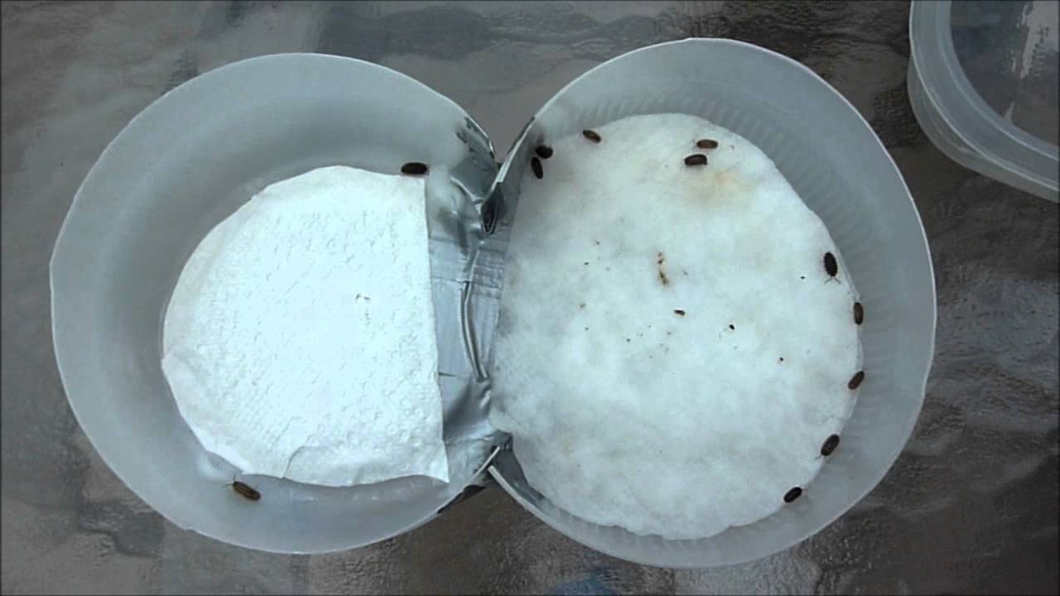

Setup: negative control (left cup) versus experimental group (right cup) Results: Pill bugs prefer moistened floor.

Individual habitats data upload today’s habitat data onto the Google drive spread sheet
“2019 Econome - Using sensors to determine temperature’s influence on pill bug respiration.”

 | time (min) | 0.5 | 1.0 | 1.5 | 2.0 | 2.5 | 3.0 | 3.5 | 4.0 | 4.5 | 5.0 | 5 min totals
# pill bugs
habitat condition:

Uniform habitat review the uploaded data describing each team’s terrarium description
and the number of pill bugs over the 5 min period of observation.

*Add up the total number of Pill bugs over the 5 min observational period for this experiment, the team that records the highest number of Pill bug visits (100% preference = 100 if you are using 10 individuals).

*Each team should share out their recommendations for optimal Pill bug habitat;
there will be a final vote will be taken.

Experiment #2 (temperature’s effect on cellular respiration)

You will be assigned a temperature for this portion of the project (4C, 22C, 37C).

Attach the temperature and carbon dioxide (CO2) sensors to the wall of your cup
(do not include negative control group)

Temperature and CO2 emissions will be recorded for the next 5 minutes.

Temperature-Respiration data upload today’s respiration data onto
the Google drive spread sheet “2019 Econome - Using sensors to determine
temperature’s influence on pill bug respiration.”

condition variables | class data –  avg CO2 emission for 5 min
4C (refrigerator)

22C (bench top)

37C (air incubator)

Final Report: temperature’s influence on pill bug respiration
Student name: _______________________________________________________________
Congratulations, you’ve just completed the scientific inquiry to understanding the role of the environment on the health of the detritivore, Armadillidium vulgare. The final step is to reflect on the experimental results and future ideas as well.
Please include the following sections in your report: 1. Describe your team’s initial habitat setup and results (number of Pill bug visits) for 5 min.
2. What do you think were the critical environmental parameters in regard to Pill bugs’ health.
3. Describe the parameters that provided the Pill bugs with an optimized habitat.
4. Explain the temperature (4C, 22C, 37C) versus cellular respiration data.
5. Discuss some of the flaws in your experimental setup and how they could be improved.
6. Describe a new experimental proposal that you may want to conduct in the future, related to how another environmental factor affecting a different aspect of Pill bug health.
*Keep in mind the following, all reputable experiments are controlled.

Hypothesis:

Independent variable:

Dependent variable:

Experimental group/s:

Negative control group:

