Scientific Inquiry – Using sensors to determine which wavelengths of light
are used for photosynthesis

Student name: __________________________________________________________________

Overview Over the next few weeks you will be applying the scientific process to better understand what wavelengths drive photosynthesis. As you (and your teammates) setup your pot and monitor the growth of a Brassica rapa plant, you will use an electronic, wireless red, blue, green light sensor to confirm the wavelength and intensity of the light being used at that time as well as carbon dioxide levels reflecting photosynthetic activity. If you recall photosynthesis is basically a two stage process whereby the light-dependent reactions generate enough adenosine triphosphate (ATP) and electron carriers (adenine dinucleotide phosphate (NADP)) for construction of glucose from carbon dioxide.
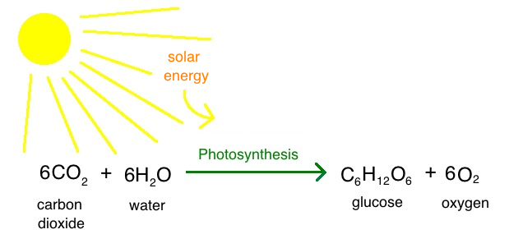
For a refresher on the principles of photosynthesis visit these tutorials: 1) http://www.biology4kids.com/files/plants_photosynthesis.html
2) https://www.khanacademy.org/science/biology/photosynthesis-in-plants/the-light-dependent-reactions-of-photosynthesis/v/conceptual-overview-of-light-dependent-reactions
3) https://www.khanacademy.org/science/biology/photosynthesis-in-plants/the-light-dependent-reactions-of-photosynthesis/v/photosynthesis-light-reactions-1
4) https://www.youtube.com/watch?v=sfihE4IuFuU

Warm-up: The image below is describing the different wavelengths of light and their effects on photosynthesis; arrange them in order of importance to photosynthesis.

#1 wavelength = ____________________ (most important)

#2 wavelength = ____________________ (second most important)

#3 wavelength = ____________________ (least important)

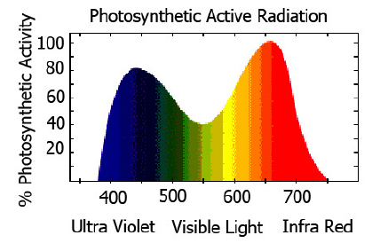

If you guessed red, blue (green the least) as most important wavelengths than you were correct!
Project grading scheme:
You (and your teammates) will graded in the following ways:
50% Team preparedness: I will briefly visit your group and asking questions regarding some aspect of the photosynthesis experiment. In addition, I will be looking for productive conversations and on-time, progress reports.

50% Individual preparedness: Homework assignments, quizzes.

Homework to submit – Name: ___________________________________________
After visiting the suggested references you should be fairly familiar with the photosynthesis process and how light plays such a major role in driving this endothermic process, resulting in glucose. With that in mind, propose an experiment to test the hypothesis that “Red wavelength of light (or blue) is the most potent fuel for photosynthesis.” Another experiment could involve characterizing the relationship between distance between a light source and plant versus its photosynthetic output (glucose produced, growth, carbon dioxide absorption).

Keep in mind that all legitimate experiments are controlled.

Hypothesis:

Independent variable:

Dependent variable:

Experimental group/s:

Negative control group:

Quiz – Student name: _____________________________________________

1-3. Explain how the following wavelengths of light affect photosynthesis:

Red (630-750nm):

Blue (450-490nm):

Green (490-570nm):

4. What is the principal pigment that is responsible for absorbing light and initiating photosynthesis’ light-dependent reactions?

5. What organelle, found in leaves, is responsible for photosynthesis?

6. What aspect/s of photosynthesis is similar to cellular respiration?

7-8. Explain the connection between a reactant and its derived product in a typical photosynthetic reaction.

Explain how carbon dioxide (CO2) gives rise to _____________ via _____________.

Explain how water (H2O) gives rise to _____________ via _____________.

Day 1 Brassica plant setup (may have been performed by your teacher) Read basic germination information: The mustard plant (Brassicaceae) is a biennial that grows 1-3 feet with many branches. Leaves can reach 12 inches long, with bright yellow flowers clustered at stem tops. The fruit is an elongated, two-parted capsule that splits open at the base to release the seeds at maturity. Seeds are nearly round, and reddish-gray to black. This is an extremely adaptable plant, growing in sandy to heavy clay soils and tolerates a pH 5-9 range. It grows best in well-drained, moist soil, but may also grow in droughty conditions, moderate heat, and soils with low fertility. Although it grows best in full sun, it will grow in moderate shade.

For best germination and growth results: Lights on all the time and 5–10 cm from growing tip, room temperature ~22°C), soil moist with water all time (reservoir system), 1 oz fertilizer (Osmocote NPK pellets @N/14, P/14, K/14).

References for the optimal germination and growing conditions for the Brassica rapa plant.
(file:///C:/Users/jason%20george%20econome/Desktop/00000%202019%20WFPgermbk!.pdf; http://www.fastplants.org/pdf/growing_instructions.pdf; https://fastplants.org/2017/09/19/physical-environment-blog/).

Homework: Explain what processes are occurring within the seed right now that are allowing it to grow in the absence of photosynthesis.

Days 2-4 Nurture germination and growth
Spend 10 minutes, before every class, watering your plant, making sure the temperature is at least 20C and exposed to light. The Brassica rapa plants should be breaking the surface soon!

Day 5 Experimental setup and measurements
Two student teams (four students each) are assigned the same colored wavelength of light.

A) Red light emitting bulb (or place a red colored cellulose sheet over a fluorescent bulb): One team will station this light source close (5 cm) to the Brassica rapa plant.
Second team will station its red filtered light further away from the plant (100cm).
*Your teacher may give you different wattage of specifically colored light bulbs instead.

Different distances of the light source should influence a plant’s photosynthetic capability (reflective in CO2 absorption or growth). Other teams will test blue light, white light (positive control) and green light (negative control).

B) Confirm identity of the intended wavelength with the sensor; in the case of red light, the sensor should indicate absorption at 630-750 nm.

C) Measure intensity of the intended wavelength, at the specified distance 5 cm or 100 cm.

D) Use sensors to measure carbon dioxide (CO2) levels in hallway; no plants present. Measure this value using several locations and calculate overall average ambience CO2 levels
(expect values near 405 parts per million or 0.1% of the atmosphere).

Hallway (ambience) CO2 levels = _________________ ppm.

E) Place a transparent bag over the plant’s light-exposed leaves and CO2 sensor and record an average CO2 value over 5 minutes.

CO2 levels near plants = _________________ ppm.

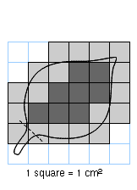
F) In addition to CO2 absorption, students can record other parameters for light-related health (stem size, root length, total mass), one being total leaf surface area. Calculate the total surface area of the plant’s leaves by tracing an outline of all the leaves onto graph paper (grid area = 1 cm²); see example below.

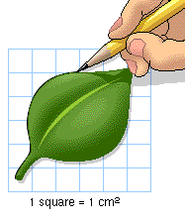

13 cm² = 3+3.5+3.5+3

Hold graph paper (1-cm² per grid ) up against a leaf and trace its outline.

Count all squares within outline; include whole and half squares but nothing smaller.

Add up all of these squares from the one leaf to calculate it’s surface area (cm²).

In the example above, the leaf’s surface area = 13 cm² and the total would be 130 cm²
if there 10 similarly sized leaves altogether; if not tally all of the individual leaf area values.

Plant’s total leaf surface area = ________ cm².

Daily data (days 5-11) upload today’s data onto the Google drive spread sheet “2019 Econome - Using sensors to determine which wavelengths of light are used for photosynthesis.”

*Be sure to include any additional comments about the plant’s overall appearance.

*Don’t forget to keep watering the plants every day; these young plants want to grow!

germination conditions
team # wavelength distance intensity
Econome | _____nm  (green, blue, red or white) | _____ cm (5 or 100) | _____ lux

daily growth results
CO2 total leaf stem root total additional
team # day # absorption surface area size mass weight comments
Econome | 5 | ___ppm | ___cm² | ___cm | ___g | ___g
 | 7
 | 9
 | 11

Homework: Explain relationship between total leaf surface area and CO2 absorption.

DAY 11 Culminating data averages (for days 5, 7, 9, 11) Include in the Google drive spread sheet “2019 Econome - Using sensors to determine which wavelengths of light are used for photosynthesis.”

*Be sure to record data plus calculated total values and culminating averages.

*Review classroom data and generate at least 3 line graphs demonstrating the different
effects of light’s wavelengths on overall plant health.

culminating growth results
CO2 total leaf stem total additional
team # day # absorption surface area size weight comments
Econome | 11 | ___ppm | ___cm² | ___cm | ___g

Day 12 - Final Report wavelengths of light, photosynthesis & overall health
Student name: ________________________________________________________________
Congratulations, you’ve just completed the scientific inquiry to understanding the role certain wavelengths of light play in photosynthesis. The final step is to communicate your results in a report by summarizing your data as well as speculate about future experiments.
Please include the following sections in your report: 1. Describe your team’s experimental setup and the results (CO2 absorption, total leaf surface area, stem size/s, total weight) over days 5-11.
2. Discuss whether the classes’ data supported the hypotheses (H1-red and blue wavelengths fuel photosynthesis; H2-distance between light and plant is inversely related to photosynthetic output.)
3. Discuss how the products of photosynthesis (glucose, oxygen) are being used by the plant; be sure to include differences in uses between young and older/matured plants.
4. Discuss some of the flaws in your experimental setup and how they could be improved.
5. Describe a new experiment that you may want to conduct in the future, related to visible wavelengths of light and photosynthesis (or overall plant health).

Keep in mind the following, all solid experiments are controlled.

Hypothesis:

Independent variable:

Dependent variable:

Experimental group/s:

Negative control group:

